# Visoka škola strukovnih studija za informacione I telekomunikacione tehnologije

HVAC

<https://hvac-blog.000webhostapp.com/>

Smer : Internet tehnologije

Modul: WEB programiranje

Predmet: WEB programiranje PHP 1

Student: Adam Nikolić 101/19

# Sadržaj

Visoka škola strukovnih studija za informacione I telekomunikacione tehnologije 1

1 Sadržaj 2

2 Uvod 5

2.1 Korisćene tehnologije 5

2.2 Opis funkcionalnosti 5

3 Sema baze podataka 7

4 Template 7

5 Mapa sajta 7

5.1 sitemap.xml 8

5.2 index.php 10

5.3 blog.php 13

5.4 login.php 16

5.5 register.php 17

5.6 profile.php 18

5.7 createPost.php 21

5.8 blog-details.php 22

5.9 contact.php 27

5.10 adminPanel.php 28

6 Kodovi 35

6.1 static 35

6.1.1 head.php 35

6.1.2 header.php 36

6.1.3 preloader.php 38

6.1.4 footer.php 38

6.2 index.php 40

6.3 login.php 43

6.4 register.php 44

6.5 profile.php 45

6.6 blog.php 48

6.7 blog-details.php 51

6.8 adminPanel.php 55

6.9 createPost.php 59

6.10 contact.php 61

6.11 error404.php 63

6.12 autor.php 63

6.13 models 64

6.13.1 obradaLogovanje.php 64

6.13.2 obradaRegistracija.php 65

6.13.3 obradaPost.php 67

6.13.4 obradaPoruka.php 70

6.13.5 obradaNewsletter.php 71

6.13.6 obradaKategorije.php 72

6.13.7 obradaIzmenaKategorija.php 73

6.13.8 obradaDodajKategoriju.php 74

6.13.9 obradaIzmenaPostova.php 75

6.13.10 obradaBrisanjePostova.php 76

6.13.11 obradaComment.php 76

6.13.12 obradaDeleteUser.php 77

6.13.13 obradaBrisanjePoruke.php 78

6.13.14 obradaBrisanjeNewsletter.php 79

6.13.15 obradaBrisanjeKomentara.php 79

6.13.16 obradaBrisanjeKategorije.php 80

6.13.17 masterGetAllUsers.php 80

6.13.18 masterGetAllPosts.php 81

6.13.19 masterAdminContent.php 82

6.13.20 logout.php 83

6.13.21 aktivirajAnketu.php 83

6.13.22 dohvatiSurvey.php 84

6.13.23 obradaAnketa.php 85

6.13.24 obradaBrisanjeAnketa.php 85

6.13.25 unesiSurvey.php 86

6.13.26 functions.php 87

6.13.27 dohvatiPostoveUser.php 97

6.13.28 dohvatiPoruke.php 98

6.13.29 dohvatiNewsletter.php 99

6.13.30 dohvatiKategorijeZaUnos.php 100

6.13.31 dohvatiKategorije.php 100

6.13.32 blog_content.php 102

6.14 js 103

6.15 my_main.js 103

# Uvod

HVAC je web-blog namenjen za postavljanje postova o automobilima.

## Korisćene tehnologije

Za izradu sajta korišćene su sledeće tehnologije:

* PHP
* HTML 5
* CSS 3/SCSS
* Bootstrap
* Javascript
* jQuery
* AJAX
* PHP Storm
* Gimp
* MyS

## Opis funkcionalnosti

Sajt se sastoji od 11 stranica:

* index.php
* blog.php
* blog-details.php
* login.php
* register.php
* createPost.php
* adminPanel.php
* contact.php
* profile.php
* autor.php
* error404.php

Sajt je responsive i poseduje sledeće funkcionalnosti:

* Registracija – Kada se korisnik registruje, njemu se omogucava da kaci postove i komentare. Ukoliko to ne uradi onda moze samo da razgleda postove.
* Logovanje – Nakon uspesne registracije, korisnik se salje ka stranici za logovanje. Uspesnim logovanjem setuje se sesija u kojoj se cuvaju podaci o ulogovanom korisniku. U zavisnosti od uloge korisnika prikazuje odredjeni sadrzaj.
* Validacija forme – Sve forme koje se nalaze su validirane na klijenskoj i na serverskoj strani
* Stranicenje – Realizovano je stranicenje na stranicama blog.php i profil.php, gde se inicijalno prikazuju maksimalno 6 postova po stranici
* Profil – Realizovana stranica za profil korisnika koja sadrzi informacije o ulogovanom korisniku, kao i sve postove koje je on okacio, ukoliko ih ima. Korisnik na ovoj stranici moze da menja svoje postove i da ih brise
* Admin Panel – Samo korisnik sa ulogom admina moze da pristupi ovoj stranici, inicijalno admin moze da vidi 4 poslednja okacena posta, kao i 4 poslednja registrovana korisnika na sajtu. Klikom na odredjeni link u navigaciji sa leve strane, adminu se AJAX-om prikazuju svi postovi, korisnici, poruke od korisnika preko kontakt forme, korisnike prijavljene za newsletter preko email-a i kategorije. Admin moze da dodaje nove postove, brise vec postojece postove i menja postove, isto tako moze da brise registrovane korisnike i mejlove prijavljene za newsletter, moze da vidi i poruke koje su mu korisnici poslali i da ih brise, moze da vidi sve kategorije postova, da ih izmenjuje, brise i da dodaje nove.
* Anketa – Admin moze da vidi statistiku ankete ukoliko ima odgovora od korisnika. Admin moze da kreira nove ankete, da brise neaktivne ankete, da aktivira anketu koja nije aktivna. Samo jedna anketa moze biti aktivna.
* Detalji o postovima – Klikom na svaki post otvara se nova stranica sa podacima vezanog za taj post. Na ovoj stranici korisnik ukoliko je autorizovan moze da postavlja komentare
* Kreiranje novog posta – Samo je omoguceno autorizovanim korisnicima, korisnik mora da unese naslov, kategoriju posta, da prilozi jednu sliku i sadrzaj tog posta. Ukoliko su podaci validni, salju se u bazu podataka
* Menu – Dinamicko ispisivanje menija iz baze podataka na svim stranicama u headeru i footeru, zavisno od uloge korisnika
* Newsletter – Korisnik, nebitno da li je autorizovan, moze da se

prijavi za newsletter pomocu svog mejla koji se upisuje u bazu podataka

* Kontakt – Svakom korisniku je omoguceno da posalje poruku administratorima preko kontakt forme
* Odjava – Ukoliko je korisnik ulogovan, klikom na logout se brisu podaci iz sesije i korisnik se preusmerava na pocetnu stranicu

# Sema baze podataka

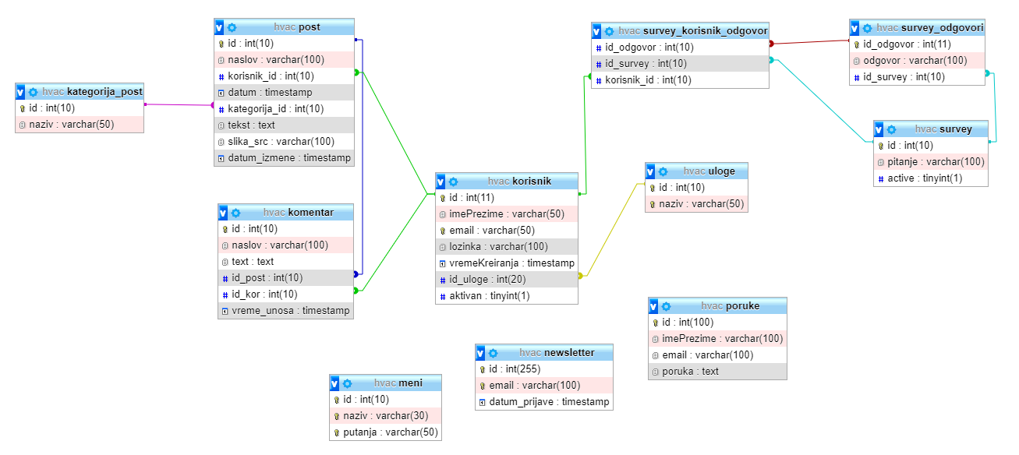

# Template

Korišćen je preuzet template sa <https://themewagon.com/themes/free-bootstrap-4-html5-automotive-business-website-template-hvac/> uz modifikacije prilagođene mojim potrebama. Admin panel je isto preuzet sa <https://themewagon.com/themes/free-bootstrap-4-admin-dashboard-template-chameleon-admin/>

# Mapa sajta

Admin panel je stranica dostupna samo autorizovanim korisnicima koji su admini. Profilna stranica je dostupna samo autorizovanim korisnicima. Login i register stranice su dostupne samo neautorizovanim korisnicima. Stranica za kreiranje postova je dostupna samo autorizovanim korisnicima.

## sitemap.xml

<urlset xmlns="http://www.sitemaps.org/schemas/sitemap/0.9">  
<url>  
 <loc>https://hvac-blog.000webhostapp.com/index.php </loc>  
 <lastmod>2021-3-12</lastmod>  
 <changefreq>daily</changefreq>  
 <priority>1</priority>  
</url>  
<url>  
 <loc>https://hvac-blog.000webhostapp.com/blog.php </loc>  
 <lastmod>2021-3-12</lastmod>  
 <changefreq>daily</changefreq>  
 <priority>0.97</priority>  
</url>  
<url>  
 <loc>https://hvac-blog.000webhostapp.com/blog-details.php </loc>  
 <lastmod>2021-3-12</lastmod>  
 <changefreq>daily</changefreq>  
 <priority>0.95</priority>  
</url>  
<url>  
 <loc> https://hvac-blog.000webhostapp.com/profile.php </loc>  
 <lastmod>2021-3-12</lastmod>  
 <changefreq>daily</changefreq>  
 <priority>0.90</priority>  
</url>  
<url>  
 <loc> https://hvac-blog.000webhostapp.com/createPost.php </loc>  
 <lastmod>2021-3-12</lastmod>  
 <changefreq>weekly</changefreq>  
 <priority>0.75</priority>  
</url>  
<url>  
 <loc> https://hvac-blog.000webhostapp.com/contact.php </loc>  
 <lastmod>2021-3-12</lastmod>  
 <changefreq>monthly</changefreq>  
 <priority>0.84</priority>  
</url>  
<url>  
 <loc> https://hvac-blog.000webhostapp.com/register.php </loc>  
 <lastmod>2021-3-12</lastmod>  
 <changefreq>monthly</changefreq>  
 <priority>0.85</priority>  
</url>  
<url>  
 <loc> https://hvac-blog.000webhostapp.com/createPost.php </loc>  
 <lastmod>2019-3-30</lastmod>  
 <changefreq>yearly</changefreq>  
 <priority>0.80</priority>  
</url>  
<url>  
 <loc>https://hvac-blog.000webhostapp.com/adminPanel.php </loc>  
 <lastmod>2021-3-12</lastmod>  
 <changefreq>weekly</changefreq>  
 <priority>0.86</priority>  
</url>  
<url>  
 <loc> https://hvac-blog.000webhostapp.com/author.php </loc>  
 <lastmod>2021-3-12</lastmod>  
 <changefreq>yearly</changefreq>  
 <priority>0.81</priority>  
</url>  
<url>  
 <loc> https://hvac-blog.000webhostapp.com/error404.php</loc>  
 <lastmod>2021-3-21</lastmod>  
 <changefreq>yearly</changefreq>  
 <priority>0.70</priority>  
</url>  
</urlset>

## index.php

Navigacija se dinamicki ispisuje iz baze podataka na osnovu korisnicke uloge



navigacija za admina



navigacija za korisnika

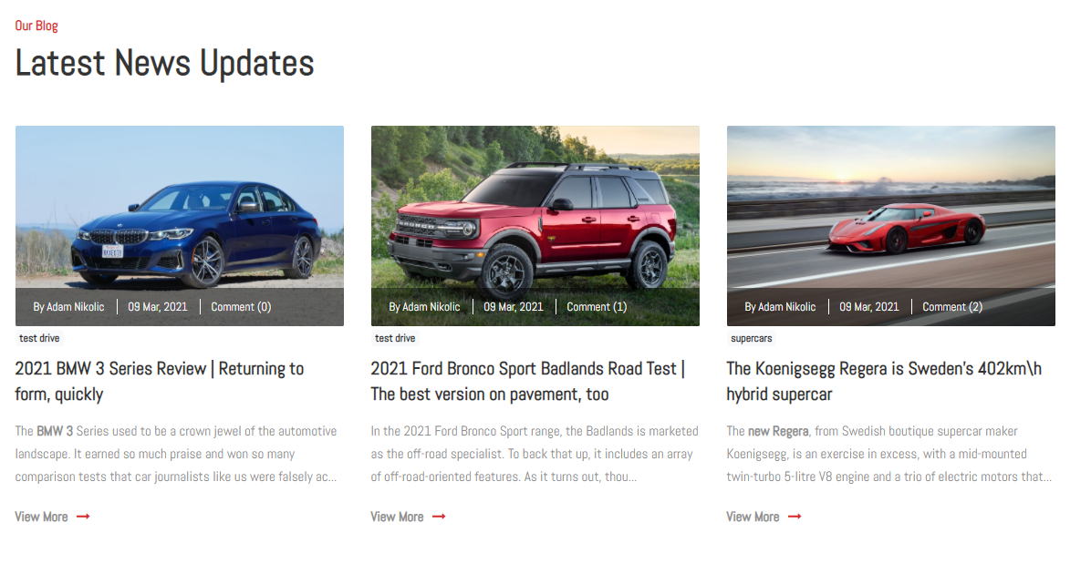

Glavna sekcija

Ova sekcija sadrzi 3 najnovija okacena posta, svaki artikal o postu sadrzi podatke o autoru, datum kad je postavljen, koliko komentara ima i kojoj kategoriji pripada. Sadrzi i naslov tog posta i mali deo glavnog teksta. Klikom na neki post korisnik se salje na stranicu blog-details.php i koja sadrzi podatke tog posta

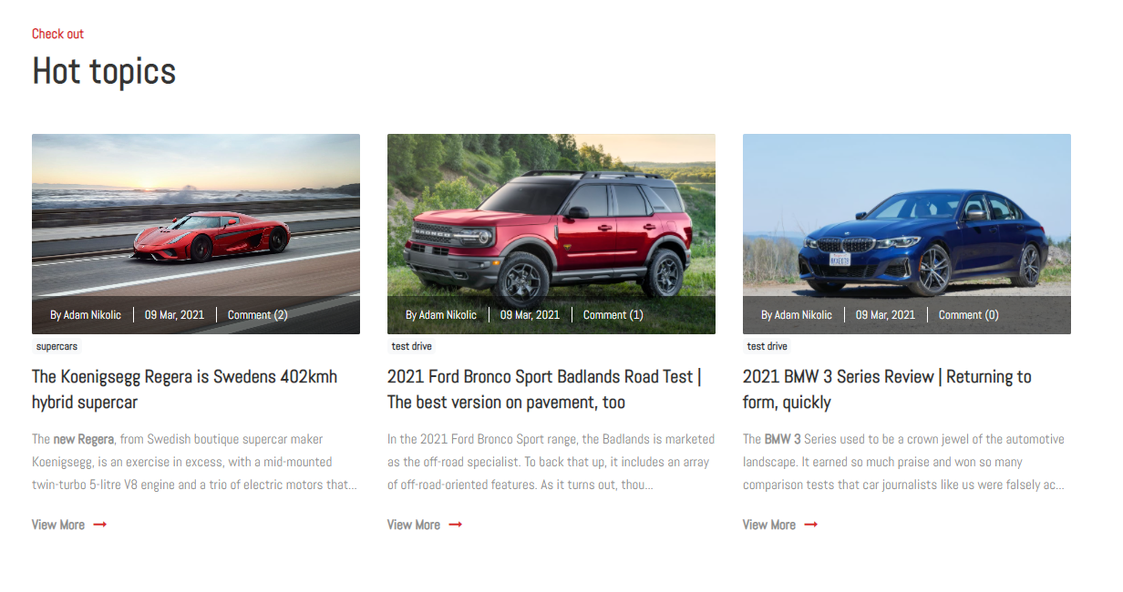

3 posta sa najvise komentara

Ova sekcija sadrzi 3 posta sa najvise komentara

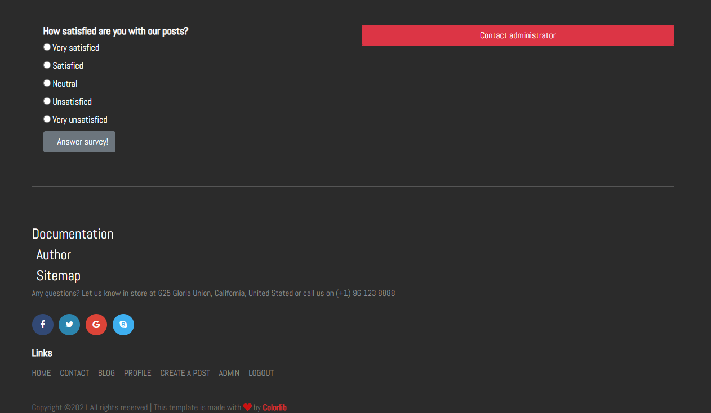

Footer

Footer koji sadrzi anketu na koju samo autorizovani korisnici mogu da odgovore, nakon sto odgovore, ispisuje se zahvalna poruka. Admin moze da vidi statistiku za svaku anketu koja je u tom trenutku aktivna. Footer takodje sadrzi dinamicki ispisane linkove iz baze podataka

## blog.php

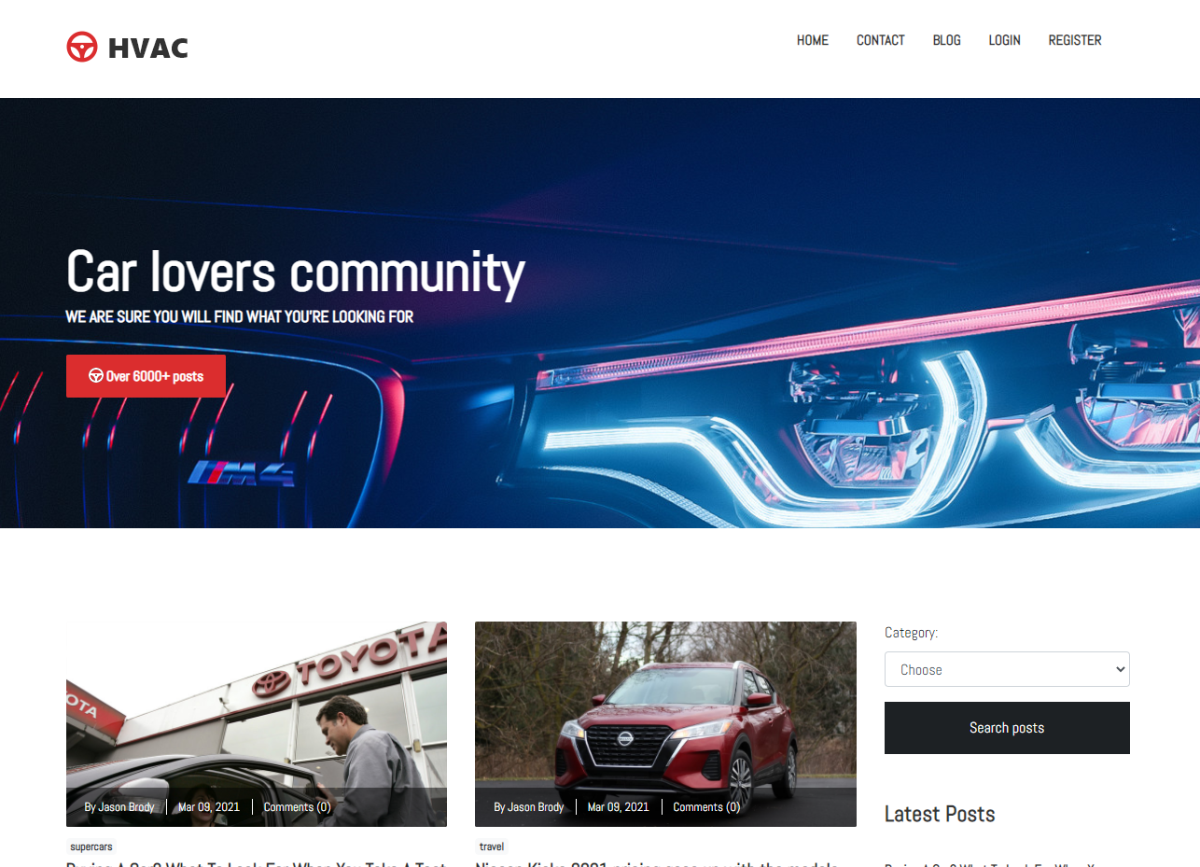

Inicijalni prikaz stranice

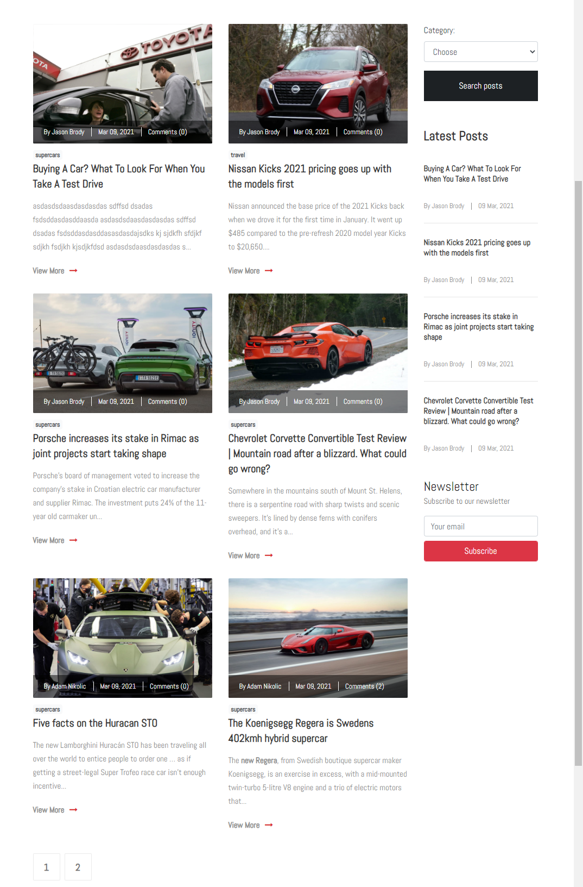

Ova sekcija inicijalno sadrzi 6 postova. Postovi sadrze iste funkcionalnosti kao i na index.php. Ispod se nalazi paginacija. Desno se nalazi dinamicka dropdown lista sa kategorijama iz baze podataka i najnoviji postovi koji su ispisani sa informacijama o njihovim autoru i datumom kad su okaceni. Filtriranje se vrsi po kategorijama i paginacija je prilagodjena broju postova koji zadovoljavaju izabranu kategoriju

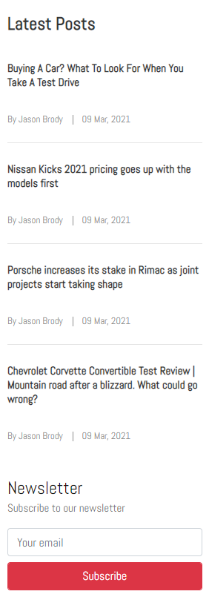

Sekcija sa najskorijim postovima koji se ucitavaju iz baze podataka i formom za prijavu za newsletter. Bilo koji korisnik moze da se prijavi ukoliko ispravno unese email. Proverava se na klijentskoj i serverskoj strani. Ukoliko je email ispravan, korisniku iskace modal sa porukom da se uspesno prijavio i podaci se salju u bazu podataka, ukoliko nije isto iskace modal samo sa porukom da nije uspelo prijavljivanje. Korisniku se ispisuje greska ukoliko se vec prijavio.

## login.php

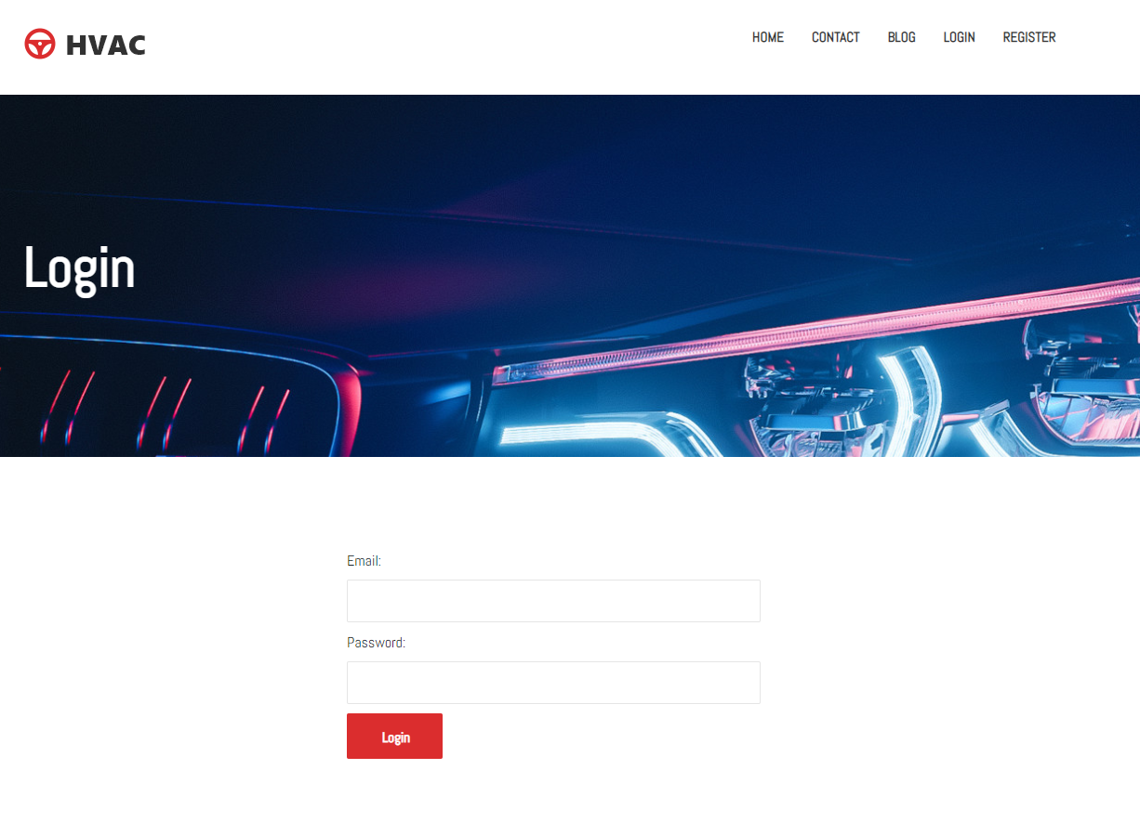

Stranica za logovanje

Na ovoj stranici se nalazi jednostavna forma za logovanje, validacija se vrsi na klijentskoj i serverskoj strani. Ukoliko se uneti mejl i lozinka ne poklapaju sa tim istim podacima od vec registrovanog korisnika, korisniku se ispisuje poruka da je uneo pogresne kredencijale za logovanje. Ukoliko su ispravni podaci, korisnik se redirektuje na njegov profil.

## register.php

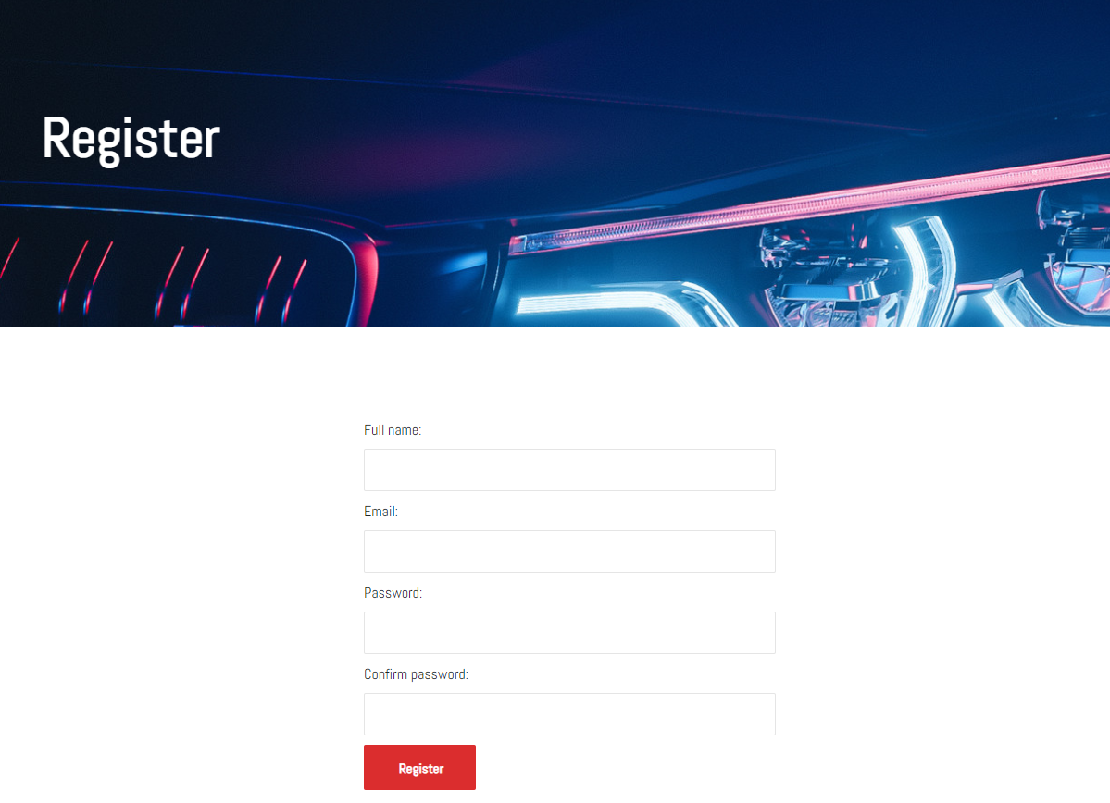

Forma za registraciju korisnika

Na ovoj stranici se nalazi forma za registraciju korisnika, korisnik mora da unese svoje ime i prezime, mejl i lozinku. Validacija se izvrsava na klijentskoj i na serverskoj strani. Ukoliko neki od podataka ne prodje proveru, korisniku se ispisuje greska ili ukoliko unese vec postojeci mejl koji se nalazi u bazi podataka. Ukoliko je sve validno, korisnik se redirektuje ka stranici login.php

## profile.php

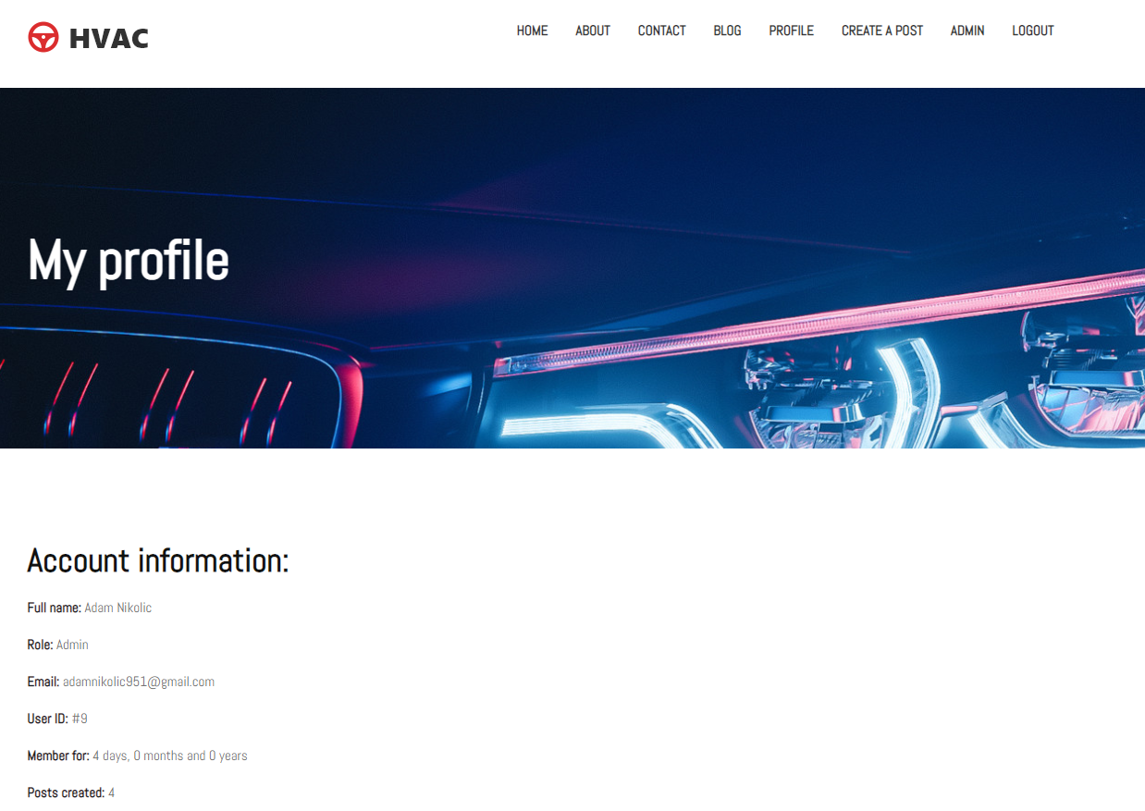

Inicijalni prikaz profil korisnika

Korisnik na ovoj stranici moze da vidi svoje unete podatke, pored njegovih unetih podataka moze da vidi i vreme koje pokazuje koliko je vremena proslo od trenutka njegove registracije. Moze da vidi i ukupan broj njegovih postova koje je okacio.

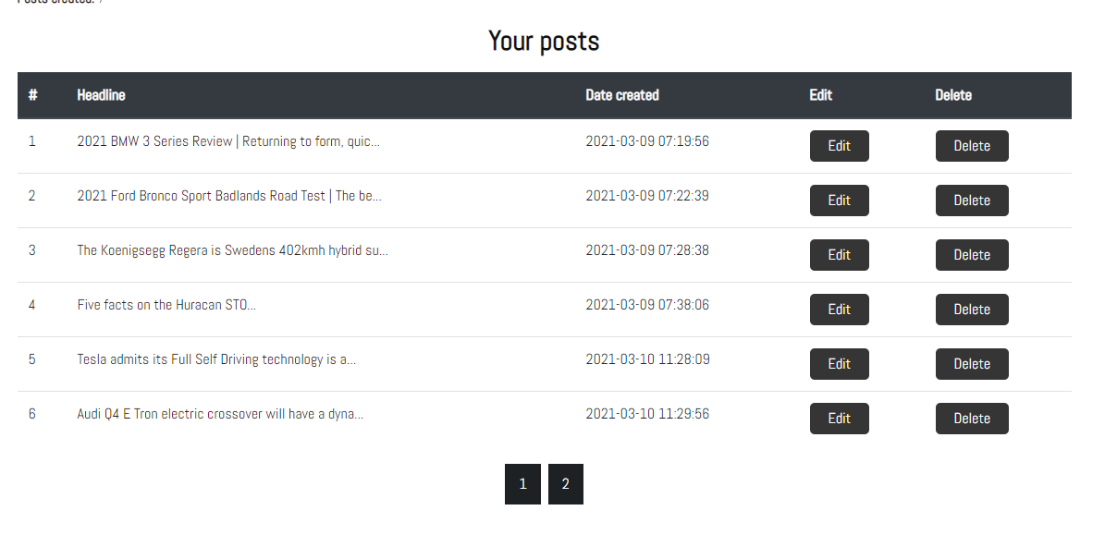

Tabela postova ulogovanog korisnika

Ulogovani korisnik moze da vidi sve svoje postove koje je okacio ukoliko ih ima, ovde moze da menja i brise iste. Odradjena je i paginacija tako da se prikazuju maksimalno 6 po stranici. Ukoliko korisnik klikne na dugme ’Delete’ korisnik brise izabran post. Klikom na ’Edit’ mu se ispisuje forma ispod sa vec unetim podacima tog posta koje korisnik moze da menja.

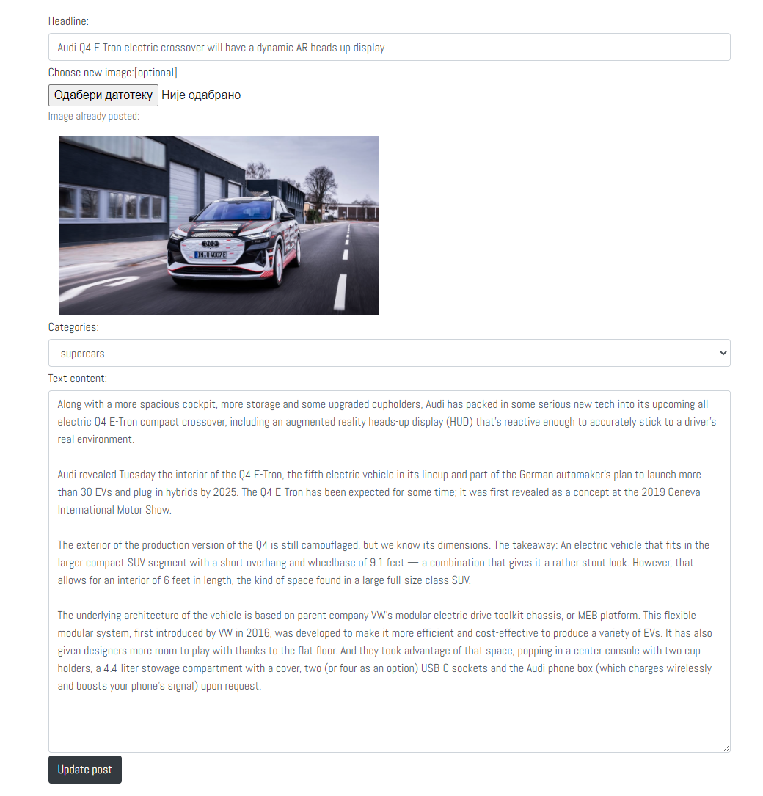

Editovanje posta ulogovanog korisnika

Korisnik klikom na dugme ’Edit’, prikazuje mu se forma sa vec popunjenim podacima tog posta. Korisnik moze da izmeni sav sadrzaj vec okacenog posta. Ukoliko zeli da izmeni podatke, obavezno je da ispravno unese sve podatke koji se proveravaju na klijentskoj i na serverskoj strani. Opciono je da li ce korisnik da prilozi sliku ili ne, inicijalno mu se prikazuje vec okacena slika tog posta. Ako je uspesna izmena, korisnik se redirektuje na stranicu koja sadrzi sadrzaj tog posta, tako da moze da vidi izmene odmah.

## createPost.php

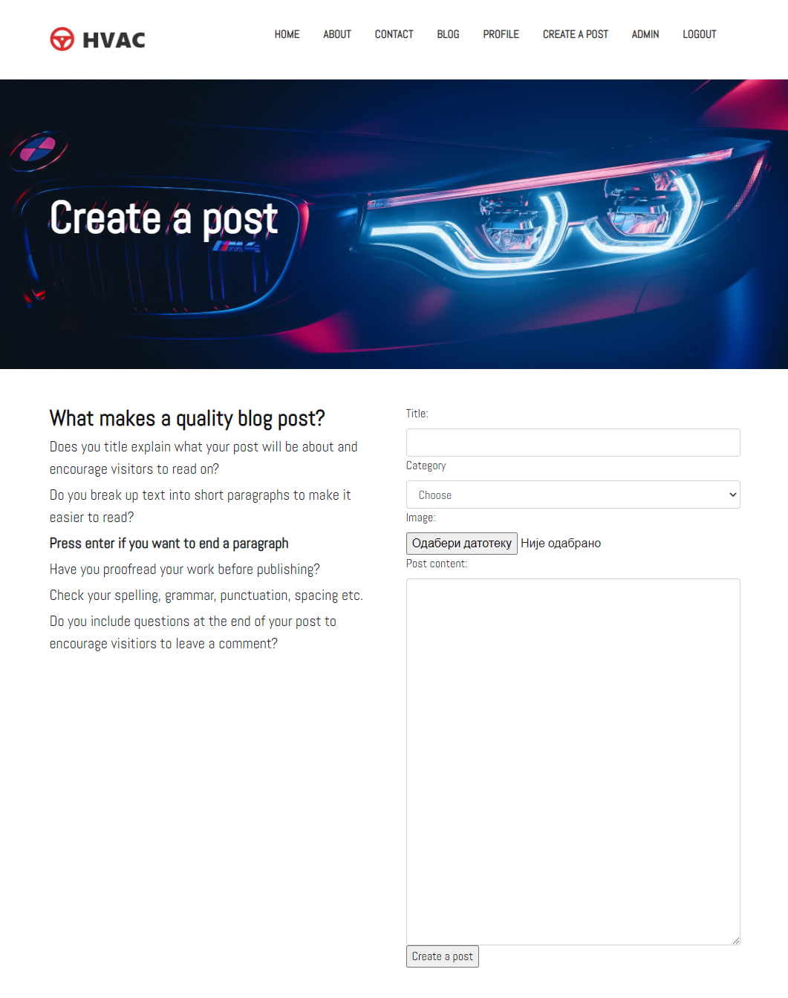

Forma za postavljanje novog posta na blog

Na ovoj stranici svi autorizovani korisnici postavljaju postove. Potrebno je da sve podatke unesu ispravno. Provera je sa klijentske i serverske strane. Korisnik mora uneti sliku sa najvecom velicinom do 2 mb. Ukoliko ne unese ispravno podatke, ispisuje se opis greske odredjenih polja.

## blog-details.php

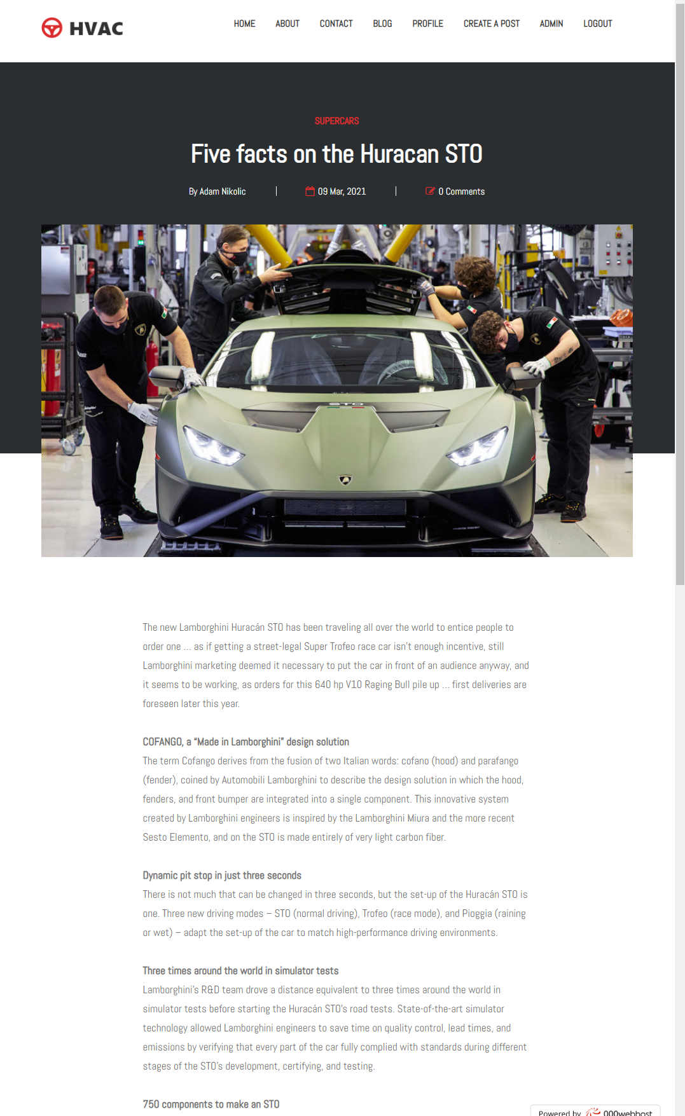

Informacije odredjenog posta koji je korisnik prethodno kliknuo

Korisnik na ovoj stranici vidi sve podatke o postu na koji je kliknuo(autor posta, kojoj kategoriji pripada, kada je postavljen, koliko ima komentara, komentare ostalih korisnika ukoliko ih ima, sliku i tekst posta)

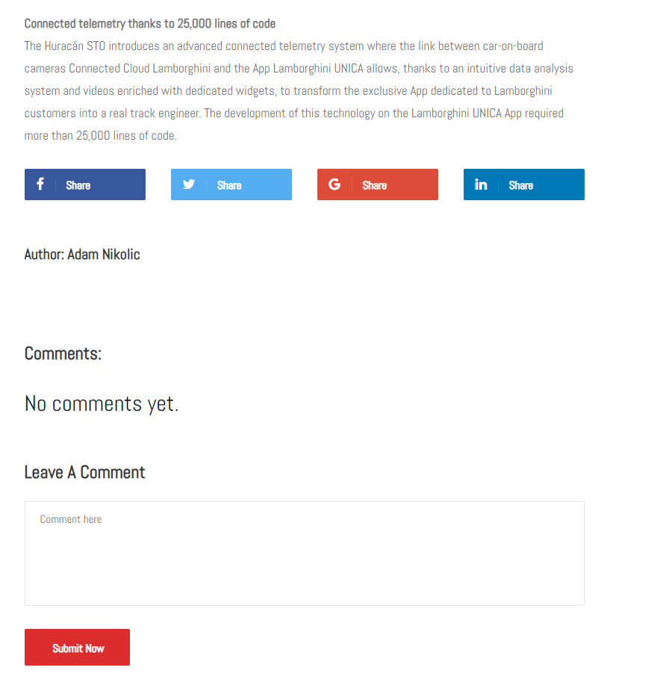

Post koji ne sadrzi nijedan komentar korisnika

Svaki autorizovani korisnik moze da postavlja komentare za postove, dok oni koji nisu ulogovani mogu samo da gledaju komentare ukoliko ih ima za taj post. Korisniku nakon sto unese komentar, ispisuje se poruka da je uspesno postavio komentar i stranica ce se ucitati ponovo kako bi video komentar. Ukoliko nema komentara, na stranici ce pisati poruka sa tekstom ’No comments yet’. Ukoliko ih ima ispisace se ime korisnika koji je postavio i datum kad je postavljen. Ukoliko autorizovani korisnik udje u post na kom je on vec komentarisao, umesto celog imena ispisace mu se ’You’.

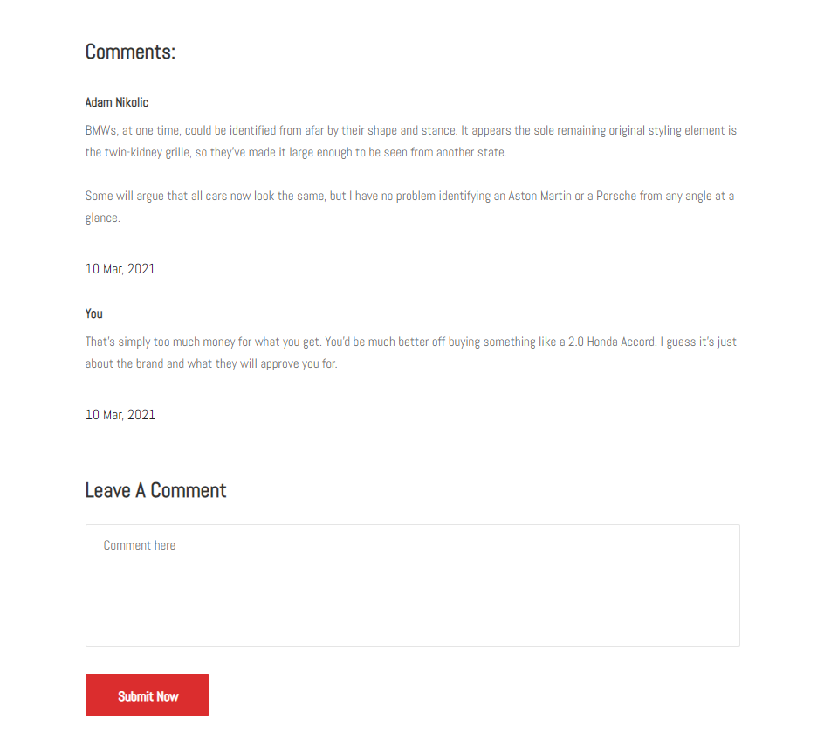

Sekcija sa komentarima korisnika

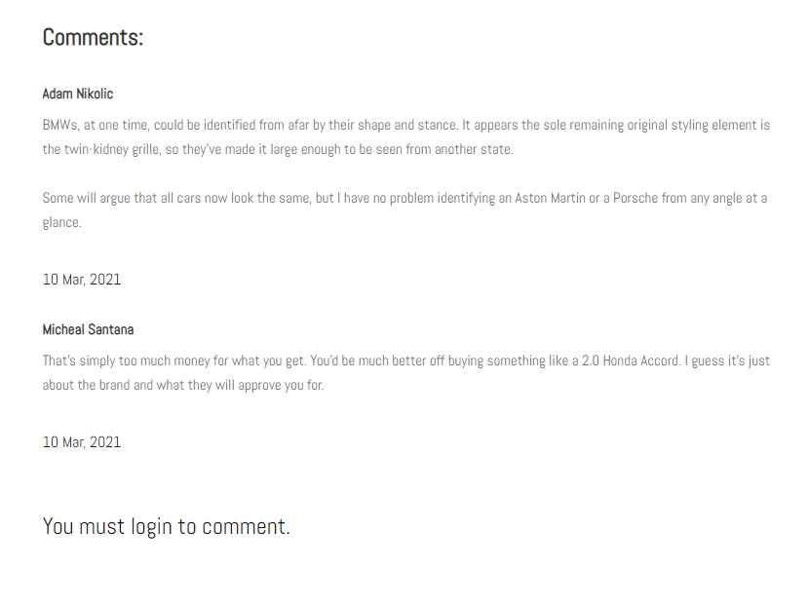

Sekcija sa komentarima ukoliko je korisnik neautorizovan

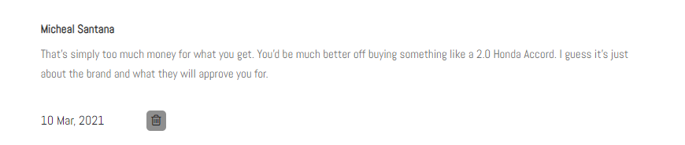

komentar korisnika iz ugla admina

Admin moze da brise komentar klikom na dugme sa ikonicom kante.

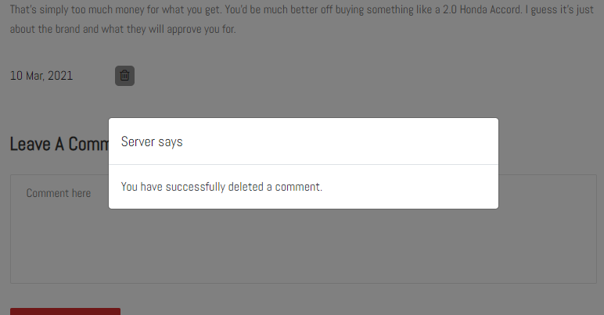

Poruka koja se ispisuje nakon sto admin obrise komentar

## contact.php

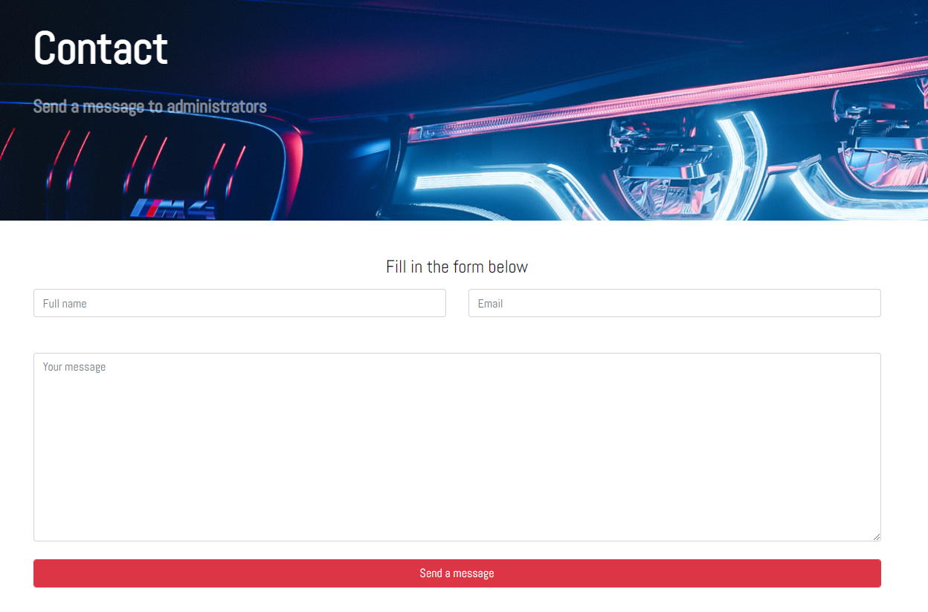

Ovoj stranici moze da pristupi svaki korisnik, validacija unetih podataka se izvrsava na klijentskoj i na serverskoj strani. Ukoliko sve ispravno popuni, ispisuje mu se poruka da je uspesno poslao.

## adminPanel.php

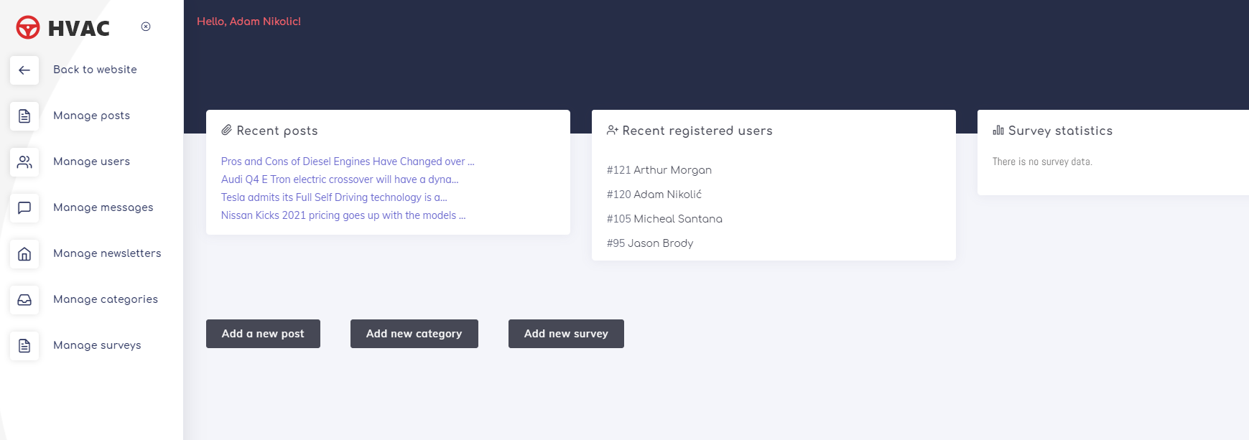

Samo korisnici sa ulogom = 1 mogu da pristupe ovoj stranici. Inicijalni prikaz admin panela, na kome se sa desne strane ispisuju poslednje interakcije korisnika, tj poslednja 4 okacena posta, 4 poslednja korisnika koja su se registrovala i statistiku za anketu koja je trenutno aktivna. Klikom na neki link AJAX-om se dohvataju podaci iz baze podataka u vidu tabele sa popunjenim podacima. Admini mogu da dodaju nove postove, edituju sve okacene postove na sajtu i da brisu. Mogu da brisu registrovane korisnike. Mogu da vide sve poslate poruke od strane korisnika koji su popunili kontakt formu. Mogu da vide i sve mejlove koji su se pretplatili na newsletter i da ih brisu. Mogu da dodaju nove kategorije, da ih menjaju i da ih brisu. Mogu da dodaju nove ankete, da brisu neaktivne, da aktiviraju neaktivne.

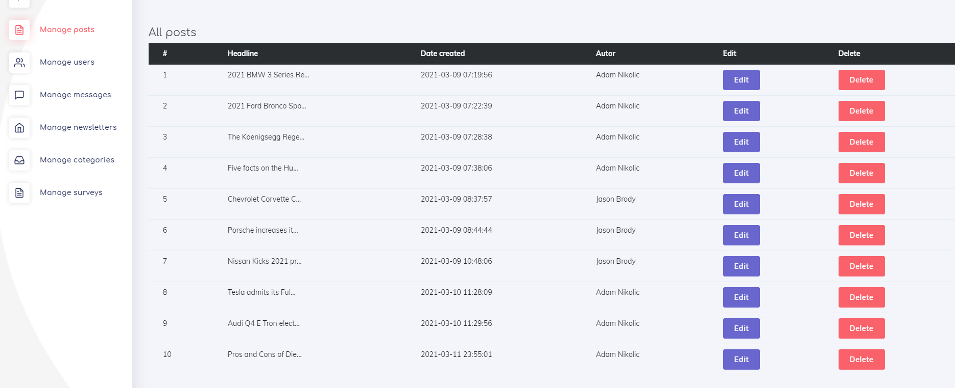

Uvid u sve postove na sajtu

Klikom na edit, adminu se ispisuje forma sa popunjenim podacima tog posta i omoguceno mu je da menja celokupan sadrzaj. Takodje moze i da ih obrise.

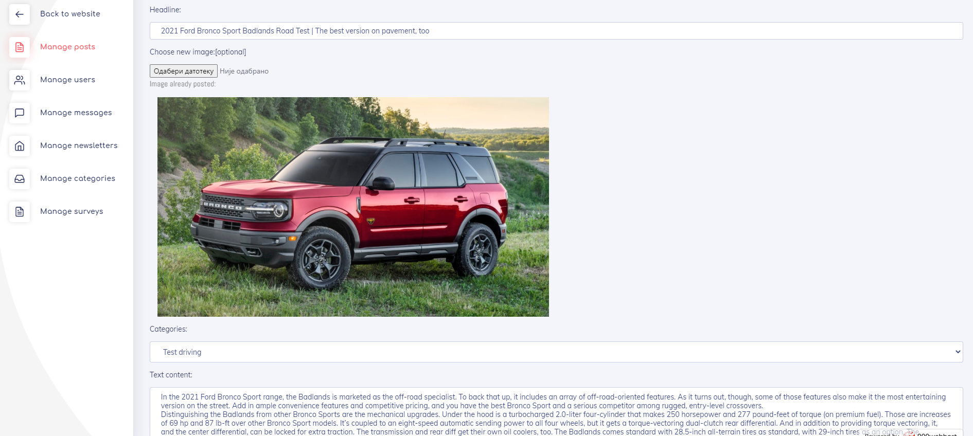

Ispis nakon klika na dugme edit

Validacija se izvrsava na klijentskoj i na serverskoj strani. Opciono je da prilozi novu sliku

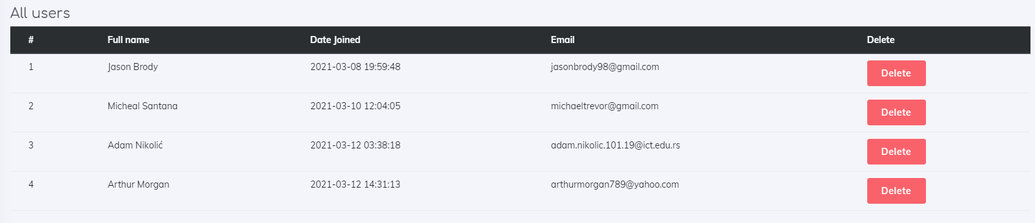

Prikaz svih registrovanih korisnika

Ispisuju se osnovni podaci o korisnicima. Admin moze da brise registrovane korisnike

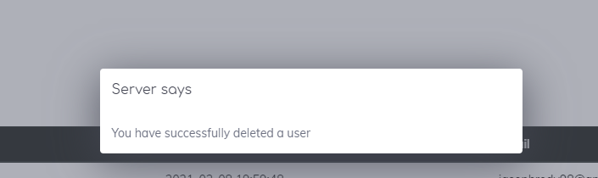

Poruka koja se ispisuje nakon brisanja korisnika

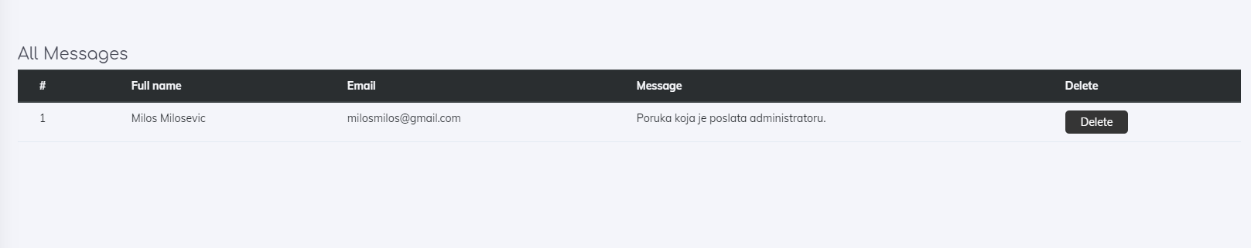

Poruke poslate administratoru preko kontakt forme

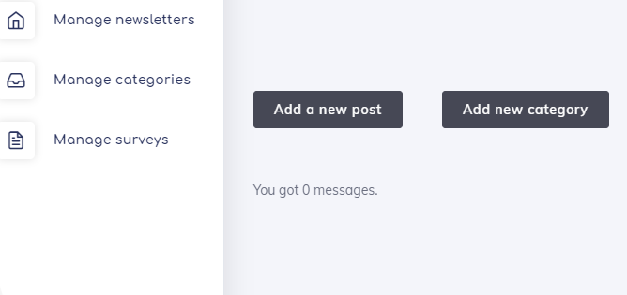

Ukoliko nema poruka

Admin moze da vidi sadrzaj poslate poruke, email tog korisnika i ime. Na njemu je da li zeli da mu odgovori na mejl ili da obrise poruku. Svaka sekcija ispisuje odgovarajucu poruku ukoliko nema sadrzaja za prikazivanje

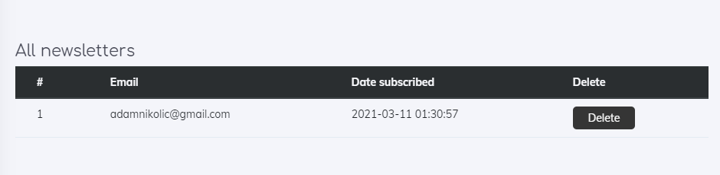

Prikaz korisnika koji su se prijavili mejlom na newsletter

Admin moze da brise prijavljene korisnike preko newslettera



Ukoliko nema prijavljenih korisnika

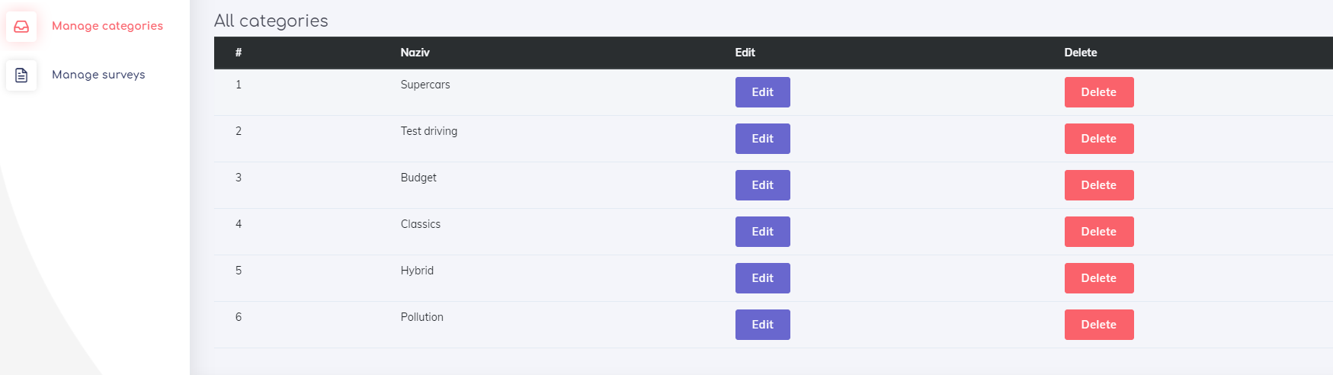

Tabela svih kategorija

Admin moze da dodaje, menja i brise kategorije. Podaci se dohvataju pomocu AJAX-a, forme za dodavanje i menjanje su takodje realizovane pomocu AJAX-a



Nakon uspesne promene

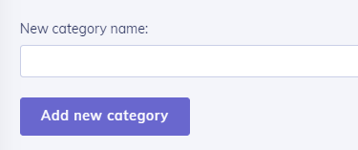

Forma za kreiranje kategorije

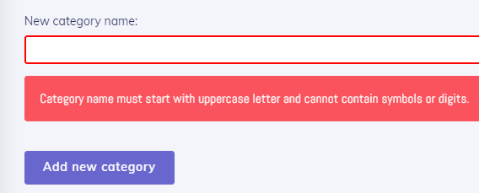

Ispis greske



Nakon uspesnog dodavanja nove kategorije

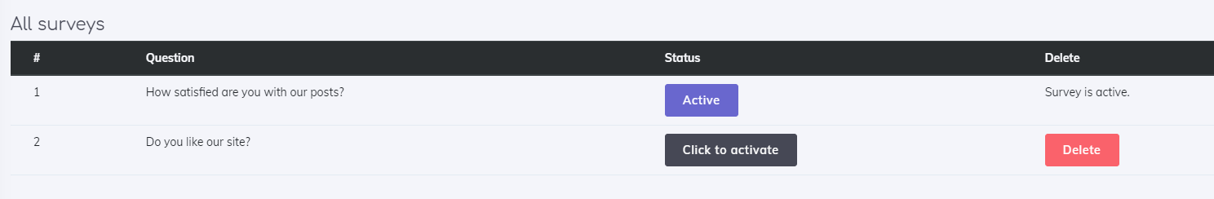

Sve unete ankete, ona koja je aktivna i sve neaktivne

Admin moze da brise neaktivne ankete, isto te moze i da aktivira. Statistiku trenutno aktivne ankete moze da vidi u gornjem desnom uglu stranice.



Ukoliko niko od korisnika nije odgovorio na anketu



Poruka koja se ispisuje ukoliko admin aktivira anketu



Ukoliko obrise anketu

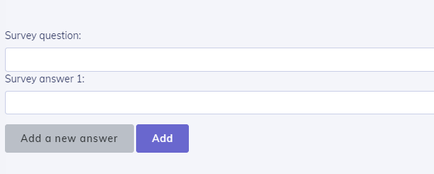

Forma za dodavanje nove ankete

Adminu je omoguceno da dinamicki dodaje odgovore na osnovu toga koje odgovore pitanje zahteva. Klikom na add a new answer, korisniku se ispisuje novo polje za unos

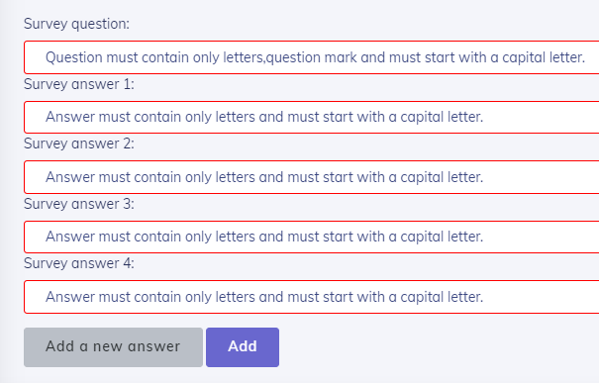

Validacija podataka se vrsi na klijentskoj i na serverskoj strani



Poruka koja se ispisuje ukoliko admin doda novu anketu

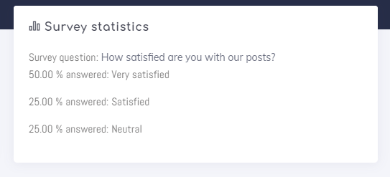

Ispis rezultata aktivne ankete, ispisuju se rezultati odgovora samo na koje su korisnici dali odgovor

# Kodovi

## static

### head.php

<?php  
 ob_start();  
session_start();  
if(isset($_SESSION['korisnik'])){  
 $korisnik = $_SESSION['korisnik'];  
}  
?><!DOCTYPE html>  
<html lang="eng">  
<head>  
<meta charset="UTF-8">  
<meta name="description" content="HVAC Car Store">  
<meta name="keywords" content="HVAC, car, blog, post">  
<meta name="author" content="Adam Nikolic">  
<meta name="viewport" content="width=device-width, initial-scale=1.0">  
<meta http-equiv="X-UA-Compatible" content="ie=edge">  
<title>HVAC | Car Blog </title>  
<link rel="icon" type="image/png" href="img/favicon.png">  
<link href="https://fonts.googleapis.com/css2?family=Lato:wght@300;400;700;900&display=swap" rel="stylesheet">  
<link rel="stylesheet" href="https://cdn.jsdelivr.net/npm/bootstrap@4.6.0/dist/css/bootstrap.min.css" integrity="sha384-B0vP5xmATw1+K9KRQjQERJvTumQW0nPEzvF6L/Z6nronJ3oUOFUFpCjEUQouq2+l" crossorigin="anonymous">  
<link rel="stylesheet" href="css/font-awesome.min.css" type="text/css">  
<link rel="stylesheet" href="css/elegant-icons.css" type="text/css">  
<link rel="stylesheet" href="css/nice-select.css" type="text/css">  
<link rel="stylesheet" href="css/owl.carousel.min.css" type="text/css">  
<link rel="stylesheet" href="sass/style.css" type="text/css">  
<?php if(isset($korisnik) && $korisnik->id_uloga == 1 && strpos($_SERVER['PHP_SELF'], 'admin') !== false):?>  
<link href="css/adminpanel.css" rel="stylesheet" type="text/css">  
<link href="https://fonts.googleapis.com/css?family=Muli:300,300i,400,400i,600,600i,700,700i%7CComfortaa:300,400,700" rel="stylesheet">  
<link href="https://maxcdn.icons8.com/fonts/line-awesome/1.1/css/line-awesome.min.css" rel="stylesheet">  
<link rel="stylesheet" type="text/css" href="admin/theme-assets/css/vendors.css">  
<link rel="stylesheet" type="text/css" href="admin/theme-assets/css/app-lite.css">  
<link rel="stylesheet" type="text/css" href="admin/theme-assets/css/core/menu/menu-types/vertical-menu.css">  
<link rel="stylesheet" type="text/css" href="admin/theme-assets/css/core/colors/palette-gradient.css">  
<?php endif;?>  
</head>

### header.php

<!-- Offcanvas Menu Begin -->  
<div class="offcanvas-menu-overlay"></div>  
<div class="offcanvas-menu-wrapper">  
 <div class="offcanvas__logo">  
 <a href="index.php"><img src="img/logo.png" alt=""></a>  
 </div>  
 <div id="mobile-menu-wrap"></div>  
 <ul class="offcanvas__widget__add">  
 <li><i class="fa fa-envelope-o"></i> Info.colorlib@gmail.com</li>  
 </ul>  
 <div class="offcanvas__phone__num">  
 <i class="fa fa-phone"></i>  
 <span>(+12) 345 678 910</span>  
 </div>  
 <div class="offcanvas__social">  
 <a href="#"><i class="fa fa-facebook"></i></a>  
 <a href="#"><i class="fa fa-twitter"></i></a>  
 <a href="#"><i class="fa fa-google"></i></a>  
 <a href="#"><i class="fa fa-instagram"></i></a>  
 </div>  
</div>  
<!-- Offcanvas Menu End -->  
  
<!-- Header Section Begin -->  
<header class="header">  
  
 <div class="container">  
 <div class="row">  
 <div class="col-lg-2">  
 <div class="header__logo">  
 <a href="index.php"><img src="img/logo.png" alt=""></a>  
 </div>  
 </div>  
 <div class="col-lg-10">  
 <div class="header__nav">  
 <nav class="header__menu">  
 <ul>  
 <?php  
 $menu = getAllData('meni');  
 global $korisnik;  
 for ($i = 0; $i < count($menu); $i++){  
 if(isset($korisnik)){  
 if(($korisnik->id_uloga != 1 && strpos($menu[$i]->naziv, 'admin') !== false) || strpos($menu[$i]->naziv, 'login') !== false || strpos($menu[$i]->naziv, 'reg') !== false){  
 continue;  
 }  
 echo '<li><a href='.$menu[$i]->putanja.' class="text-uppercase">'.$menu[$i]->naziv.'</a></li>';  
 }  
 else {  
 if (strpos($menu[$i]->naziv, 'admin') !== false || strpos($menu[$i]->naziv, 'profile') !== false || strpos($menu[$i]->naziv, 'create') !== false || strpos($menu[$i]->naziv, 'out') !== false) {  
 continue;  
 }  
 echo '<li><a href=' . $menu[$i]->putanja . '>' . $menu[$i]->naziv . '</a></li>';  
 }  
 }  
 ?>  
 </ul>  
 </nav>  
 </div>  
 </div>  
 </div>  
 <div class="canvas__open">  
 <span class="fa fa-bars"></span>  
 </div>  
 </div>  
</header>

### preloader.php

<body>  
<!-- Page Preloder -->  
<div id="preloder">  
 <div class="loader"></div>  
</div>

### footer.php

<!-- Footer Section Begin -->  
<footer class="footer">  
 <div class="container">  
 <div class="footer__contact">  
 <div class="row">  
 <div class="col-lg-6 col-md-6">  
 <div class="footer__contact__title">  
 <h2>Contact Us Now!</h2>  
 </div>  
 </div>  
 <div class="col-lg-6 col-md-6">  
 <div class="footer__contact__option">  
 <a href="contact.php"><button type="button" class="form-control btn-danger">Contact administrator</button></a>  
 </div>  
 </div>  
 </div>  
 </div>  
 <div class="row">  
 <div class="col">  
 <div class="footer__about">  
 <div>  
 <a href="docs.pdf">Documentation</a>  
 <a href="autor.php" class="ml-2">Author</a>  
 </div>  
 <p>Any questions? Let us know in store at 625 Gloria Union, California, United Stated or call us  
 on (+1) 96 123 8888</p>  
 <div class="footer__social">  
 <a href="#" class="facebook"><i class="fa fa-facebook"></i></a>  
 <a href="#" class="twitter"><i class="fa fa-twitter"></i></a>  
 <a href="#" class="google"><i class="fa fa-google"></i></a>  
 <a href="#" class="skype"><i class="fa fa-skype"></i></a>  
 </div>  
 <div class="footer__brand">  
 <h5>Links</h5>  
 <ul class="d-flex w-100 flex-row justify-content-start align-items-center">  
 <?php  
 for ($i = 0; $i < count($menu); $i++){  
 if(isset($korisnik)){  
 if(($korisnik->id_uloga != 1 && strpos($menu[$i]->naziv, 'admin') !== false) || strpos($menu[$i]->naziv, 'login') !== false || strpos($menu[$i]->naziv, 'reg') !== false){  
 continue;  
 }  
 echo '<li class="mr-1 mr-sm-3"><a href='.$menu[$i]->putanja.' class="text-uppercase">'.$menu[$i]->naziv.'</a></li>';  
 }  
 else {  
 if (strpos($menu[$i]->naziv, 'admin') !== false || strpos($menu[$i]->naziv, 'profile') !== false || strpos($menu[$i]->naziv, 'create') !== false || strpos($menu[$i]->naziv, 'out') !== false) {  
 continue;  
 }  
 echo '<li class="mr-1 mr-sm-3"><a href=' . $menu[$i]->putanja . '>' . $menu[$i]->naziv . '</a></li>';  
 }  
 }  
 ?>  
 </ul>  
 </div>  
 </div>  
 </div>  
 </div>  
 <!-- Link back to Colorlib can't be removed. Template is licensed under CC BY 3.0. -->  
 <div class="footer__copyright__text">  
 <p>Copyright &copy;<script>document.write(new Date().getFullYear());</script> All rights reserved | This template is made with <i class="fa fa-heart" aria-hidden="true"></i> by <a href="https://colorlib.com" target="_blank">Colorlib</a></p>  
 </div>  
 <!-- Link back to Colorlib can't be removed. Template is licensed under CC BY 3.0. -->  
 </div>  
</footer>  
<!-- Footer Section End -->  
  
<!-- Search Begin -->  
<div class="search-model">  
 <div class="h-100 d-flex align-items-center justify-content-center">  
 <div class="search-close-switch">+</div>  
 <form class="search-model-form">  
 <input type="text" id="search-input" placeholder="Search here.....">  
 </form>  
 </div>  
</div>  
<!-- Search End -->  
  
<!-- Js Plugins -->  
<script src="https://code.jquery.com/jquery-3.6.0.min.js" integrity="sha256-/xUj+3OJU5yExlq6GSYGSHk7tPXikynS7ogEvDej/m4=" crossorigin="anonymous"></script>  
<script src="https://cdn.jsdelivr.net/npm/popper.js@1.16.1/dist/umd/popper.min.js" integrity="sha384-9/reFTGAW83EW2RDu2S0VKaIzap3H66lZH81PoYlFhbGU+6BZp6G7niu735Sk7lN" crossorigin="anonymous"></script>  
<script src="https://cdn.jsdelivr.net/npm/bootstrap@4.6.0/dist/js/bootstrap.min.js" integrity="sha384-+YQ4JLhjyBLPDQt//I+STsc9iw4uQqACwlvpslubQzn4u2UU2UFM80nGisd026JF" crossorigin="anonymous"></script>  
<script src="js/jquery-ui.min.js"></script>  
<script src="js/jquery.magnific-popup.min.js"></script>  
<script src="js/jquery.slicknav.js"></script>  
<script src="js/owl.carousel.min.js"></script>  
<script src="js/main.js"></script>  
<script src="js/my_main.js" type="text/javascript"></script>  
</body>  
  
</html>

## index.php

<?php  
 include_once "config/connection.php";  
 include_once "models/functions.php";  
 include_once "static/head.php";  
 include_once "static/preloader.php";  
 include_once "static/header.php";  
 $limit = 3;  
 $postovi = dohvatiPostove($limit, 0);  
 $poKomentarima = dohvatiPostovePoBrojuKomentara($limit, 0);  
?>  
  
  
  
 <!-- Header Section End -->  
  
 <!-- Hero Section Begin -->  
 <section class="hero spad set-bg" data-setbg="img/hero-bg.jpg">  
 <div class="container">  
 <div class="row">  
 <div class="col-lg-7">  
 <div class="hero__text">  
 <div class="hero__text__title">  
 <h2>Car lovers community</h2>  
 <span>We are sure you will find what you're looking for</span>  
 </div>  
 <a href="#" class="primary-btn"><img src="img/wheel.png" alt=""> Over 6000+ posts</a>  
 </div>  
 </div>  
 </div>  
 </div>  
 </section>  
 <!-- Hero Section End -->  
  
 <!-- Latest Blog Section Begin -->  
 <section class="latest spad pt-5">  
 <div class="container">  
 <div class="row">  
 <div class="col-lg-12">  
 <div class="section-title text-left">  
 <span>Our Blog</span>  
 <h2>Latest News Updates</h2>  
 </div>  
 </div>  
 </div>  
 <div class="row">  
 <?php foreach ($postovi as $post):?>  
 <?php $date = new DateTime($post->vremeKreiranja); ?>  
 <div class="col-lg-4 col-md-6">  
 <div class="latest__blog__item">  
 <div class="latest__blog__item__pic set-bg" data-setbg="img/<?=$post->slika?>">  
 <ul>  
 <li>By <?=$post->imePrezime?></li>  
 <li><?=$date->format('d M, Y')?></li>  
 <li>Comment (<?=brojKomentara($post->id_post)?>)</li>  
 </ul>  
 </div>  
 <span class="badge badge-light"><?=ucfirst($post->naziv_kategorije)?></span>  
 <div class="latest__blog__item__text pt-2">  
 <a href="blog-details.php?id=<?=$post->id_post?>"><h5><?=$post->naslov?></h5></a>  
 <p><?=substr_replace($post->tekst, '...', 180);?></p>  
 <a href="blog-details.php?id=<?=$post->id_post?>">View More <i class="fa fa-long-arrow-right"></i></a>  
 </div>  
 </div>  
 </div>  
 <?php endforeach;?>  
 </div>  
 </div>  
 </section>  
 <section class="latest spad pt-3">  
 <div class="container">  
 <div class="row">  
 <div class="col-lg-12">  
 <div class="section-title text-left">  
 <span>Check out</span>  
 <h2>Hot topics</h2>  
 </div>  
 </div>  
 </div>  
 <div class="row">  
 <?php foreach ($poKomentarima as $kom):?>  
 <?php $date = new DateTime($kom->vremeKreiranja); ?>  
 <div class="col-lg-4 col-md-6">  
 <div class="latest__blog__item">  
 <div class="latest__blog__item__pic set-bg" data-setbg="img/<?=$kom->slika?>">  
 <ul>  
 <li>By <?=$kom->imePrezime?></li>  
 <li><?=$date->format('d M, Y')?></li>  
 <li>Comment (<?=brojKomentara($kom->id_post)?>)</li>  
 </ul>  
 </div>  
 <span class="badge badge-light"><?=$kom->naziv_kategorije?></span>  
 <div class="latest__blog__item__text pt-2">  
 <a href="blog-details.php?id=<?=$kom->id_post?>"><h5><?=$kom->naslov?></h5></a>  
 <p><?=substr_replace($kom->tekst, '...', 180);?></p>  
 <a href="blog-details.php?id=<?=$kom->id_post?>">View More <i class="fa fa-long-arrow-right"></i></a>  
 </div>  
 </div>  
 </div>  
 <?php endforeach;?>  
 </div>  
 </div>  
 </section>  
 <!-- Latest Blog Section End -->  
  
<?php  
 include_once "static/footer.php";  
?>

## login.php

<?php  
include_once "config/connection.php";  
include_once "models/functions.php";  
include_once "static/head.php";  
include_once "static/preloader.php";  
include_once "static/header.php";  
if(isset($_SESSION['korisnik'])){  
 header("Location: error404.php");  
};  
?>  
  
  
  
 <!-- Header Section End -->  
  
 <!-- Hero Section Begin -->  
 <section class="hero spad set-bg" data-setbg="img/hero-bg.jpg">  
 <div class="container">  
 <div class="row">  
 <div class="col-lg-7">  
 <div class="hero__text">  
 <div class="hero__text__title">  
 <h2>Login</h2>  
 </div>  
 </div>  
 </div>  
  
 </div>  
 </div>  
 </section>  
 <!-- Hero Section End -->  
 <section class="spad">  
 <div class="container">  
 <div class="row">  
 <div class="col d-flex justify-content-center align-items-center flex-column">  
 <form class="col-5">  
 <label for="emailLog">Email:</label>  
 <input type="text" name="emailLog" id="emailLog" class="text-input"/>  
 <label for="passwordLog">Password:</label>  
 <input type="password" name="passwordLog" id="passwordLog" class="text-input"/>  
 <input type="button" class="site-btn" id="login" value="Login"/>  
 </form>  
 <p id="msgLog" class="mt-2"></p>  
 </div>  
 </div>  
 </div>  
 </section>  
  
<?php  
include_once "static/footer.php";  
?>

## register.php

<?php  
include_once "config/connection.php";  
include_once "models/functions.php";  
include_once "static/head.php";  
if(isset($_SESSION['korisnik'])){  
 header("Location: error404.php");  
};  
include_once "static/preloader.php";  
include_once "static/header.php";  
  
?>  
 <!-- Header Section End -->  
 <!-- Hero Section Begin -->  
 <section class="hero spad set-bg" data-setbg="img/hero-bg.jpg">  
 <div class="container">  
 <div class="row">  
 <div class="col-lg-7">  
 <div class="hero__text">  
 <div class="hero__text__title">  
 <h2>Register</h2>  
 </div>  
 </div>  
 </div>  
  
 </div>  
 </div>  
 </section>  
 <!-- Hero Section End -->  
 <section class="spad">  
 <div class="container">  
 <div class="row">  
 <div class="col d-flex justify-content-center align-items-center flex-column">  
 <form class="col-5">  
 <label for="fullname">Full name:</label>  
 <input type="text" name="fullname" id="fullname" class="text-input"/>  
 <label for="email">Email:</label>  
 <input type="text" name="email" id="email" class="text-input"/>  
 <label for="password">Password:</label>  
 <input type="password" name="password" id="password" class="text-input"/>  
 <label for="passwordConfirm">Confirm password:</label>  
 <input type="password" name="passwordConfirm" id="passwordConfirm" class="text-input"/>  
 <input type="button" class="site-btn" id="registerBtn" value="Register"/>  
 </form>  
 <p id="msg" class="mt-2"></p>  
 </div>  
 </div>  
 </div>  
 </section>  
<?php  
include_once "static/footer.php";  
?>

## profile.php

<?php  
include_once "config/connection.php";  
include_once "models/functions.php";  
include_once "static/head.php";  
if(!isset($_SESSION['korisnik'])){  
 header("Location: error404.php");  
}else{  
 global $korisnik;  
 $date1 = new DateTime($korisnik->vremeKreiranja);  
 $date2 = new DateTime('now');  
 $razlika = $date1->diff($date2);  
 $memberTime = $razlika->format('%d days, %m months and %y years');  
 $limit = 6;  
 $offset = 0;  
 if(isset($_GET['user-page']) && isset($_SESSION['korisnik']) && $_SESSION['korisnik']->id_uloga == 1){  
 $offset = ($_GET['user-page'] - 1) * $limit;  
 if($offset < 0){  
 header("Location: error404.php");  
 }  
 }  
 $postovi = getUserPosts($korisnik->id_kor, $limit, $offset);  
 $ukupanBrojPostova = getCountUserPosts($korisnik->id_kor)->brojPostova;  
 $stranice = ceil($ukupanBrojPostova/$limit);  
 $broj = 1;  
}  
include_once "static/preloader.php";  
include_once "static/header.php";  
?>  
  
  
  
 <!-- Header Section End -->  
  
 <!-- Hero Section Begin -->  
 <section class="hero spad set-bg" data-setbg="img/hero-bg.jpg">  
 <div class="container">  
 <div class="row">  
 <div class="col-lg-7">  
 <div class="hero__text">  
 <div class="hero__text__title">  
 <h2>My profile</h2>  
 </div>  
 </div>  
 </div>  
  
 </div>  
 </div>  
 </section>  
 <!-- Hero Section End -->  
 <section class="spad">  
 <div class="container">  
 <div class="row">  
 <div class="col">  
 <div id="infoAcc">  
 <h2 class="mb-3">Account information:</h2>  
 <p><span>Full name:</span> <?= $korisnik->imePrezime?></p>  
 <p><span>Role:</span> <?= ucfirst($korisnik->uloga)?></p>  
 <p><span>Email:</span> <?= $korisnik->email?></p>  
 <p><span>User ID:</span> #<?= $korisnik->id_kor?></p>  
 <p><span>Member for:</span> <?= $memberTime?></p>  
 <p><span>Posts created:</span> <?= $ukupanBrojPostova?></p>  
 </div>  
 <div>  
 <h3 class="font-weight-bold text-center my-3">Your posts</h3>  
 </div>  
 <div id="allPostsUser">  
 <?php if(count($postovi)):?>  
 <div class="table-responsive">  
 <table class="table table-hover">  
 <thead class="thead-dark">  
 <tr>  
 <th>#</th>  
 <th>Headline</th>  
 <th>Date created</th>  
 <th>Edit</th>  
 <th>Delete</th>  
 </tr></thead>  
  
 <?php foreach ($postovi as $post):?>  
 <tr>  
 <td><?=$broj?></td>  
 <td><a class="naslov" href="blog-details.php?id=<?=$post->id?>"><?= substr_replace($post->naslov, '...', 50)?></a></td>  
 <td><?= $post->datum?></td>  
 <td><button type="button" data-toggle="modal" data-target="#content" data-post="<?=$post->id?>" class="dgm editPost" >Edit</button></td>  
 <td><button type="button" data-post="<?=$post->id?>" class="dgm delPost">Delete</button></td>  
 </tr>  
 <?php $broj++; endforeach;?>  
 <?php else:?>  
 <h5 class="text-center">Create posts to see them here.</h5>  
 <?php endif;?>  
  
 </table></div>  
 <div class="d-flex justify-content-center align-items-center">  
 <?php for ($i = 0; $i < $stranice; $i++):?>  
 <a href="profile.php?user-page=<?= $i + 1?>" class="m-1"><button type="button" class="btnPag"><?=$i + 1?></button></a>  
 <?php endfor;?>  
 </div>  
  
 </div>  
 </div>  
 </div>  
 <div class="row">  
 <div class="col" id="adminContent">  
  
 </div>  
 </div>  
 </div>  
 </section>  
 <div class="modal fade" id="messageAdmin" tabindex="-1" role="dialog" aria-labelledby="content" aria-hidden="true">  
 <div class="modal-dialog modal-dialog-centered" role="document">  
 <div class="modal-content">  
 <div class="modal-header">  
 <h5 class="modal-title" id="contentHeader">Server says</h5>  
 </div>  
 <div class="modal-body" id="adminContent">  
  
 </div>  
 </div>  
 </div>  
 </div>  
<?php  
include_once "static/footer.php";  
?>

## blog.php

<?php  
include_once "config/connection.php";  
include_once "models/functions.php";  
include_once "static/head.php";  
include_once "static/preloader.php";  
include_once "static/header.php";  
include_once "models/blog_content.php";  
?>  
 <!-- Breadcrumb End -->  
 <section class="hero spad set-bg" data-setbg="img/hero-bg.jpg">  
 <div class="container">  
 <div class="row">  
 <div class="col-lg-7">  
 <div class="hero__text">  
 <div class="hero__text__title">  
 <h2>Blogs</h2>  
 <span>Take a deep dive into our posts</span>  
 </div>  
 <a href="#" class="primary-btn"><img src="img/wheel.png" alt=""> Over 6000+ posts</a>  
 </div>  
 </div>  
 </div>  
 </div>  
 </section>  
  
  
 <!-- Breadcrumb Begin -->  
  
 <!-- Blog Section Begin -->  
 <section class="blog spad">  
 <div class="container">  
 <div class="row">  
 <div class="col-lg-9">  
 <div class="row">  
 <?php if (isset($GLOBALS['results'])):?>  
 <h5 class="my-3"><?=$GLOBALS['results']['msg']?></h5>  
 <?php endif;?>  
 <?php if(isset($postovi)):?>  
 <?php foreach ($postovi as $post):?>  
 <?php $datum = new DateTime($post->vremeKreiranja);?>  
 <div class="col-lg-6 col-md-6">  
 <div class="latest__blog__item">  
 <div class="latest__blog__item__pic set-bg" data-setbg="img/<?=$post->slika?>">  
 <ul>  
 <li>By <?= getUserCreator($post->id_kor)?></li>  
 <li><?= $datum->format('M d, Y')?></li>  
 <li>Comments (<?= brojKomentara($post->id_post)?>)</li>  
 </ul>  
 </div>  
 <div class="latest__blog__item__text pt-2">  
 <span class="badge badge-light"><?=ucfirst($post->naziv_kategorije)?></span>  
 <a href="blog-details.php?id=<?=$post->id_post?>" class="d-block"><h5><?= $post->naslov?></h5></a>  
 <p><?= substr_replace($post->tekst, "...", 180)?></p>  
 <a href="<?='blog-details.php?id='.$post->id_post?>">View More <i class="fa fa-long-arrow-right"></i></a>  
 </div>  
 </div>  
 </div>  
 <?php endforeach;?>  
 <?php endif;?>  
 </div>  
 <ul class="pagination__option d-flex flex-row" style="list-style: none">  
 <?php if(isset($brojStranica)):?>  
 <?php for ($i = 0; $i < $brojStranica; $i++):?>  
 <li class="mr-2">  
 <?php if(isset($_GET['category'])):?>  
 <a href="blog.php?page=<?=$i+1?>&searchFilter=1&category=<?=$_GET['category']?>"><?= $i + 1?></a>  
 <?php else:?>  
 <a href="blog.php?page=<?=$i+1?>"><?= $i + 1?></a>  
 <?php endif;?>  
 </li>  
 <?php endfor;?>  
 <?php endif;?>  
 </ul>  
 </div>  
 <div class="col-lg-3 col-md-6 col-sm-9">  
 <div class="blog__sidebar">  
 <form action="<?=$_SERVER['PHP_SELF']?>" method="GET" class="blog__sidebar__search">  
 <label for="catSearch">Category:</label>  
 <select name="category" class="form-control" id="catSearch">  
 <option value="0">Choose</option>  
 <?php foreach ($kategorije as $kat): var_dump($kat);?>  
 <?php if(isset($_GET['category']) && $kat->id == $_GET['category']):?>  
 <option value="<?=$kat->id?>" selected><?=ucfirst($kat->naziv)?></option>  
 <?php else:?>  
 <option value="<?=$kat->id?>"><?=ucfirst($kat->naziv)?></option>  
 <?php endif;?>  
 <?php endforeach;?>  
 </select>  
 <button type="submit" class="my-3 d-block p-3" name="searchFilter" value="1"> Search posts</button>  
 </form>  
 <div class="blog__sidebar__feature">  
 <h4>Latest Posts</h4>  
 <?php foreach ($najskoriji as $post):?>  
 <?php $datum = new DateTime($post->datum);?>  
 <div class="blog__sidebar__feature__item">  
 <h6><a href="blog-details.php?id=<?=$post->id?>"><?= $post->naslov?></a></h6>  
 <ul>  
 <li>By <?= getUserCreator($post->korisnik_id)?></li>  
 <li><?= $datum->format('d M, Y');?></li>  
 </ul>  
 </div>  
 <?php endforeach;?>  
 </div>  
 <div class="">  
 <h4>Newsletter</h4>  
 <p>Subscribe to our newsletter</p>  
 <form id="newsletter">  
 <input type="email" placeholder="Your email" class="form-control" name="newsletter" id="newsletterMail">  
 <span id="newsMess"></span>  
 <button type="submit" class="form-control btn btn-danger my-2">Subscribe</button>  
 </form>  
 </div>  
 </div>  
 </div>  
 </div>  
 </div>  
 </section>  
 <div class="modal fade" id="messageAdmin" tabindex="-1" aria-labelledby="messageAdmin" aria-hidden="true" style="z-index: 9999">  
 <div class="modal-dialog modal-dialog-centered">  
 <div class="modal-content">  
 <div class="modal-header">  
 <h5 class="modal-title" id="messageAdminLabel">Server says</h5>  
 </div>  
 <div class="modal-body">  
  
 </div>  
 </div>  
 </div>  
 </div>  
 <!-- Blog Section End -->  
  
<?php  
 include_once 'static/footer.php';  
?>

## blog-details.php

<?php  
include_once "config/connection.php";  
include_once "models/functions.php";  
include_once "static/head.php";  
include_once "static/preloader.php";  
include_once "static/header.php";  
if(isset($_GET['id'])){  
 $id = $_GET['id'];  
 $postDetails = getPostData($id);  
 if($postDetails->rowCount() == 1){  
 $post = $postDetails->fetch();  
 $komentari = dohvatiKomentare($post->id_post);  
 $date = new DateTime($post->datum);  
 }  
 else{  
 header("Location: error404.php");  
 }  
}  
else{  
 header("Location: error404.php");  
}  
?>  
  
 <!-- Blog Details Hero Begin -->  
 <section class="blog-details-hero spad set-bg" style="background: #2A2E30">  
 <div class="container">  
 <div class="row d-flex justify-content-center">  
 <div class="col-lg-10">  
 <div class="blog__details__hero__text">  
 <span class="label"><?= $post->naziv_kat;?></span>  
 <h2><?= stripslashes($post->naslov); ?></h2>  
 <ul>  
 <li><span>By <?=stripslashes($post->imePrezime)?></span></li>  
 <li><i class="fa fa-calendar-o"></i> <span><?= $date->format('d M, Y')?></span></li>  
 <li><i class="fa fa-edit"></i> <span><?=brojKomentara($post->id_post)?> Comments</span></li>  
 </ul>  
 </div>  
 </div>  
 </div>  
 </div>  
 </section>  
 <!-- Blog Details Hero End -->  
  
 <!-- Blog Details Section Begin -->  
 <section class="blog-details spad">  
 <div class="container">  
 <div class="row">  
 <div class="col-lg-12">  
 <div class="blog__details__pic">  
 <img src="img/<?=$post->slika?>" alt="blog_img_<?=$post->id?>">  
 </div>  
 </div>  
 </div>  
 <div class="row d-flex justify-content-center">  
 <div class="col-lg-8">  
 <div class="blog__details__text">  
 <p><?=stripslashes(nl2br($post->tekst))?></p>  
 </div>  
 <div class="blog__details__share">  
 <a href="#" class="blog__details__share__item">  
 <i class="fa fa-facebook"></i>  
 <span>Share</span>  
 </a>  
 <a href="#" class="blog__details__share__item twitter">  
 <i class="fa fa-twitter"></i>  
 <span>Share</span>  
 </a>  
 <a href="#" class="blog__details__share__item google">  
 <i class="fa fa-google"></i>  
 <span>Share</span>  
 </a>  
 <a href="#" class="blog__details__share__item linkedin">  
 <i class="fa fa-linkedin"></i>  
 <span>Share</span>  
 </a>  
 </div>  
 <div class="blog__details__author">  
 <div class="blog__details__author__text">  
 <h5>Author: <?= stripslashes($post->imePrezime)?></h5>  
 </div>  
 </div>  
 <div class="blog__details__btns">  
 <div class="row">  
 <div class="col-lg-12">  
 <div class="row">  
 </div>  
 </div>  
 </div>  
 </div>  
 <div class="blog__details__comment">  
 <h4>Comments:</h4>  
 <?php if($brojKomentara = brojKomentara($post->id_post)):?>  
 <?php foreach ($komentari as $komentar):?>  
 <?php $date = new DateTime($komentar->datum);?>  
 <div class="blog__details__comment__item">  
 <div class="blog__details__comment__item__text">  
 <?php if(isset($_SESSION['korisnik'])):?>  
 <?php if(!($_SESSION['korisnik']->id_kor == $komentar->id_kor)):?>  
 <h6><?=stripslashes($komentar->imePrezime)?></h6>  
 <?php else:?>  
 <h6>You</h6>  
 <?php endif;?>  
 <?php else:?>  
 <h6><?=stripslashes($komentar->imePrezime)?></h6>  
 <?php endif;?>  
 <p><?=stripslashes(nl2br($komentar->tekst, false))?></p>  
 <span><?=$date->format('d M, Y')?></span>  
 <?php if(isset($_SESSION['korisnik'])):?>  
 <?php if($_SESSION['korisnik']->id_uloga == 1):?>  
 <button type="button" class="mr-auto d-inline delComm" data-comment="<?= $komentar->id?>"><i class="fa fa-trash-o"></i></button>  
 <?php endif; ?>  
 <?php endif;?>  
 </div>  
 </div>  
 <?php endforeach;?>  
 <?php else:?>  
 <div class="my-3">  
 <h3>No comments yet.</h3>  
 </div>  
  
 <?php endif;?>  
 </div>  
 <?php if(isset($_SESSION['korisnik'])):?>  
 <div class="blog__details__comment__form">  
 <h4>Leave A Comment</h4>  
 <form action="#">  
 <div class="input-desc">  
 <textarea placeholder="Comment here" name="comment" id="message" data-id="<?= $post->id_post?>"></textarea>  
 <span id="msgComment"></span>  
 </div>  
 <button type="button" class="site-btn" id="sendComment">Submit Now</button>  
 </form>  
 </div>  
 <?php else:?>  
 <div class="my-3">  
 <h4>You must login to comment.</h4>  
 </div>  
 <?php endif;?>  
 </div>  
 </div>  
 </div>  
 </section>  
 <div class="modal fade" id="messageAdmin" tabindex="-1" aria-labelledby="messageAdmin" aria-hidden="true">  
 <div class="modal-dialog modal-dialog-centered">  
 <div class="modal-content">  
 <div class="modal-header">  
 <h5 class="modal-title" id="messageAdminLabel">Server says</h5>  
 </div>  
 <div class="modal-body">  
  
 </div>  
 </div>  
 </div>  
 </div>  
 <!-- Blog Details Section End -->  
  
<?php  
 include_once 'static/footer.php';  
?>

## adminPanel.php

<?php  
include_once 'static/head.php';  
include_once 'config/connection.php';  
include_once 'models/functions.php';  
include_once 'models/masterAdminContent.php';  
$limit = 6;  
$offset = 0;  
if(isset($_GET['table-page']) && isset($_SESSION['korisnik']) && $_SESSION['korisnik']->id_uloga == 1){  
 $offset = ($_GET['table-page'] - 1) * $limit;  
 if($offset < 0){  
 header("Location: error404.php");  
 }  
}  
?>  
 <body class="vertical-layout vertical-menu 2-columns menu-expanded fixed-navbar" data-open="click" data-menu="vertical-menu" data-color="bg-chartbg" data-col="2-columns">  
  
 <!-- fixed-top-->  
 <nav class="header-navbar navbar-expand-md navbar navbar-with-menu navbar-without-dd-arrow fixed-top navbar-semi-light">  
 <div class="navbar-wrapper">  
 <div class="navbar-container content">  
 <div class="collapse navbar-collapse show h-100" id="navbar-mobile">  
 <ul class="nav navbar-nav mr-auto float-left h-100">  
 <li class="nav-item d-block d-md-none"><a class="nav-link nav-menu-main menu-toggle hidden-xs" href="#"><i class="ft-menu"></i></a></li>  
 <li class="d-flex justify-content-center align-items-center text-danger font-weight-bold">Hello, <?=$_SESSION['korisnik']->imePrezime?>!</li>  
 </ul>  
 </div>  
 </div>  
 </div>  
 </nav>  
  
 <!-- ////////////////////////////////////////////////////////////////////////////-->  
  
  
 <div class="main-menu menu-fixed menu-light menu-accordion menu-shadow " data-scroll-to-active="true" data-img="admin/theme-assets/images/backgrounds/02.jpg">  
 <div class="navbar-header d-flex align-items-center">  
 <img class="brand-logo ml-1 mt-1" alt="Chameleon admin logo" src="img/logo.png"/>  
 <a class="nav-link close-navbar ml-3 mt-1"><i class="ft-x-circle"></i></a>  
 </div>  
 <div class="main-menu-content">  
 <ul class="navigation navigation-main" id="main-menu-navigation" data-menu="menu-navigation">  
 <li class="nav-item">  
 <a href="index.php"><i class="ft-arrow-left"></i><span class="menu-title" data-i18n="">Back to website</span></a>  
 </li>  
 <li class="nav-item" id="allPosts">  
 <a><i class="ft-file-text"></i><span class="menu-title" data-i18n="">Manage posts</span></a>  
 </li>  
 <li class="nav-item" id="allUsers">  
 <a><i class="ft-users"></i><span class="menu-title" data-i18n="">Manage users</span></a>  
 </li>  
 <li class="nav-item" id="messages">  
 <a><i class="ft-message-square"></i><span class="menu-title" data-i18n="">Messages</span></a>  
 </li>  
 <li class="nav-item" id="newsletterShow">  
 <a><i class="ft-home"></i><span class="menu-title" data-i18n="">Newsletter</span></a>  
 </li>  
 <li class="nav-item" id="categoriesShow">  
 <a><i class="ft-inbox"></i><span class="menu-title" data-i18n="">Categories</span></a>  
 </li>  
 </ul>  
 </div>  
 <div class="navigation-background"></div>  
 </div>  
  
 <div class="app-content content">  
 <div class="content-wrapper">  
 <div class="content-wrapper-before"></div>  
 <div class="content-header row">  
 </div>  
<!-- Chart -->  
<!-- eCommerce statistic -->  
<!--/ eCommerce statistic -->  
  
<!-- Statistics -->  
<div class="row match-height mt-5 mb-xl-5 mb-0">  
 <div class="col-xl-8 col-lg-12">  
 <div class="card pl-3">  
 <div class="card-content">  
 <div class="card-body p-0 py-2">  
 <h4 class="card-title m-0">Recent posts</h4>  
 </div>  
 <ul id="recentPosts" style="list-style-type: revert">  
 <?php foreach ($postovi as $post):?>  
 <li><a href="blog-details.php?id=<?=$post->id?>"> <?= substr_replace($post->naslov, '...', 50)?></a> </li>  
 <?php endforeach;?>  
 </ul>  
 </div>  
 </div>  
 </div>  
 <div class="col-xl-4 col-lg-12">  
 <div class="card">  
 <div class="card-header">  
 <h4 class="card-title">Recent registered users</h4>  
  
 </div>  
 <div class="card-content">  
 <div id="recent-buyers" class="media-list">  
 <?php foreach ($korisniciPoslednji as $korisnik):?>  
 <div class="my-1">  
 <span class="d-inline ml-2">#<?=$korisnik->id?></span>  
 <h6 class="d-inline"><?=$korisnik->imePrezime?></h6>  
 </div>  
 <?php endforeach;?>  
 </div>  
 </div>  
 </div>  
 </div>  
</div>  
 <div class="row mt-xl-5 mb-0">  
 <div class="col-12" id="adminContent">  
  
  
 <?php if(isset($_SESSION['katErr'])):?>  
 <p class="my-1 alert-danger alert" id="catErr"><?=$_SESSION['katErr']?></p>  
 <?php endif; unset($_SESSION['katErr'])?>  
 <?php if(isset($_SESSION['katSucces'])):?>  
 <?=$_SESSION['katSucces']; unset($_SESSION['katSucces'])?>  
 <?php endif;?>  
 <?php if(isset($_SESSION['errType'])):?>  
 <p class="alert alert-danger"><?=$_SESSION['errType']?></p>  
 <?php unset($_SESSION['errType']); endif;?>  
 <?php if(isset($_SESSION['errSize'])):?>  
 <p class="alert alert-danger"><?=$_SESSION['errSize']?></p>  
 <?php unset($_SESSION['errSize']); endif;?>  
 </div>  
 </div>  
 </div>  
  
<!--/ Statistics -->  
 </div>  
 </div>  
 <!-- ////////////////////////////////////////////////////////////////////////////-->  
 <div class="modal fade" id="messageAdmin" tabindex="-1" aria-labelledby="messageAdmin" aria-hidden="true" style="z-index: 9999">  
 <div class="modal-dialog modal-dialog-centered">  
 <div class="modal-content">  
 <div class="modal-header">  
 <h5 class="modal-title" id="messageAdminLabel">Server says</h5>  
 </div>  
 <div class="modal-body">  
  
 </div>  
 </div>  
 </div>  
 </div>  
  
 <footer class="footer footer-static footer-light navbar-border navbar-shadow">  
 <div class="clearfix blue-grey lighten-2 text-sm-center mb-0 px-2"><span class="float-md-left d-block d-md-inline-block">2021 &copy; Copyright <a class="text-bold-800 grey darken-2" href="https://themeselection.com" target="_blank">ThemeSelection</a></span>  
 <ul class="list-inline float-md-right d-block d-md-inline-blockd-none d-lg-block mb-0">  
 <li class="list-inline-item"> By: Adam Nikolic 101/19</li>  
 </ul>  
 </div>  
 </footer>  
  
  
 <script src="admin/theme-assets/vendors/js/vendors.min.js" type="text/javascript"></script>  
 <script src="admin/theme-assets/js/core/app-menu-lite.js" type="text/javascript"></script>  
 <script src="admin/theme-assets/js/core/app-lite.js" type="text/javascript"></script>  
 <script src="js/my_main.js" type="text/javascript"></script>  
 </body>  
</html>

## createPost.php

<?php  
include_once "config/connection.php";  
include_once "models/functions.php";  
include_once "static/head.php";  
include_once "static/preloader.php";  
include_once "static/header.php";  
if(!isset($_SESSION['korisnik'])){  
 header('Location: error404.php');  
}  
?>  
  
  
  
 <!-- Header Section End -->  
  
 <!-- Hero Section Begin -->  
 <section class="hero spad set-bg" data-setbg="img/hero-bg.jpg">  
 <div class="container">  
 <div class="row">  
 <div class="col-lg-7">  
 <div class="hero__text">  
 <div class="hero__text__title">  
 <h2>Create a post</h2>  
 </div>  
 </div>  
 </div>  
 </div>  
 </div>  
 </section>  
 <!-- Hero Section End -->  
  
  
 <!-- Latest Blog Section Begin -->  
 <section class="latest spad p-0 my-5">  
 <div class="container">  
 <div class="row">  
 <div class="col-lg-6 col-md-6">  
 <h3 class="font-weight-bold">What makes a quality blog post?</h3>  
 <ul style="list-style-type: none" class="tips">  
 <li>Does you title explain what your post will be about and encourage visitors to read on?</li>  
 <li>Do you break up text into short paragraphs to make it easier to read?</li>  
 <li class="font-weight-bold">Press enter if you want to end a paragraph</li>  
 <li>Have you proofread your work before publishing?</li>  
 <li>Check your spelling, grammar, punctuation, spacing etc.</li>  
 <li>Do you include questions at the end of your post to encourage visitiors to leave a comment?</li>  
 </ul>  
 </div>  
 <div class="col-lg-6">  
 <form onSubmit="return dodajPost();" enctype="multipart/form-data" action="models/obradaPost.php" method="post">  
 <label for="naslovPost" class="">Title:</label>  
 <input type="text" id="naslovPost" class="form-control" name="naslovPost"/>  
 <label for="postCat" class="">Category</label>  
 <select name="postCat" id="postCat" class="form-control">  
 <option value="0">Choose</option>  
 <?php  
 $data = getAllData('kategorija_post');  
 foreach ($data as $option):  
 ?>  
 <option value="<?= $option->id?>"><?=ucfirst($option->naziv)?></option>  
 <?php endforeach;?>  
 </select>  
 <label for="slika">Image:</label>  
 <input type="file" class="form-control-file" id="slika" size="50" name="slika"/>  
 <label for="tekstPost">Post content:</label>  
 <textarea rows="20" name="tekstPost" id="tekstPost" class="form-control"></textarea>  
 <input type="submit" name="posaljiPost" value="Create a post">  
 </form>  
 <div id="ispisGreske">  
 <?php if(isset($_SESSION['errType'])):?>  
 <p class="danger alert alert-danger"><?=$_SESSION['errType']?></p>  
 <?php unset($_SESSION['errType']); endif;?>  
 <?php if(isset($_SESSION['errSize'])):?>  
 <p class="danger alert alert-danger"><?=$_SESSION['errSize']?></p>  
 <?php unset($_SESSION['errSize']); endif;?>  
 </div>  
 </div>  
 </div>  
 </div>  
 </section>  
 <div class="modal fade" id="messageAdmin" tabindex="-1" role="dialog" aria-labelledby="content" aria-hidden="true">  
 <div class="modal-dialog modal-dialog-centered" role="document">  
 <div class="modal-content">  
 <div class="modal-header">  
 <h5 class="modal-title" id="contentHeader">Server says</h5>  
 </div>  
 <div class="modal-body" id="adminContent">  
  
 </div>  
 </div>  
 </div>  
 </div>  
 <!-- Latest Blog Section End -->  
  
<?php  
include_once "static/footer.php";  
?>

## contact.php

<?php  
include_once "config/connection.php";  
include_once "models/functions.php";  
include_once "static/head.php";  
include_once "static/preloader.php";  
include_once "static/header.php";  
?>  
  
  
  
 <!-- Header Section End -->  
  
 <!-- Hero Section Begin -->  
 <section class="hero spad set-bg" data-setbg="img/hero-bg.jpg">  
 <div class="container">  
 <div class="row">  
 <div class="col-lg-7">  
 <div class="hero__text">  
 <div class="hero__text__title">  
 <h2>Contact</h2>  
 </div>  
 <h4 class="text-white-50 font-weight-bold">Send a message to administrators</h4>  
 </div>  
 </div>  
 </div>  
 </div>  
 </section>  
 <!-- Hero Section End -->  
  
 <!-- Latest Blog Section Begin -->  
 <section class="latest spad pt-5">  
 <div class="container">  
 <div class="row">  
 <div class="col">  
 <h4 class="text-center">Fill in the form below</h4>  
 </div>  
 </div>  
 <div class="row mt-3">  
 <div class="col">  
 <?php if(isset($_SESSION['wow']) && $_SESSION['wow']== 1):?>  
 <p class="alert-success p-2">You have successfully sent a message!</p>  
 <?php unset($_SESSION['wow']);endif;?>  
 <form action="models/obradaPoruka.php" method="POST" onsubmit="return proveriPoruku()">  
 <div class="row">  
 <div class="col mb-4">  
 <input type="text" id="fullname" class="form-control" name="nameContact" placeholder="Full name">  
 <?php echo (isset($_SESSION['nameErr'])) ? $_SESSION['nameErr'] : "";unset($_SESSION['nameErr']) ?>  
 </div>  
 <div class="col">  
 <input id="mail" type="email" name="emailContact" class="form-control" placeholder="Email">  
 <?php echo (isset($_SESSION['mailErr'])) ? $_SESSION['mailErr'] : "";unset($_SESSION['mailErr']) ?>  
 </div>  
 </div>  
 <textarea name="messageContact" id="messContent" rows="10" class="form-control mt-4" placeholder="Your message"></textarea>  
 <?php echo (isset($_SESSION['messErr'])) ? $_SESSION['messErr'] : ""; unset($_SESSION['messErr'])?>  
 <input type="submit" name="sendMessageAdmin" id="sendMessageAdmin" class="form-control btn btn-danger mt-4" value="Send a message">  
 </form>  
 </div>  
 </div>  
 </div>  
 </section>  
<?php  
include_once "static/footer.php";  
?>

## error404.php

<?php  
include_once "config/connection.php";  
include_once "models/functions.php";  
include_once "static/head.php";  
include_once "static/preloader.php";  
include_once "static/header.php";  
?>  
 <section class="hero spad">  
 <div class="container">  
 <div class="row">  
 <div class="col-12">  
 <h3>Access denied.</h3>  
 <p>You don't have a permission</p>  
 </div>  
 </div>  
 </div>  
 </section>  
<?php  
include_once "static/footer.php";  
?>

## autor.php

<?php  
include_once "config/connection.php";  
include_once "models/functions.php";  
include_once "static/head.php";  
include_once "static/preloader.php";  
include_once "static/header.php";  
?>  
  
  
  
 <!-- Header Section End -->  
  
 <!-- Hero Section Begin -->  
 <section class="hero spad set-bg" data-setbg="img/hero-bg.jpg">  
 <div class="container">  
 <div class="row">  
 <div class="col-lg-7">  
 <div class="hero__text">  
 <div class="hero__text__title">  
 <h2>Author</h2>  
 </div>  
 <a href="https://adamnik101.github.io/adamportfolio/" target="_blank" class="primary-btn"> Portfolio</a>  
 </div>  
 </div>  
 </div>  
 </div>  
 </section>  
 <!-- Hero Section End -->  
  
 <!-- Latest Blog Section Begin -->  
 <section class="latest spad pt-5">  
 <div class="container">  
 <div class="row">  
 <div class="col-lg-8">  
 <div class="section-title text-left">  
 <span>About me</span>  
 <h2>Adam Nikolic 101/19</h2>  
 </div>  
 </div>  
 </div>  
 <div class="row">  
 <div class="col-lg-6">  
 <p class="autorTekst">Hi. I'm a web developer from Požega, Serbia. Right now I'm studying Internet Technologies at Information and Communication Technologies College in Belgrade and I'm pursuing career in Web programming.</p>  
 </div>  
 <div class="col-lg-4">  
 <img src="img/autor.jpg" class="img-fluid" alt="autor">  
 </div>  
 </div>  
 </div>  
 </section>  
<?php  
include_once "static/footer.php";  
?>

## models

### obradaLogovanje.php

<?php  
 if($_SERVER["REQUEST_METHOD"] == "POST"){  
 session_start();  
 include_once '../config/connection.php';  
 include_once 'functions.php';  
 $email = $_POST['email'];  
 $pass = $_POST['pass'];  
  
 $emailReg = '/^[a-z][a-z\.\d\-\_]+\@[a-z]+(\.[a-z]+)+$/';  
 $passReg = '/^(?=.*\d)(?=.*[a-z])(?=.*[A-Z])(?=.*[a-zA-Z]).{8,}$/';  
 $brojGresaka = 0;  
 if(isset($email)){  
 if(!preg_match($emailReg, $email)){  
 $brojGresaka++;  
 }  
 }  
 else{  
 $brojGresaka++;  
 }  
 if(isset($pass)){  
 if(!preg_match($passReg, $pass)){  
 $brojGresaka++;  
 }  
 }  
 if(!$brojGresaka){  
 $provera = proveriLogovanje($email, $pass);  
  
 if(!is_null($provera->id_kor)){  
 $_SESSION['korisnik'] = $provera;  
 $odgovor = ['msg' => 'Uspesno ste se ulogovali.'];  
 http_response_code(200);  
 echo json_encode($odgovor);  
 }  
 else{  
 $odgovor = ['msg'=>'Wrong combination of email/password.'];  
 http_response_code(401);  
 echo json_encode($odgovor);  
 }  
 }  
 }  
 else{  
 header("Location: ../error404.php");  
 }  
  
?>

### obradaRegistracija.php

<?php  
if($_SERVER['REQUEST_METHOD'] == "POST"){  
 header("Content-type: application/json");  
 include_once '../config/connection.php';  
 include_once 'functions.php';  
 ini_set('SMTP', 'localhost');  
 ini_set('smtp_port', 25);  
 try{  
 $fullname = addslashes($_POST['imePrezime']);  
 $email = addslashes($_POST['email']);  
 $pass = addslashes($_POST['password']);  
 $passConfirm = $_POST['passwordConfirm'];  
 $brojGresaka = 0;  
  
 $fullnameReg = '/^[A-ZŠĐČĆŽ][a-zšđčćž]{2,}(\s[A-ZŠĐČĆŽ][a-zšđčćž]{2,})+$/';  
 $emailReg = '/^[a-z][a-z\.\d\-\_]+\@[a-z]+(\.[a-z]+)+$/';  
 $passReg = '/^(?=.*\d)(?=.*[a-z])(?=.*[A-Z])(?=.*[a-zA-Z]).{8,}$/';  
 $id_uloge = 2;  
 $status = 0;  
 $dataToSend = [$id_uloge, $status];  
 if(isset($fullname)){  
 if(preg_match($fullnameReg, $fullname)){  
 array_push($dataToSend, $fullname);  
 }  
 else{  
 $brojGresaka++;  
 }  
 }  
 else{  
 $brojGresaka++;  
 }  
 if(isset($email)){  
 if(preg_match($emailReg, $email)){  
 array_push($dataToSend, $email);  
 }  
 else{  
 $brojGresaka++;  
 }  
 }  
 else{  
 $brojGresaka++;  
 }  
 if(isset($pass)){  
 if(!preg_match($passReg, $pass)){  
 $brojGresaka++;  
 }  
 }  
 else{  
 $brojGresaka++;  
 }  
 if(isset($passConfirm)){  
 if($pass == $passConfirm){  
 if(preg_match($passReg, $passConfirm)){  
 $encryptedPass = md5($passConfirm);  
 array_push($dataToSend, $encryptedPass);  
 }  
 else{  
 $brojGresaka++;  
 }  
 }  
 else{  
 $brojGresaka++;  
 }  
 }  
 else{  
 $brojGresaka++;  
 }  
  
 if(!$brojGresaka){  
 try{  
 $unosKorisnika = unesiKorisnika($dataToSend);  
 if($unosKorisnika){

$odgovor = ['msg' => 'You have successfully registered'];  
 echo json_encode($odgovor);  
 http_response_code(201);  
 }  
 }catch (PDOException $exception){  
 $odgovor = ['msg'=>'Oops, looks like there\'s already an account linked to that email.'];  
 http_response_code(500);  
 echo json_encode($odgovor);  
 }  
 }  
 }  
 catch (PDOException $exception){  
 http_response_code(500);  
 }  
  
}  
else{  
 header("Location: ../error404.php");  
}  
?>

### obradaPost.php

<?php session_start();  
if($_SERVER["REQUEST_METHOD"] == "POST" && isset($_SESSION['korisnik']) && isset($_POST['posaljiPost']) || isset($_POST['promeniPost'])){  
 include_once '../config/connection.php';  
 include_once 'functions.php';  
 $id_kor = $_SESSION['korisnik']->id_kor;  
 $naslov = addslashes($_POST['naslovPost']);  
 $kat_id = $_POST['postCat'];  
 $tekst = strip_tags($_POST['tekstPost']);  
 $file = $_FILES['slika'];  
 $nameFile = $file['name'];  
 $tmpFile = $file['tmp_name'];  
 $err = $file['error'];  
 $size = $file['size'];  
 $type = $file['type'];  
 $types = ['image/jpeg', 'image/jpg', 'image/png'];  
 $limit = 2;  
 $errCount = 0;  
 $korisnikGreske = [];  
 $naslovReg = '/^[A-Z0-9][a-z0-9]+(\s\w+|\d+|\W)+/';  
 if (!isset($naslov)){  
 $korisnikGreske [] = "Please enter headline.";  
 }  
 if(!preg_match($naslovReg, $naslov)){  
 $korisnikGreske [] = "Title must start with capital letter, it can contain non-letter character.";  
 }  
 if(strlen($naslov) < 20 || strlen($naslov) > 100){  
 $korisnikGreske [] = "Headline must contain min 20 letters and max 100 letter";  
 }  
 if(!isset($tekst)){  
 $korisnikGreske [] = "Please enter post content.";  
 }  
 if(strlen($tekst) < 150){  
 $korisnikGreske [] = "Post content must contain min 150 letters.";  
 }  
 if(isset($_POST['promeniPost']) && !count($korisnikGreske)){  
 $id_post = $_POST['promeniPost'];  
 if($file['size']){  
 // ako je ubacena slika  
 $dohvatiTajPost = getPostData($id_post);  
 if($dohvatiTajPost->rowCount() == 1){  
 if(!$err){  
 if(!in_array($type, $types)){  
 $errCount++;  
 $_SESSION['errType'] = 'You must upload images with .jpeg . jpg .png';  
 }  
 if($size > (1024*1024 * 2)){  
 $errCount++;  
 $_SESSION['errSize'] = 'File cannot be larger than 2MB';  
 }  
 }  
 if($errCount){  
 if(strpos($_SERVER['HTTP_REFERER'], 'adminPanel')){  
 header("Location: ../adminPanel.php");  
 }  
 else{  
 header("Location: ../createPost.php");  
 }  
 }  
 else{  
 $imeFajla = time().'_'.$nameFile;  
 $loc = '../img/'.$imeFajla;  
 if(move_uploaded_file($tmpFile, $loc)){  
 $izmeni = updatePostSaSlikom($naslov, $kat_id, $imeFajla, addslashes($tekst) , $id_post);  
 if($izmeni){  
 header('Location: ../blog-details.php?id='.$id_post);  
 }  
 else{  
 if(strpos($_SERVER['HTTP_REFERER'], 'adminPanel')){  
 header("Location: ../adminPanel.php");  
 }  
 else{  
 header("Location: ../createPost.php");  
 }  
 }  
 }  
 else{  
 echo 'nope';  
 }  
 }  
 }  
 }  
 else{  
 $izmeni = updatePostBezSlike($naslov, $kat_id, addslashes($tekst), $id_post);  
 if($izmeni){  
 header('Location: ../blog-details.php?id='.$id_post);  
 }  
 }  
 die();  
 }  
 $errCount = 0;  
 if(!$err){  
 if(!in_array($type, $types)){  
 $errCount++;  
 $_SESSION['errType'] = 'You must upload images with .jpeg . jpg .png';  
 }  
 if($size > (1024*1024 * 2)){  
 $errCount++;  
 $_SESSION['errSize'] = 'File cannot be larger than 2MB';  
 }  
 }  
 if($errCount){  
 if(strpos($_SERVER['HTTP_REFERER'], 'adminPanel')){  
 header("Location: ../adminPanel.php");  
 }  
 else{  
 header("Location: ../createPost.php");  
 }  
 }  
 else{  
 $imeFajla = time().'_'.$nameFile;  
 $loc = '../img/'.$imeFajla;  
 if(move_uploaded_file($tmpFile, $loc)){  
 $insertFile = dodajPost($naslov, $kat_id, $imeFajla, addslashes($tekst) ,$id_kor);  
 if($insertFile){  
 header('Location: ../blog.php');  
 }  
 else{  
 $_SESSION['errUnos'] = 'Failed to post.';  
 }  
 }  
 else{  
 $_SESSION['errMove'] = 'Failed to send image.';  
 }  
 }  
}  
else{  
 header("Location: ../error404.php");  
}  
  
?>

### obradaPoruka.php

<?php  
session_start();  
if($_SERVER['REQUEST_METHOD'] == "POST") {  
 header("Content-type: application/json");  
 include_once '../config/connection.php';  
 include_once 'functions.php';  
 if(isset($_POST['sendMessageAdmin'])){  
 $fullname = addslashes($_POST['nameContact']);  
 $email = addslashes($_POST['emailContact']);  
 $message = strip_tags($_POST['messageContact']);  
 $brojGresaka = 0;  
 $fullnameReg = '/^([\w]{3,})+\s+([\w\s]{3,})+$/i';  
 $emailReg = '/^[a-z][a-z\.\d\-\_]+\@[a-z]+(\.[a-z]+)+$/';  
 $messReg = "/^.{20,500}$/";  
 if(!preg_match($emailReg, $email)){  
 $brojGresaka++;  
 $_SESSION['mailErr'] = 'E.q. johndoe@gmail.com';  
 }  
 if(!preg_match($fullnameReg, $fullname)){  
 $brojGresaka++;  
 $_SESSION['nameErr'] = 'First name/last name must contain at least 3 letters';  
 }  
  
 if(!preg_match($messReg, $message)) {  
 $brojGresaka++;  
 $_SESSION['messErr'] = 'Message length must be between 20 and 500 letters';  
 }  
 try {  
 if ($brojGresaka) {  
 header("Location: ../contact.php");  
 }  
 else {  
 $posalji = unesiPoruku($fullname, $email, addslashes($message));  
 if ($posalji) {  
 $_SESSION['wow'] = 1;  
 header("Location: ../contact.php");  
 }  
 }  
 } catch (PDOException $exception) {  
 $_SESSION['dbErr'] = 'Error send a message, try again.';  
 header("Location: ../contact.php");  
 }  
}  
}  
else{  
 header("Location: ../error404.php");  
}  
?>

### obradaNewsletter.php

<?php  
session_start();  
if(isset($_POST['email']) && $_SERVER['REQUEST_METHOD'] == "POST"){  
 include_once '../config/connection.php';  
 include_once 'functions.php';  
 header('Content-type: application/json');  
 $mail = $_POST['email'];  
 $emailReg = '/^[a-z][a-z\.\d\-\_]+\@[a-z]+(\.[a-z]+)+$/';  
 if(!preg_match($emailReg, $mail)){  
 $odg = ['msg' => 'E.q. johndoe@gmail.com'];  
 echo json_encode($odg);  
 http_response_code(500);  
 }  
 else{  
 try {  
 $unos = unesiMail($mail);  
 if(is_null($unos)){  
 throw $exception = new Exception('already exists');  
 }  
 if($unos->rowCount() == 1){  
 $odg = ['msg' => 'You have successfully subscribed to our newsletter.'];  
 echo json_encode($odg);  
 http_response_code(200);  
 }  
  
 }  
 catch (Exception $exception){  
 $odg = ['msg' => 'Oops. Looks like that email is already subscribed.'];  
 echo json_encode($odg);  
 http_response_code(500);  
 }  
  
 }  
  
  
}  
else{  
 header('Location: ../error404.php');  
}

### obradaKategorije.php

<?php  
session_start();  
if(isset($_SESSION['korisnik'])&& $_SESSION['korisnik']->id_uloga == 1 && $_SERVER['REQUEST_METHOD'] == "POST"){  
 include_once '../config/connection.php';  
 include_once 'functions.php';  
 header('Content-type: application/json');  
 $kat = $_POST['naslovKat'];  
 $kat_id = $_POST['izmeniKat'];  
 $katReg = '/^[A-ZŠĐČĆŽ][a-zšđčćž]{2,19}(\s[a-zšđčćž]{2,19})*$/';  
 if(!preg_match($katReg,$kat)){  
 $err++;  
 $_SESSION['katErr'] = 'Category name must start with uppercase letter and cannot contain symbols or digits.';  
 header('Location: ../adminPanel.php');  
 die();  
 }  
 if(isset($kat) && !isset($err) && isset($kat_id)){  
 $dohvatiKategoriju = getCatEdit($kat_id);  
 if($dohvatiKategoriju){  
 $izmeni = izmeniKategoriju($dohvatiKategoriju->id, $kat);  
 if($izmeni){  
 $_SESSION['katSucces'] = '<p class="alert alert-success mt-2">You have successfully updated a category.</p>';  
 header('Location: ../adminPanel.php');  
 die();  
 }  
 else{  
 $_SESSION['katErr'] = 'Looks like you did not change category name';  
 header('Location: ../adminPanel.php');  
 die();  
 }  
 }  
 else{  
 $_SESSION['katErr'] = 'There was an error with fetching category data';  
 header('Location: ../adminPanel.php');  
 die();  
 }  
  
 }  
 else{  
 $_SESSION['katErr'] = 'There was an error.';  
 header('Location: ../adminPanel.php');  
 die();  
 }  
}  
else{  
 header('Location: ../error404.php');  
}

### obradaIzmenaKategorija.php

<?php  
session_start();  
if(isset($_SESSION['korisnik'])&& $_SESSION['korisnik']->id_uloga == 1 && $_SERVER['REQUEST_METHOD'] == "POST"){  
 include_once '../config/connection.php';  
 include_once 'functions.php';  
 header('Content-type: application/json');  
 $id_kat = $_POST['id_cat'];  
 if(isset($id_kat)){  
 $kat = getCatEdit($id_kat);  
 if($kat){  
 $naslov = $kat->naziv;  
 $kat_id = $kat->id;  
 $ispis = '';  
 $ispis.='<form class="mt-5" onSubmit="return proveriKat();" action="models/obradaKategorije.php" method="POST"><label for="naslovKat" class="my-1">Category name:</label><input type="text" id="addKat" value="'.stripslashes($naslov).'" name="naslovKat" class="form-control"> <button type="submit" name="izmeniKat" value="'.$kat_id.'" class="btn btn-secondary mt-3" data-cat="'.$kat_id.'">Update</button>';  
 http_response_code(200);  
 echo json_encode($ispis);  
 }  
 else{  
 http_response_code(500);  
 $odgovor = ['msg' => 'There was an error with category data'];  
 echo json_encode($odgovor);  
 }  
 }  
 else{  
 http_response_code(500);  
 $odgovor = ['msg' => 'There was an error.'];  
 echo json_encode($odgovor);  
 }  
  
}  
else{  
 header('Location: ../error404.php');  
}

### obradaDodajKategoriju.php

<?php  
session_start();  
if(isset($_SESSION['korisnik'])&& $_SESSION['korisnik']->id_uloga == 1 && $_SERVER['REQUEST_METHOD'] == "POST"){  
 include_once '../config/connection.php';  
 include_once 'functions.php';  
 header('Content-type: application/json');  
 $kat = $_POST['newKat'];  
 $katReg = '/^[A-ZŠĐČĆŽ][a-zšđčćž]{2,19}(\s[a-zšđčćž]{2,19})*$/';  
 if(!preg_match($katReg,$kat)){  
 $err++;  
 $_SESSION['katErr'] = 'Category name must start with uppercase letter and cannot contain symbols or digits.';  
 header('Location: ../adminPanel.php');  
 }  
 if(isset($kat) && !isset($err)){  
 $dodaj = dodajKategoriju($kat);  
 if($dodaj){  
 $_SESSION['katSucces'] = '<p class="alert alert-success mt-2">You have successfully added a category.</p>';  
 header('Location: ../adminPanel.php');  
 }  
 else{  
 http_response_code(500);  
 $odgovor = ['msg' => 'There was an error with inserting data'];  
 echo json_encode($odgovor);  
 }  
 }  
 else{  
 http_response_code(500);  
 $odgovor = ['msg' => 'There was an error'];  
 echo json_encode($odgovor);  
 }  
  
}  
else{  
 header('Location: ../error404.php');  
}

### obradaIzmenaPostova.php

<?php  
session_start();  
if(isset($_SESSION['korisnik']) && $_SERVER['REQUEST_METHOD'] == "POST"){  
 include_once '../config/connection.php';  
 include_once 'functions.php';  
 header('Content-type: application/json');  
 $id_post = $_POST['id_post'];  
 if(isset($id_post)){  
 $post = getPostData($id_post)->fetch();  
 if(isset($post)){  
 $naslov = $post->naslov;  
 $kat_id = $post->kat_id;  
 $dohvatiKat = getCategories();  
 $tekst =$post->tekst;  
 $kategorija = $post->naziv_kat;  
 $ispis = '';  
 $ispis.='<form class="mt-5" enctype="multipart/form-data" onSubmit="return dodajPost();" action="models/obradaPost.php" method="POST"><label for="naslovPost" class="my-1">Headline:</label><input type="text" id="naslovPost" value="'.stripslashes($naslov).'" name="naslovPost" class="form-control">';  
 $ispis.='<label for="slika" class="my-1">Choose new image:[optional]</label><input type="file" id="slika" data-optional="1" value="'.$post->slika.'" name="slika" class="form-control-file">';  
 $ispis.="<p>Image already posted:</p><div class='col-lg-6 col'> <img src='img/".$post->slika."' class='img-fluid' /></div>";  
 $ispis.='<label for="postCat" class="my-1 d-block">Categories:</label><select name="postCat" class="form-control" id="postCat">';  
 foreach ($dohvatiKat as $kat){  
 if($kat->id == $kat_id){  
 $ispis.='<option value="'.$kat->id.'" selected>'.$kat->naziv.'</option>';  
 }  
 else{  
 $ispis.='<option value="'.$kat->id.'">'.$kat->naziv.'</option>';  
 }  
  
 }  
 $ispis.='</select>';  
 $ispis.='<label for="tekstPost" class="my-1">Text content:</label><textarea rows="20" type="text" name="tekstPost" id="tekstPost" class="form-control">'.stripslashes($tekst).'</textarea>';  
 $ispis.='<button id="promeniPost" type="submit" class="my-1 btn btn-dark" data-id="'.$id_post.'" value="'.$id_post.'" name="promeniPost">Update post</button></form>';  
 echo json_encode($ispis);  
 http_response_code(200);  
 }  
 }  
 else{  
 $odgovor = ['msg' => 'Error with getting post data'];  
 echo json_encode($odgovor);  
 http_response_code(500);  
 }  
  
}  
else{  
 header('Location: ../error404.php');  
}

### obradaBrisanjePostova.php

<?php  
session_start();  
if(isset($_SESSION['korisnik']) && $_SERVER['REQUEST_METHOD'] == "POST"){  
 include_once '../config/connection.php';  
 include_once 'functions.php';  
 header('Content-type: application/json');  
 $id_post = $_POST['id_post'];  
 if(isset($id_post)){  
 $post = deletePost($id_post);  
 if(isset($post)){  
 $odgovor = ['msg' => 'You have successfully deleted a post.'];  
 echo json_encode($odgovor);  
 http_response_code(200);  
 }  
 }  
 else{  
 $odgovor = ['msg' => 'Error with getting post data'];  
 echo json_encode($odgovor);  
 http_response_code(500);  
 }  
  
}  
else{  
 header('Location: ../error404.php');  
}

### obradaComment.php

<?php  
session_start();  
if(isset($_SESSION['korisnik']) && $_SERVER['REQUEST_METHOD'] == "POST"){  
 header("Content-type: application/json");  
 include_once '../config/connection.php';  
 include_once 'functions.php';  
 $id_kor = $_SESSION['korisnik']->id_kor;  
 $poruka = strip_tags($_POST['message']);  
 $post_id = $_POST['id_post'];  
 if(isset($id_kor)){  
 if(isset($poruka) && isset($post_id)){  
 if(strlen($poruka) < 20){  
 $odgovor = ['msg' => 'Comment must contain at least 20 characters'];  
 echo json_encode($odgovor);  
 http_response_code(500);  
 }  
 else{  
 $unos = unesiKomentar($poruka, $post_id, $id_kor);  
 if($unos->rowCount() == 1){  
 $odgovor = ['msg' => 'You have successfully sent a comment.'];  
 echo json_encode($odgovor);  
 http_response_code(201);  
 }  
 else{  
 $odgovor = ['msg' => 'Oops, we could not send a comment'];  
 echo json_encode($odgovor);  
 http_response_code(500);  
 }  
 }  
 }  
 else{  
 $odgovor = ['msg' => 'Error'];  
 echo json_encode($odgovor);  
 http_response_code(500);  
 }  
 }  
 else{  
 $odgovor = ['msg' =>'Error with fetching user data'];  
 echo json_encode($id_kor);  
 http_response_code(200);  
 }  
  
}  
else{  
 header("Location: error404.php");  
}

### obradaDeleteUser.php

<?php  
session_start();  
if($_SERVER['REQUEST_METHOD'] == "POST" && isset($_SESSION['korisnik']) && $_SESSION['korisnik']->id_uloga == 1){  
 header("Content-type: application/json");  
 include_once '../config/connection.php';  
 include_once 'functions.php';  
 $id_post = $_POST['user_id'];  
  
 $delete = deleteUser($id_post);  
 if($delete->rowCount() == 1){  
 $odgovor = ['msg' => 'You have successfully deleted a user'];  
 echo json_encode($odgovor);  
 http_response_code(200);  
 }  
 else{  
 $odgovor = ['msg' => 'I could not proccess your request.'];  
 echo json_encode($odgovor);  
 http_response_code(500);  
 }  
}  
else{  
 header("Location: ../error404.php");  
}  
?>

### obradaBrisanjePoruke.php

<?php  
session_start();  
if(isset($_SESSION['korisnik']) && $_SESSION['korisnik']->id_uloga == 1 && $_SERVER['REQUEST_METHOD'] == "POST"){  
 include_once '../config/connection.php';  
 include_once 'functions.php';  
 header('Content-type: application/json');  
 $id_mess = $_POST['id_mess'];  
 if(isset($id_mess)){  
 $message = deleteMessage($id_mess);  
 if($message == 1){  
 $odgovor = ['msg' => 'You have successfully deleted a message.'];  
 echo json_encode($odgovor);  
 http_response_code(200);  
 }  
 }  
 else{  
 $odgovor = ['msg' => 'Error with getting deleting a message'];  
 echo json_encode($odgovor);  
 http_response_code(500);  
 }  
  
}  
else{  
 header('Location: ../error404.php');  
}

### obradaBrisanjeNewsletter.php

<?php  
session_start();  
if(isset($_SESSION['korisnik']) && $_SESSION['korisnik']->id_uloga == 1 && $_SERVER['REQUEST_METHOD'] == "POST"){  
 include_once '../config/connection.php';  
 include_once 'functions.php';  
 header('Content-type: application/json');  
 $id_news = $_POST['id_news'];  
 if(isset($id_news)){  
 $news = deleteNewsletter($id_news);  
 if($news == 1){  
 $odgovor = ['msg' => 'You have successfully deleted a subscribed email.'];  
 echo json_encode($odgovor);  
 http_response_code(200);  
 }  
 }  
 else{  
 $odgovor = ['msg' => 'Error with deleting newsletter data'];  
 echo json_encode($odgovor);  
 http_response_code(500);  
 }  
  
}  
else{  
 header('Location: ../error404.php');  
}

### obradaBrisanjeKomentara.php

<?php  
session_start();  
if(isset($_SESSION['korisnik']) && $_SERVER['REQUEST_METHOD'] == "POST" && $_SESSION['korisnik']->id_uloga == 1){  
 include_once '../config/connection.php';  
 include_once 'functions.php';  
 header('Content-type: application/json');  
 $id_kom = $_POST['id_kom'];  
 if(isset($id_kom)){  
 $kom = deleteComment($id_kom);  
 if(isset($kom)){  
 $odgovor = ['msg' => 'You have successfully deleted a comment.'];  
 echo json_encode($odgovor);  
 http_response_code(200);  
 }  
 }  
 else{  
 $odgovor = ['msg' => 'Error with getting post data'];  
 echo json_encode($odgovor);  
 http_response_code(500);  
 }  
  
}  
else{  
 header('Location: ../error404.php');  
}

### obradaBrisanjeKategorije.php

<?php  
session_start();  
if(isset($_SESSION['korisnik']) && $_SERVER['REQUEST_METHOD'] == "POST" && $_SESSION['korisnik']->id_uloga == 1){  
 include_once '../config/connection.php';  
 include_once 'functions.php';  
 header('Content-type: application/json');  
 $id_cat = $_POST['id_cat'];  
 if(isset($id_cat)){  
 $obrisi = deleteCategory($id_cat);  
 if(isset($obrisi)){  
 $odgovor = ['msg' => 'You have successfully deleted a category.'];  
 echo json_encode($odgovor);  
 http_response_code(200);  
 }  
 else{  
 $odgovor = ['msg' => 'There was an error deleting a category.'];  
 echo json_encode($odgovor);  
 http_response_code(500);  
 }  
 }  
 else{  
 $odgovor = ['msg' => 'Error with getting category data'];  
 echo json_encode($odgovor);  
 http_response_code(500);  
 }  
  
}  
else{  
 header('Location: ../error404.php');  
}

### masterGetAllUsers.php

<?php  
session_start();  
if(isset($_SESSION['korisnik']) && $_SESSION['korisnik']->id_uloga == 1){  
 include_once '../config/connection.php';  
 include_once 'functions.php';  
 header('Content-type: application/json');  
 $dohvati = getAllUsers();  
 if($dohvati->rowCount() >= 1){  
 $broj = 1;  
 $korisnici = $dohvati->fetchAll();  
 $ispis = '<h3 class="mt-xl-5 mt-0">All users</h3>';  
 $ispis.= '<div class="table-responsive"><table class="table table-hover">';  
 $ispis.='<thead class="thead-dark">';  
 $ispis.='<th>#</th>';  
 $ispis.='<th>Full name</th>';  
 $ispis.='<th>Date Joined</th>';  
 $ispis.='<th>Email</th>';  
 $ispis.='<th>Delete</th>';  
 $ispis.='</tr></thead class="thead-dark">';  
 foreach ($korisnici as $korisnik){  
 $ispis.='<tr>';  
 $ispis.='<td>'.$broj++.'</td>';  
 $ispis.='<td>'.$korisnik->imePrezime.'</td>';  
 $ispis.='<td>'.date($korisnik->vremeKreiranja).'</td>';  
 $ispis.='<td>'.$korisnik->email.'</td>';  
 $ispis.='<td><button type="button" class="dgm delUser" data-user="'.$korisnik->id.'">Delete</button></td>';  
 }  
 $ispis.='</table></div>';  
 http_response_code(200);  
 echo json_encode($ispis);  
 }  
 else{  
 http_response_code(500);  
 $odgovor = ['msg' => 'There are no users registered.'];  
 echo json_encode($odgovor);  
 }  
  
}  
else{  
 header("Location: ../error404.php");  
}

### masterGetAllPosts.php

<?php  
session_start();  
if(isset($_SESSION['korisnik']) && $_SESSION['korisnik']->id_uloga == 1){  
 include_once '../config/connection.php';  
 include_once 'functions.php';  
 header('Content-type: application/json');  
 $dohvati = getAllPostsMaster();  
 if($dohvati){  
 $broj = 1;  
 $postovi = $dohvati;  
 $ispis = '<h3 class="mt-0 mt-xl-5">All posts</h3>';  
 $ispis.= '<div class="table-responsive"><table class="table table-hover">';  
 $ispis.='<thead class="thead-dark">';  
 $ispis.='<th>#</th>';  
 $ispis.='<th>Headline</th>';  
 $ispis.='<th>Date created</th>';  
 $ispis.='<th>Autor</th>';  
 $ispis.='<th>Edit</th>';  
 $ispis.='<th>Delete</th>';  
 $ispis.='</tr></thead class="thead-dark">';  
 foreach ($postovi as $post){  
 $ispis.='<tr>';  
 $ispis.='<td>'.$broj++.'</td>';  
 $ispis.='<td>'.substr_replace(stripslashes($post->naslov), '...', 20).'</td>';  
 $ispis.='<td>'.$post->datum.'</td>';  
 $ispis.='<td>'.stripslashes($post->imePrezime).'</td>';  
 $ispis.='<td><button type="button" class="dgm editPost" data-post="'.$post->id_post.'">Edit</button></td>';  
 $ispis.='<td><button type="button" class="dgm delPost" data-post="'.$post->id_post.'">Delete</button></td>';  
 }  
 $ispis.='</table></div><button type="button" class="dgm addPost">Add a new post</button>';  
 http_response_code(200);  
 echo json_encode($ispis);  
 }  
 else{  
 http_response_code(500);  
 $odgovor = ['msg' => 'There are no posts to show.'];  
 echo json_encode($odgovor);  
 }  
  
}  
else{  
 header("Location: ../error404.php");  
}

### masterAdminContent.php

<?php  
if(isset($_SESSION['korisnik']) && $_SESSION['korisnik']->id_uloga == 1){  
 include_once "config/connection.php";  
 include_once "models/functions.php";  
 $podaci = getAllUsers();  
 $postovi = getLatestPosts(4);  
 $korisniciPoslednji = getLatestUsersRegistered();  
 $broj = 1;  
}  
else{  
 header("Location: ../error404.php");  
}  
  
?>

### logout.php

<?php  
 session_start();  
 if(isset($_SESSION['korisnik'])){  
 unset($_SESSION['korisnik']);  
 header("Location: ../index.php");  
 }  
 else{  
 header("Location: ../error404.php");  
 }  
?>

### aktivirajAnketu.php

<?php  
session_start();  
if(isset($_SESSION['korisnik']) && $_SESSION['korisnik']->id_uloga == 1 && $_SERVER['REQUEST_METHOD'] == 'POST'){  
 include_once '../config/connection.php';  
 include_once 'functions.php';  
 $survey = $_POST['id_survey'];  
 $aktiviraj = aktivirajAnketu($survey);  
 if($aktiviraj){  
 $odgovor = ['msg'=>'You have successfully activated a survey!'];  
 http_response_code(200);  
 echo json_encode($odgovor);  
 }  
 else{  
 $odgovor = ['msg'=>'Oops, looks like there was an error!'];  
 http_response_code(500);  
 echo json_encode($odgovor);  
 }  
}  
else{  
 header('Location: ../error404.php');  
}

### dohvatiSurvey.php

<?php  
session_start();  
if($_SERVER['REQUEST_METHOD'] == 'GET' && isset($_SESSION['korisnik']) && $_SESSION['korisnik']->id_uloga == 1){  
 include_once '../config/connection.php';  
 include_once 'functions.php';  
 header('Content-type: application/json');  
 $survey = dohvatiSveAnkete();  
 $ispis = '<div>';  
 if($survey){  
 $broj = 1;  
 $ispis = '<h3 class="mt-0 mt-xl-5">All surveys</h3>';  
 $ispis.= '<div class="table-responsive"><table class="table table-hover">';  
 $ispis.='<thead class="thead-dark">';  
 $ispis.='<th>#</th>';  
 $ispis.='<th>Question</th>';  
 $ispis.='<th>Status</th>';  
 $ispis.='<th>Delete</th>';  
 $ispis.='</tr></thead class="thead-dark">';  
 foreach ($survey as $sub){  
 if($sub->active){  
 $active = '<button type="button" class="btn btn-primary">Active</button>';  
 }  
 else{  
 $active = '<button type="button" class="btn btn-dark activate" data-survey="'.$sub->id.'">Click to activate</button>';  
 }  
 $ispis.='<tr>';  
 $ispis.='<td>'.$broj++.'</td>';  
 $ispis.='<td>'.$sub->pitanje.'</td>';  
 $ispis.='<td>'.$active.'</td>';  
 if(!$sub->active){  
 $ispis.='<td><button type="button" class="btn btn-danger deleteSurvey" data-survey="'.$sub->id.'">Delete</button></td>';  
 }  
 else{  
 $ispis.='<td>Survey is active.</td>';  
 }  
 }  
 $ispis.='</table></div>';  
 http_response_code(200);  
 echo json_encode($ispis);  
 }  
 else{  
 http_response_code(500);  
 $odgovor = ['msg' => 'There are no surveys to show.'];  
 echo json_encode($odgovor);  
 }  
}  
else{  
 header('Location: ../error404.php');  
}

### obradaAnketa.php

<?php  
session_start();  
if(isset($_SESSION['korisnik']) && $_SERVER['REQUEST_METHOD'] == 'POST' && isset($_POST['sent'])){  
 include_once '../config/connection.php';  
 include_once 'functions.php';  
 $odgovor_id = $_POST['odgovor'];  
 $survey_id = $_POST['sent'];  
 $korisnik_id = $_SESSION['korisnik']->id_kor;  
 $unesiOdgovor = unesiOdgovor($survey_id, $odgovor_id, $korisnik_id);  
 if($unesiOdgovor){  
 $loc = explode('/', $_SERVER['HTTP_REFERER'])[4];  
 $_SESSION['anketaUspeh'] = 'Thank you for answering our survey!';  
 header('Location: ../'.$loc);  
 die();  
 }  
 else{  
 $_SESSION['anketaErr'] = 'There was an error with getting your survey data.';  
 header('Location: ../'.$loc);  
 die();  
 }  
}  
else{  
 header('Location: ../error404.php');  
}  
?>

### obradaBrisanjeAnketa.php

<?php  
session_start();  
if(isset($_SESSION['korisnik']) && $_SERVER['REQUEST_METHOD'] == "POST" && $_SESSION['korisnik']->id_uloga == 1){  
 include_once '../config/connection.php';  
 include_once 'functions.php';  
 header('Content-type: application/json');  
 $id = $_POST['id'];  
 if(isset($id)){  
 $obrisi = deleteAnketa($id);  
 if(isset($obrisi)){  
 $odgovor = ['msg' => 'You have successfully deleted a survey.'];  
 echo json_encode($odgovor);  
 http_response_code(200);  
 }  
 else{  
 $odgovor = ['msg' => 'There was an error deleting a survey.'];  
 echo json_encode($odgovor);  
 http_response_code(500);  
 }  
 }  
 else{  
 $odgovor = ['msg' => 'Error with getting survey data'];  
 echo json_encode($odgovor);  
 http_response_code(500);  
 }  
  
}  
else{  
 header('Location: ../error404.php');  
}

### unesiSurvey.php

<?php  
session_start();  
if(isset($_SESSION['korisnik']) && $_SESSION['korisnik']->id_uloga == 1 && $_SERVER['REQUEST_METHOD'] == 'POST' && isset($_POST['addSurvey'])){  
 include_once '../config/connection.php';  
 include_once 'functions.php';  
 $survey = $_POST['answer'];  
 $pitanje = $_POST['pitanje'];  
 $regPitanje = '/[A-ZŠĐČĆŽ][a-zšđčćž]{1,19}(\s[a-zšđčćž]{2,19})*[?]/';  
 $reg = '/[A-ZŠĐČĆŽ][a-zšđčćž]{1,19}(\s[a-zšđčćž]{2,19})*/';  
 if(is_array($survey)){  
 foreach ($survey as $odgovor){  
 if(!preg_match($reg, $odgovor)){  
 $_SESSION['surrErr'] = 'Answer must contain only letters and must start with a capital letter.';  
 header('Location: ../adminPanel.php');  
 die();  
 }  
 }  
 }  
 if(isset($pitanje)){  
 if(!preg_match($regPitanje, $pitanje)){  
 $_SESSION['surrErr'] = 'Question must contain only letters, question mark and must start with a capital letter.';  
 header("Location: ../adminPanel.php");  
 die();  
 }  
 }  
 global $connection;  
 $unos = unesiNovoPitanjeAnketa($pitanje);  
 $poslednji = $connection->lastInsertId();  
 $uneti = [];  
 foreach ($survey as $odgovor){  
 $rez = unesiNoveOdgovoreAnketa($poslednji, $odgovor);  
 if(!$rez){  
 $uneti [] = 'greska';  
 }  
 }  
 if(!count($uneti)){  
 $_SESSION['unosSurvey'] = 'You have successfully added a survey.';  
 header('Location: ../adminPanel.php');  
 die();  
 }  
 else{  
 $_SESSION['unosNoSurvey'] = 'There was an error inserting a new survey.';  
 header('Location: ../adminPanel.php');  
 die();  
 }  
  
}  
else{  
 header('Location: ../error404.php');  
}

### functions.php

<?php  
function getAllData($tabela){  
 global $connection;  
 $upit = "SELECT * FROM $tabela";  
 $priprema = $connection->prepare($upit);  
 $priprema->execute();  
 return $priprema->fetchAll();  
}  
function unesiKorisnika($data){  
 global $connection;  
 $upit = "INSERT INTO korisnik (imePrezime, email, lozinka, id_uloge, aktivan) VALUES(:imePrezime, :email, :lozinka, :id_uloge, :aktivan)";  
 $priprema = $connection->prepare($upit);  
 $priprema->bindParam(":imePrezime", $data[2]);  
 $priprema->bindParam(":email", $data[3]);  
 $priprema->bindParam(":lozinka", $data[4]);  
 $priprema->bindParam(":id_uloge", $data[0]);  
 $priprema->bindParam(":aktivan", $data[1]);  
 $rezultat = $priprema->execute();  
 return $rezultat;  
}  
function proveriLogovanje($email, $pass){  
 global $connection;  
 $encrypted = md5($pass);  
 $upit = "SELECT k.id AS id_kor, k.imePrezime AS imePrezime, k.email AS email, u.naziv AS uloga, u.id AS id_uloga,COUNT(p.id) AS brojPostova, k.vremeKreiranja AS vremeKreiranja FROM korisnik k INNER JOIN uloge u ON k.id_uloge = u.id INNER JOIN post p ON p.korisnik_id = k.id WHERE k.email = :email AND k.lozinka = :lozinka";  
 $priprema = $connection->prepare($upit);  
 $priprema->bindParam(':email', $email);  
 $priprema->bindParam(':lozinka', $encrypted);  
 $priprema->execute();  
 return $priprema->fetch();  
}  
function dodajPost($naslov, $kat_id, $putanja, $tekst, $kor_id){  
 global $connection;  
 try {  
 $upit = "INSERT INTO post (naslov, korisnik_id, kategorija_id, slika_src, tekst) VALUES(:naslov, :kor_id, :kat_id, :slika, :tekst)";  
 $priprema = $connection->prepare($upit);  
 $priprema->bindParam(":naslov", $naslov);  
 $priprema->bindParam(":kor_id", $kor_id);  
 $priprema->bindParam(":kat_id", $kat_id);  
 $priprema->bindParam(":slika", $putanja);  
 $priprema->bindParam(":tekst", $tekst);  
 $priprema->execute();  
 return $connection->lastInsertId();  
 }  
 catch (PDOException $exception){  
 echo $exception->getMessage();  
 }  
}  
function dohvatiPostove($limit, $offset){  
 global $connection;  
 $upit = "SELECT p.id AS id_post, p.slika_src AS slika, p.naslov AS naslov, p.korisnik_id AS id_kor, p.tekst AS tekst, kat.naziv AS naziv_kategorije, p.datum AS vremeKreiranja, count(kom.id_post) AS komentar, k.imePrezime AS imePrezime FROM post p LEFT JOIN komentar kom ON p.id = kom.id_post LEFT JOIN korisnik k ON p.korisnik_id = k.id LEFT JOIN kategorija_post kat ON p.kategorija_id = kat.id GROUP BY p.id ORDER BY p.datum DESC LIMIT :limit OFFSET :offset ";  
 $priprema = $connection->prepare($upit);  
 $priprema->bindParam(":limit", $limit, PDO::PARAM_INT);  
 $priprema->bindParam(":offset", $offset, PDO::PARAM_INT);  
 $priprema->execute();  
 return $priprema->fetchAll();  
}  
function dohvatiPostovePoBrojuKomentara($limit, $offset){  
 global $connection;  
 $upit = "SELECT p.id AS id_post, p.slika_src AS slika, p.naslov AS naslov, p.korisnik_id AS id_kor, p.tekst AS tekst, kat.naziv AS naziv_kategorije, p.datum AS vremeKreiranja, count(kom.id_post) AS komentar, k.imePrezime AS imePrezime FROM post p LEFT JOIN komentar kom ON p.id = kom.id_post LEFT JOIN korisnik k ON p.korisnik_id = k.id LEFT JOIN kategorija_post kat ON p.kategorija_id = kat.id GROUP BY p.id ORDER BY komentar DESC LIMIT :limit OFFSET :offset ";  
 $priprema = $connection->prepare($upit);  
 $priprema->bindParam(":limit", $limit, PDO::PARAM_INT);  
 $priprema->bindParam(":offset", $offset, PDO::PARAM_INT);  
 $priprema->execute();  
 return $priprema->fetchAll();  
}  
function getLatestPosts($broj){  
 global $connection;  
 $upit = "SELECT * FROM post ORDER BY datum DESC LIMIT :broj";  
 $priprema = $connection->prepare($upit);  
 $priprema->bindParam(":broj", $broj, PDO::PARAM_INT);  
 $priprema->execute();  
 return $priprema->fetchAll();  
}  
function showRole($kor_id){  
 global $connection;  
 $upit = "SELECT naziv FROM uloge WHERE id = :kor_id";  
 $priprema = $connection->prepare($upit);  
 $priprema->bindParam(':kor_id', $kor_id);  
 $priprema->execute();  
 $rezultat = $priprema->fetch();  
 return $rezultat->naziv;  
}  
function getUserPosts($id, $limit, $offset){  
 global $connection;  
 $upit = "SELECT * FROM post WHERE korisnik_id = :kor_id LIMIT :limit OFFSET :offset";  
 $priprema = $connection->prepare($upit);  
 $priprema->bindParam(":kor_id", $id);  
 $priprema->bindParam(":limit", $limit, PDO::PARAM_INT);  
 $priprema->bindParam(":offset", $offset, PDO::PARAM_INT);  
 $priprema->execute();  
 $rezultat = $priprema->fetchAll();  
 return $rezultat;  
}  
function getUserCreator($id){  
 global $connection;  
 $upit = "SELECT * FROM korisnik WHERE id = :kor_id";  
 $priprema = $connection->prepare($upit);  
 $priprema->bindParam(":kor_id", $id);  
 $priprema->execute();  
 $rezultat = $priprema->fetch();  
 return $rezultat->imePrezime;  
}  
function deleteUser($id_kor){  
 global $connection;  
 $upit = "DELETE FROM korisnik WHERE id = :id_kor";  
 $priprema = $connection->prepare($upit);  
 $priprema->bindParam(":id_kor", $id_kor);  
 $priprema->execute();  
 $rezultat = $priprema;  
 return $rezultat;  
}  
function editPost($naslov, $tekst, $id_post){  
 global $connection;  
 $upit = "UPDATE post SET naslov = :naslov, tekst = :tekst WHERE id = :id_post";  
 $priprema = $connection->prepare($upit);  
 $priprema->bindParam(":naslov", $naslov);  
 $priprema->bindParam(":tekst", $tekst);  
 $priprema->bindParam(":id_post", $id_post);  
 $priprema->execute();  
 $rezultat = $priprema;  
 return $rezultat;  
}  
function getSearchHeadline($text){  
 global $connection;  
 $upit = "SELECT * FROM post WHERE naslov LIKE CONCAT('%', :text, '%')";  
 $priprema = $connection->prepare($upit);  
 $priprema->bindParam(":text", $text);  
 $priprema->execute();  
 $rezultat = $priprema->fetchAll();  
 return $rezultat;  
}  
function getPostData($id){  
 global $connection;  
  
 $upit = "SELECT k.imePrezime AS imePrezime, p.slika_src AS slika, p.kategorija_id AS kat_id, p.slika_src AS slika, p.datum AS datum, p.id AS id_post,p.tekst AS tekst, p.naslov AS naslov, k.id AS id, k2.naziv AS naziv_kat FROM post p JOIN korisnik k ON p.korisnik_id = k.id JOIN kategorija_post k2 ON k2.id = p.kategorija_id WHERE p.id = :id";  
 $priprema = $connection->prepare($upit);  
 $priprema->bindParam(":id", $id);  
 $priprema->execute();  
 $rezultat = $priprema;  
 return $rezultat;  
}  
function brojKomentara($id){  
 global $connection;  
 $upit = "SELECT COUNT(*) AS brojKomentara FROM komentar WHERE id_post = :id";  
 $priprema = $connection->prepare($upit);  
 $priprema->bindParam(":id", $id);  
 $priprema->execute();  
 $rezultat = $priprema->fetch();  
 return $rezultat->brojKomentara;  
}  
function dohvatiKomentare($id){  
 global $connection;  
 $upit = "SELECT k1.id AS id, k.imePrezime AS imePrezime, k1.text AS tekst, k.id AS id_kor, k1.vreme_unosa AS datum FROM komentar k1 JOIN korisnik k ON k.id = k1.id_kor WHERE k1.id_post = :id";  
 $priprema = $connection->prepare($upit);  
 $priprema->bindParam(":id", $id);  
 $priprema->execute();  
 $rezultat = $priprema->fetchAll();  
 return $rezultat;  
}  
function unesiKomentar($poruka, $id_post, $id_kor){  
 global $connection;  
 $upit = "INSERT INTO komentar (text, id_post, id_kor) VALUES (:tekst, :id_post, :id_kor)";  
 $priprema = $connection->prepare($upit);  
 $priprema->bindParam(":tekst", $poruka);  
 $priprema->bindParam(":id_post", $id_post);  
 $priprema->bindParam(":id_kor", $id_kor);  
 $priprema->execute();  
 $rezultat = $priprema;  
 return $rezultat;  
}  
function getAllUsers(){  
 global $connection;  
  
 $upit = "SELECT id, imePrezime, email, vremeKreiranja FROM korisnik WHERE id_uloge NOT IN(1)";  
 $rezultat = $connection->query($upit);  
 return $rezultat;  
}  
function getCountUserPosts($id){  
 global $connection;  
  
 $upit = "SELECT COUNT(p.id) AS brojPostova FROM post p JOIN korisnik k ON p.korisnik_id = k.id WHERE p.korisnik_id = :id";  
 $rezultat = $connection->prepare($upit);  
 $rezultat->bindParam(":id", $id);  
 $rezultat->execute();  
 return $rezultat->fetch();  
}  
function getLatestUsersRegistered(){  
 global $connection;  
  
 $upit = "SELECT id, imePrezime, email, vremeKreiranja FROM korisnik WHERE id_uloge NOT IN(1) ORDER BY vremeKreiranja DESC LIMIT 4 OFFSET 0";  
 $rezultat = $connection->query($upit);  
 return $rezultat;  
}  
function getCategories(){  
 global $connection;  
 $upit = "SELECT * FROM kategorija_post";  
 $rezultat = $connection->query($upit);  
 return $rezultat->fetchAll();  
}  
function updatePostBezSlike($naslov, $kat, $tekst, $id_post){  
 global $connection;  
  
 $upit = "UPDATE post SET naslov = :naslov, kategorija_id = :kat, tekst = :tekst WHERE id = :id_post";  
 $priprema = $connection->prepare($upit);  
 $priprema->bindParam(":naslov", $naslov);  
 $priprema->bindParam(":kat", $kat);  
 $priprema->bindParam(":tekst", $tekst);  
 $priprema->bindParam(":id_post", $id_post);  
 $rezultat = $priprema->execute();  
 return $rezultat;  
}  
function updatePostSaSlikom($naslov, $kat, $slika, $tekst, $id_post){  
 global $connection;  
  
 $upit = "UPDATE post SET naslov = :naslov, kategorija_id = :kat, slika_src = :slika, tekst = :tekst WHERE id = :id_post";  
 $priprema = $connection->prepare($upit);  
 $priprema->bindParam(":naslov", $naslov);  
 $priprema->bindParam(":kat", $kat);  
 $priprema->bindParam(":slika", $slika);  
 $priprema->bindParam(":tekst", $tekst);  
 $priprema->bindParam(":id_post", $id_post);  
 $rezultat = $priprema->execute();  
 return $rezultat;  
}  
function deletePost($id){  
 global $connection;  
  
 $upit = "DELETE FROM post WHERE id = :id";  
 $priprema = $connection->prepare($upit);  
 $priprema->bindParam(":id", $id);  
 $rezultat = $priprema->execute();  
 return $rezultat;  
}  
function deleteComment($id){  
 global $connection;  
  
 $upit = "DELETE FROM komentar WHERE id = :id";  
 $priprema = $connection->prepare($upit);  
 $priprema->bindParam(":id", $id);  
 $rezultat = $priprema->execute();  
 return $rezultat;  
}  
function getAllPostsMaster(){  
 global $connection;  
  
 try{  
 $upit = "SELECT p.id AS id_post, p.naslov AS naslov, p.datum AS datum, k.imePrezime AS imePrezime FROM post p JOIN korisnik k ON k.id = p.korisnik_id";  
 $rezultat = $connection->query($upit);  
 return $rezultat->fetchAll();  
 }  
 catch (PDOException $exception){  
 echo $exception->getMessage();  
 }  
}  
function unesiMail($mail){  
 global $connection;  
 try {  
 $upit = "INSERT INTO newsletter (email) VALUES(:mail)";  
 $priprema = $connection->prepare($upit);  
 $priprema->bindParam(":mail", $mail);  
 $priprema->execute();  
 $rezultat = $priprema;  
 return $rezultat;  
 }  
 catch (PDOException $exception){  
 }  
}  
function getNews(){  
 global $connection;  
 $upit = 'SELECT * FROM newsletter';  
 $rez = $connection->query($upit);  
 return $rez->fetchAll();  
}  
function unesiPoruku($imePrezime, $email, $poruka){  
 global $connection;  
  
 try{  
 $upit = 'INSERT INTO poruke (imePrezime, email, poruka) VALUES (:ime, :email, :poruka)';  
 $priprema = $connection->prepare($upit);  
 $priprema->bindParam(':ime', $imePrezime, PDO::PARAM_STR);  
 $priprema->bindParam(':email', $email, PDO::PARAM_STR);  
 $priprema->bindParam(':poruka', $poruka, PDO::PARAM_STR);  
 $priprema->execute();  
 $rezultat = $priprema->rowCount();  
 return $rezultat;  
 }  
 catch (PDOException $exception){  
 echo 'Connection error with database: '.$exception->getMessage();  
 }  
}  
function deleteNewsletter($id){  
 global $connection;  
  
 $upit = 'DELETE FROM newsletter WHERE id = :id';  
 $priprema = $connection->prepare($upit);  
 $priprema->bindParam(':id', $id, PDO::PARAM_INT);  
 $priprema->execute();  
 $rezultat = $priprema->rowCount();  
 return $rezultat;  
}  
function deleteMessage($id){  
 global $connection;  
  
 $upit = 'DELETE FROM poruke WHERE id = :id';  
 $priprema = $connection->prepare($upit);  
 $priprema->bindParam(':id', $id, PDO::PARAM_INT);  
 $priprema->execute();  
 $rezultat = $priprema->rowCount();  
 return $rezultat;  
}  
function getCatEdit($id){  
 global $connection;  
 $upit = "SELECT * FROM kategorija_post WHERE id = :id";  
 $priprema = $connection->prepare($upit);  
 $priprema->bindParam(":id", $id, PDO::PARAM_INT);  
 $priprema->execute();  
 $rez = $priprema->fetch();  
 return $rez;  
}  
function dodajKategoriju($kat){  
 global $connection;  
  
 $upit = 'INSERT INTO kategorija_post (naziv) VALUES (:kat)';  
 try {  
 $priprema = $connection->prepare($upit);  
 $priprema->bindParam(':kat', $kat);  
 $priprema->execute();  
 $rezultat = $priprema->rowCount();  
 return $rezultat;  
 }  
 catch (PDOException $exception){  
 echo $exception->getMessage();  
 }  
}  
function deleteCategory($id){  
 global $connection;  
 try {  
 $upit = "DELETE FROM kategorija_post WHERE id = :id";  
 $priprema = $connection->prepare($upit);  
 $priprema->bindParam(":id", $id);  
 $priprema->execute();  
 $rez = $priprema->rowCount();  
 return $rez;  
 }  
 catch (PDOException $exception){  
 echo $exception->getMessage();  
 }  
}  
function izmeniKategoriju($id, $naziv){  
 global $connection;  
 try {  
 $upit = "UPDATE kategorija_post SET naziv = :naziv WHERE id = :id";  
 $priprema = $connection->prepare($upit);  
 $priprema->bindParam(":id", $id, PDO::PARAM_INT);  
 $priprema->bindParam(":naziv", $naziv, PDO::PARAM_STR);  
 $priprema->execute();  
 $rez = $priprema->rowCount();  
 return $rez;  
 }  
 catch (PDOException $exception){  
 echo $exception->getMessage();  
 }  
}  
function dohvatiAnketu(){  
 global $connection;  
 $upit = "SELECT s.pitanje AS pitanje, so.odgovor AS odgovor, ROUND (COUNT(sko.korisnik_id) / (SELECT COUNT(sko.korisnik_id) FROM survey_korisnik_odgovor sko LEFT JOIN survey s ON sko.id_survey = s.id WHERE s.active = 1) * 100, 2) AS procenat FROM survey s LEFT JOIN survey_odgovori so ON s.id = so.id_survey LEFT JOIN survey_korisnik_odgovor sko ON s.id = sko.id_survey WHERE sko.id_odgovor = so.id_odgovor AND s.active = 1 GROUP BY so.id_odgovor";  
 $prepare = $connection->prepare($upit);  
 $prepare->execute();  
 $rez = $prepare->fetchAll();  
 return $rez;  
}  
function proveriAnketuKorisnika($id){  
 global $connection;  
 $upit = "SELECT sko.korisnik_id FROM survey_korisnik_odgovor sko LEFT JOIN survey s ON sko.id_survey = s.id WHERE korisnik_id = :id";  
 $prepare = $connection->prepare($upit);  
 $prepare->bindParam(':id', $id, PDO::PARAM_INT);  
 $prepare->execute();  
 $rez = $prepare->rowCount();  
 return $rez;  
}  
function dohvatiFormuZaAnketu(){  
 global $connection;  
 $upit = "SELECT s.id AS id_survey, s.pitanje AS pitanje, so.odgovor AS odgovor, so.id_odgovor AS id_odgovor FROM survey s LEFT JOIN survey_odgovori so ON s.id = so.id_survey WHERE s.active = 1";  
 $prepare = $connection->prepare($upit);  
 $prepare->execute();  
 $rez = $prepare->fetchAll();  
 return $rez;  
}  
function unesiOdgovor($survey, $odgovor, $korisnik){  
 global $connection;  
 $upit = "INSERT INTO survey_korisnik_odgovor (id_survey, id_odgovor, korisnik_id) VALUES (:survey, :odgovor, :korisnik)";  
 $prepare = $connection->prepare($upit);  
 $prepare->bindParam(":survey", $survey, PDO::PARAM_INT);  
 $prepare->bindParam(":odgovor", $odgovor, PDO::PARAM_INT);  
 $prepare->bindParam(":korisnik", $korisnik, PDO::PARAM_INT);  
 $prepare->execute();  
 $rez = $prepare->rowCount();  
 return $rez;  
}  
function dohvatiSveAnkete(){  
 global $connection;  
 $upit = "SELECT s.pitanje AS pitanje, s.id AS id, s.active AS active FROM survey s LEFT JOIN survey_odgovori so ON s.id = so.id_survey GROUP BY s.id";  
 $prepare = $connection->prepare($upit);  
 $prepare->execute();  
 $rez = $prepare->fetchAll();  
 return $rez;  
}  
function aktivirajAnketu($id){  
 global $connection;  
 $upit = "UPDATE survey SET active = 0";  
 $deactivateAll = $connection->prepare($upit);  
 $deactivateAll->execute();  
 $activateOneQuery = 'UPDATE survey SET active = 1 WHERE id = :id';  
 $activate = $connection->prepare($activateOneQuery);  
 $activate->bindParam(":id", $id, PDO::PARAM_INT);  
 $activate->execute();  
 $rez = $activate->rowCount();  
 return $rez;  
}  
function unesiNovoPitanjeAnketa($pitanje){  
 global $connection;  
 $upit = "INSERT INTO survey (pitanje, active) VALUES (:pitanje, 0)";  
 $prepare = $connection->prepare($upit);  
 $prepare->bindParam(":pitanje", $pitanje, PDO::PARAM_STR);  
 $prepare->execute();  
 $rez = $prepare->rowCount();  
 return $rez;  
}  
function unesiNoveOdgovoreAnketa($id_survey, $odgovor){  
 global $connection;  
 $upit = "INSERT INTO survey_odgovori (odgovor, id_survey) VALUES (:odgovor, :id)";  
 $prepare = $connection->prepare($upit);  
 $prepare->bindParam(":odgovor", $odgovor, PDO::PARAM_STR);  
 $prepare->bindParam(":id", $id_survey, PDO::PARAM_INT);  
 $prepare->execute();  
 $rez = $prepare->rowCount();  
 return $rez;  
}  
function deleteAnketa($id){  
 global $connection;  
 $upit = "DELETE FROM survey WHERE id = :id";  
 $priprema = $connection->prepare($upit);  
 $priprema->bindParam(":id", $id, PDO::PARAM_INT);  
 $priprema->execute();  
 $rez = $priprema->rowCount();  
 return $rez;  
}  
?>

### dohvatiPostoveUser.php

<?php  
session_start();  
 if(isset($_SESSION['korisnik'])){  
 header("Content-type: application/json");  
 include_once '../config/connection.php';  
 include_once 'functions.php';  
 $id = $_SESSION['korisnik']->id_kor;  
 $id_uloge = $_SESSION['korisnik']->id_uloga;  
 if($id_uloge != 1){  
 $dohvati = getUserPosts($id);  
 if($dohvati->rowCount() >= 1) {  
 $odgovor = $dohvati->fetchAll();  
 echo json_encode($odgovor);  
 http_response_code(200);  
 }  
 else{  
 $odgovor = ['msg' => 'There is 0 posts created by you.'];  
 echo json_encode($odgovor);  
 }  
 }  
 else{  
 $dohvati = getAllData('post');  
 if($dohvati){  
 $odgovor = $dohvati;  
 echo json_encode($odgovor);  
 http_response_code(200);  
 }  
 else{  
 $odgovor = ['msg' => 'There is 0 posts to show.'];  
 echo json_encode($odgovor);  
 }  
 }  
 }  
 else{  
 header("Location: ../error404.php");  
 }  
  
?>

### dohvatiPoruke.php

<?php  
session_start();  
if(isset($_SESSION['korisnik']) && $_SESSION['korisnik']->id_uloga == 1){  
 header("Content-type: application/json");  
 include_once '../config/connection.php';  
 include_once 'functions.php';  
 $broj = 1;  
 try{  
 $dohvati = getAllData('poruke');  
 if($dohvati) {  
 $messages = $dohvati;  
 $ispis = '<h3 class="mt-0 mt-xl-5">All Messages</h3>';  
 $ispis.= '<div class="table-responsive"><table class="table table-hover">';  
 $ispis.='<thead class="thead-dark">';  
 $ispis.='<th>#</th>';  
 $ispis.='<th>Full name</th>';  
 $ispis.='<th>Email</th>';  
 $ispis.='<th>Message</th>';  
 $ispis.='<th>Delete</th>';  
 $ispis.='</tr></thead class="thead-dark">';  
 foreach ($messages as $message){  
 $ispis.='<tr>';  
 $ispis.='<td>'.$broj++.'</td>';  
 $ispis.='<td>'.stripslashes($message->imePrezime).'</td>';  
 $ispis.='<td>'.stripslashes($message->email).'</td>';  
 $ispis.='<td>'.stripslashes($message->poruka).'</td>';  
 $ispis.='<td><button type="button" class="dgm delMessage" data-message="'.$message->id.'">Delete</button></td>';  
 }  
 $ispis.='</table></div>';  
 http_response_code(200);  
 echo json_encode($ispis);  
 }  
 else {  
 http_response_code(500);  
 $odgovor = ['msg' => 'You got 0 messages.'];  
 echo json_encode($odgovor);  
 }  
 }  
 catch (PDOException $exception){  
 http_response_code(500);  
 $odgovor = ['msg' =>'Error fetching data from database'];  
 echo json_encode($odgovor);  
 }  
  
}  
else{  
 header("Location: ../error404.php");  
}  
  
?>

### dohvatiNewsletter.php

<?php  
session_start();  
if(isset($_SESSION['korisnik']) && $_SERVER['REQUEST_METHOD'] == 'GET' && $_SESSION['korisnik']->id_uloga == 1){  
 include_once '../config/connection.php';  
 include_once 'functions.php';  
 header('Content-type: application/json');  
 $news = getNews();  
 if($news){  
 $broj = 1;  
 $postovi = $news;  
 $ispis = '<h3 class="mt-0 mt-xl-5">All newsletters</h3>';  
 $ispis.= '<div class="table-responsive"><table class="table table-hover">';  
 $ispis.='<thead class="thead-dark">';  
 $ispis.='<th>#</th>';  
 $ispis.='<th>Email</th>';  
 $ispis.='<th>Date subscribed</th>';  
 $ispis.='<th>Delete</th>';  
 $ispis.='</tr></thead class="thead-dark">';  
 foreach ($news as $sub){  
 $ispis.='<tr>';  
 $ispis.='<td>'.$broj++.'</td>';  
 $ispis.='<td>'.$sub->email.'</td>';  
 $ispis.='<td>'.$sub->datum_prijave.'</td>';  
 $ispis.='<td><button type="button" class="dgm delNewsletter" data-post="'.$sub->id.'">Delete</button></td>';  
 }  
 $ispis.='</table></div>';  
 http_response_code(200);  
 echo json_encode($ispis);  
 }  
 else{  
 http_response_code(500);  
 $odgovor = ['msg' => 'There are no newsletter to show.'];  
 echo json_encode($odgovor);  
 }  
}  
else{  
 header('Location: ../error404.php');  
}

### dohvatiKategorijeZaUnos.php

<?php  
session_start();  
if(isset($_SESSION['korisnik']) && $_SESSION['korisnik']->id_uloga == 1){  
 header("Content-type: application/json");  
 include_once '../config/connection.php';  
 include_once 'functions.php';  
 $broj = 1;  
 try{  
 $dohvati = getAllData('kategorija_post');  
 if($dohvati) {  
 $messages = $dohvati;  
 $ispis = '';  
 foreach ($dohvati as $kat){  
 $ispis.='<option value="'.$kat->id.'">'.$kat->naziv.'</option>';  
 }  
 http_response_code(200);  
 echo json_encode($ispis);  
 }  
 else {  
 http_response_code(500);  
 $odgovor = ['msg' => 'There is no categories. You might want to add some.'];  
 echo json_encode($odgovor);  
 }  
 }  
 catch (PDOException $exception){  
 http_response_code(500);  
 $odgovor = ['msg' =>'Error fetching data from database'];  
 echo json_encode($odgovor);  
 }  
  
}  
else{  
 header("Location: ../error404.php");  
}  
  
?>

### dohvatiKategorije.php

<?php  
session_start();  
if(isset($_SESSION['korisnik']) && $_SESSION['korisnik']->id_uloga == 1){  
 header("Content-type: application/json");  
 include_once '../config/connection.php';  
 include_once 'functions.php';  
 $broj = 1;  
 try{  
 $dohvati = getAllData('kategorija_post');  
 if($dohvati) {  
 $messages = $dohvati;  
 $ispis = '<h3 class="mt-0 mt-xl-5">All categories</h3>';  
 $ispis.= '<div class="table-responsive"><table class="table table-hover">';  
 $ispis.='<thead class="thead-dark">';  
 $ispis.='<th>#</th>';  
 $ispis.='<th>Naziv</th>';  
 $ispis.='<th>Edit</th>';  
 $ispis.='<th>Delete</th>';  
 $ispis.='</tr></thead class="thead-dark">';  
 foreach ($messages as $message){  
 $ispis.='<tr>';  
 $ispis.='<td>'.$broj++.'</td>';  
 $ispis.='<td>'.ucfirst($message->naziv).'</td>';  
 $ispis.='<td><button type="button" class="dgm editCat" data-category="'.$message->id.'">Edit</button></td>';  
 $ispis.='<td><button type="button" class="dgm delCat" data-category="'.$message->id.'">Delete</button></td>';  
 }  
 $ispis.='</table></div><button type="button" class="dgm addCat my-3">Add new category</button>';  
 http_response_code(200);  
 echo json_encode($ispis);  
 }  
 else {  
 http_response_code(500);  
 $odgovor = ['msg' => 'There is no categories. You might want to add some.'];  
 echo json_encode($odgovor);  
 }  
 }  
 catch (PDOException $exception){  
 http_response_code(500);  
 $odgovor = ['msg' =>'Error fetching data from database'];  
 echo json_encode($odgovor);  
 }  
  
}  
else{  
 header("Location: ../error404.php");  
}  
  
?>

### blog_content.php

<?php  
if(isset($_GET['id'])) {  
 $brojNajskorijihMAX = 4;  
 $najskoriji = getLatestPosts($brojNajskorijihMAX);  
  
 $limit = 6;  
 $offset = 0;  
 if (isset($_GET['page'])) {  
 $offset = ($_GET['page'] - 1) * $limit;  
 }  
  
 $kategorije = getAllData('kategorija_post');  
 if (isset($_GET['searchFilter'])) {  
 global $connection;  
 $cat = $_GET['category'];  
 $upit = "SELECT p.id AS id_post, p.slika_src AS slika, p.naslov AS naslov, p.korisnik_id AS id_kor, p.tekst AS tekst, kat.naziv AS naziv_kategorije, p.datum AS vremeKreiranja, count(kom.id_post) AS komentar, k.imePrezime AS imePrezime FROM post p LEFT JOIN komentar kom ON p.id = kom.id_post LEFT JOIN korisnik k ON p.korisnik_id = k.id LEFT JOIN kategorija_post kat ON p.kategorija_id = kat.id WHERE p.kategorija_id = :kat GROUP BY p.id LIMIT :limit OFFSET :offset";  
 $upit2 = "SELECT COUNT(*) AS brojPostova FROM post p LEFT JOIN kategorija_post kp ON p.kategorija_id = kp.id WHERE p.kategorija_id = :kat1";  
 $priprema1 = $connection->prepare($upit2);  
 $priprema1->bindParam(":kat1", $cat, PDO::PARAM_INT);  
 $priprema1->execute();  
 $ukupno = $priprema1->fetch();  
 if (isset($_GET['category'])) {  
 $priprema = $connection->prepare($upit);  
 $priprema->bindParam(":kat", $cat, PDO::PARAM_INT);  
 $priprema->bindParam(':offset', $offset, PDO::PARAM_INT);  
 $priprema->bindParam(':offset', $offset, PDO::PARAM_INT);  
 $priprema->bindParam(':limit', $limit, PDO::PARAM_INT);  
 $priprema->execute();  
 $rezultat = $priprema->rowCount();  
 if ($rezultat >= 1) {  
 $postovi = $priprema->fetchAll();  
 $total = count($postovi);  
 $brojStranica = ceil($ukupno->brojPostova / $limit);  
 } else {  
 $GLOBALS['results'] = ['msg' => 'Unfortunalety I could not find any posts matching your criteria.'];  
 }  
 }  
 } else {  
 $brojPostova = count(getAllData('post'));  
 $brojStranica = ceil($brojPostova / $limit);  
 $postovi = dohvatiPostove($limit, $offset);  
 }  
}  
else{  
 header("Location: ../error404.php");  
}  
?>

## js

## my_main.js

function dodajPost(){  
 let naslov = $("#naslovPost");  
 let kat_id = $("#postCat");  
 let tekst = $("#tekstPost");  
 let slika = $("#slika");  
 const naslovReg = /^[A-Z0-9][a-z0-9]+(\s\w+|\d+|\W)+$/;  
 let brojErr = 0;  
 if(!naslovReg.test(naslov.val()) || naslov.val().length < 20 || naslov.val().length > 100){  
 if(!$('#titleErr').length){  
 let err = '<p id="titleErr" class="alert-danger alert mt-1">Title must start with capital letter and contain min 20 letters and max 100 letters.</p>';  
 $(err).insertAfter(naslov);  
 naslov.css('border', '1px solid red');  
 }  
 brojErr++;  
 }  
 else{  
 $("#titleErr").remove();  
 naslov.css('border', '1px solid rgba(0,0,0,0.1)');  
 }  
 if(kat_id.val() == 0){  
 if(!$('#katErr').length){  
 let err = '<p id="katErr" class="alert-danger alert mt-1">You must choose category.</p>';  
 $(err).insertAfter(kat_id);  
 kat_id.css('border', '1px solid red');  
 }  
 brojErr++;  
 }  
 else {  
 $("#katErr").remove();  
 kat_id.css('border', '1px solid rgba(0,0,0,0.1)');  
 }  
 if(!slika.data("optional")){  
 if(!slika.val()){  
 if(!$("#slikaErr").length){  
 let err = '<p id="slikaErr" class="alert-danger alert mt-1">Please choose an image.</p>';  
 $(err).insertAfter(slika);  
 }  
 brojErr++;  
 }  
 else{  
 $("#slikaErr").remove();  
 }  
 }  
  
 if(tekst.val().length < 150){  
 if(!$('#tekstErr').length){  
 let err = '<p id="tekstErr" class="alert-danger alert mt-1">Content must contain at least 150 characters.</p>';  
 $(err).insertAfter(tekst);  
 tekst.css('border', '1px solid red');  
 }  
 brojErr++;  
 }  
 else{  
 $("#tekstErr").remove();  
 tekst.css('border', '1px solid rgba(0,0,0,0.1)');  
 }  
 if(!brojErr){  
 return true;  
 }  
 else{  
 return false;  
 }  
}  
function proveriPoruku(){  
 const fullnameReg = /^([\w]{3,})+\s+([\w\s]{3,})+$/i;  
 const emailReg = /^[a-z][a-z\.\d\-\_]+\@[a-z]+(\.[a-z]+)+$/;  
 const messReg = /^.{20,500}$/;  
 let brojGresaka = 0;  
 let fullname = $("#fullname");  
 let mail = $("#mail");  
 let message = $("#messContent");  
 if(!fullnameReg.test(fullname.val())){  
 if(!$(".nameErr").length) {  
 fullname.css('border', '2px solid red');  
 let err = '<p class="alert-danger nameErr">First name/last name must contain at least 3 letters</p>';  
 $(err).insertAfter($(fullname));  
 }  
 brojGresaka++  
 }  
 else {  
 fullname.css('border', '2px solid rgba(0,0,0,0.1)');  
 $(".nameErr").remove();  
 }  
 if(!emailReg.test(mail.val())){  
 if(!$(".mailErr").length){  
 mail.css('border', '2px solid red');  
 let err = '<p class="alert-danger mailErr">E.q. johndoe@gmail.com</p>';  
 $(err).insertAfter($(mail));  
 }  
 brojGresaka++;  
 }  
 else {  
 mail.css('border', '2px solid rgba(0,0,0,0.1)');  
 $(".mailErr").remove();  
 }  
 if(!messReg.test(message.val())){  
 if(!$(".messErr").length) {  
 message.css('border', '2px solid red');  
 let err = '<p class="alert-danger messErr">Message length must be between 20 and 500 letters</p>';  
 $(err).insertAfter($(message));  
 }  
 brojGresaka++;  
 }  
 else {  
 message.css('border', '2px solid rgba(0,0,0,0.1)');  
 $(".messErr").remove();  
 }  
 console.log(brojGresaka)  
 if(brojGresaka){  
 return false;  
 }  
 else{  
 return true;  
 }  
  
}  
function proveriKat(){  
 let catReg = /^[A-ZŠĐČĆŽ][a-zšđčćž]{2,19}(\s[a-zšđčćž]{2,19})*$/;  
 let text = $("#addKat");  
 if(!catReg.test(text.val())){  
 $(text).css('border', '2px solid red');  
 if(!$("#catErr").length) {  
 let err = '<p class="my-1 alert-danger alert" id="catErr">Category name must start with uppercase letter and cannot contain symbols or digits.</p>'  
 $(err).insertAfter(text);  
 }return false;  
 }  
 else{  
 return true;  
 }  
}  
function proveriSurvey(){  
 let odgovori = $(".odg");  
 let pitanje = $('#pitanje');  
 let reg = /[A-ZŠĐČĆŽ][a-zšđčćž]{1,19}(\s[a-zšđčćž]{2,19})*[?]/;  
 let regOdg = /[A-ZŠĐČĆŽ][a-zšđčćž]{1,19}(\s[a-zšđčćž]{2,19})*/;  
 let greske = 0;  
 for(let x of odgovori){  
 if(!regOdg.test($(x).val())){  
 $(x).css('border', '1px solid red');  
 $(x).val( 'Answer must contain only letters and must start with a capital letter.');  
 greske++;  
 }  
 else{  
 $(x).css('border', '1px solid rgba(0,0,0,0.1)');  
 }  
 }  
 if(!reg.test(pitanje.val())){  
 greske++;  
 pitanje.css('border', '1px solid red');  
 pitanje.val( 'Question must contain only letters,question mark and must start with a capital letter.');  
 }  
 else{  
 pitanje.css('border', '1px solid rgba(0,0,0,0.1)');  
 }  
 if(greske){  
 return false;  
 }  
 else{  
 return true;  
 }  
}  
$(document).ready(()=>{  
  
 let emailReg = /^[a-z][a-z\.\d-\_]+\@[a-z]+(\.[a-z]+)+$/;  
 let passReg = /^(?=.*\d)(?=.*[a-z])(?=.*[A-Z])(?=.*[a-zA-Z]).{8,}$/;  
  
 //region Registracija AJAX  
 $('#registerBtn').on("click", function(){  
 proveraRegistracija();  
 $("#msg").html('');  
 })  
 function proveraRegistracija(){  
 let imePrezime = $('#fullname');  
 let email = $('#email');  
 let password = $('#password');  
 let passwordConfirm = $('#passwordConfirm');  
 let brojGresaka = 0;  
 let nameReg = /^[A-ZŠĐČĆŽ][a-zšđčćž]{2,}(\s[A-ZŠĐČĆŽ][a-zšđčćž]{2,})+$/;  
  
  
 if(!nameReg.test(imePrezime.val())){  
 if(!$('#nameErr').length){  
 let err = '<p id="nameErr" class="alert-danger alert mt-1">E.q John Doe</p>'  
 imePrezime.css('border', '2px solid red');  
 $(err).insertAfter(imePrezime);  
 }  
 brojGresaka++;  
 }  
 else{  
 imePrezime.css('border', '1px solid rgba(0,0,0,0.1)');  
 if($('#nameErr').length){  
 $('#nameErr').remove();  
 }  
 }  
 if(!emailReg.test(email.val())){  
 if(!$('#mailErr').length){  
 let err = '<p id="mailErr" class="alert-danger alert mt-1">E.q. johndoe@something.com</p>'  
 email.css('border', '2px solid red');  
 $(err).insertAfter(email);  
 }  
 brojGresaka++  
 }  
 else{  
 email.css('border', '1px solid rgba(0,0,0,0.1)');  
 if($('#mailErr').length){  
 $('#mailErr').remove();  
 }  
 }  
 if(!passReg.test(password.val())){  
 if(!$('#passErr').length){  
 let err = '<p id="passErr" class="alert-danger alert mt-1">Password must contain at least 8 letters, 1 symbol, 1 uppercase letter, 1 lowercase and 1 number.</p>'  
 password.css('border', '2px solid red');  
 $(err).insertAfter(password);  
 }  
 brojGresaka++;  
 }  
 else{  
 password.css('border', '1px solid rgba(0,0,0,0.1)');  
 if($('#passErr').length){  
 $('#passErr').remove();  
 }  
 }  
 if(!(password.val() == passwordConfirm.val())){  
 if(!$("#passConfirmErr").length){  
 let err = '<p id="passConfirmErr" class="alert-danger alert mt-1">Password does not match.</p>';  
 $(err).insertAfter(passwordConfirm);  
 }  
 passwordConfirm.css('border', '2px solid red');  
 brojGresaka++;  
 }  
 else if(password.val() == passwordConfirm.val() && passwordConfirm.val().length){  
 passwordConfirm.css('border', '1px solid rgba(0,0,0,0.1)');  
 $('#passConfirmErr').remove();  
 }  
 else{  
 brojGresaka++;  
 }  
 if(!brojGresaka){  
 ajaxCall('obradaRegistracija.php', imePrezime, email, password, passwordConfirm);  
 }  
 }  
 function ajaxCall (path, name, mail, pass, passConfirm){  
 $.ajax({  
 url : 'models/' + path,  
 type : 'POST',  
 data : {  
 imePrezime : name.val(),  
 email : mail.val(),  
 password : pass.val(),  
 passwordConfirm : passConfirm.val()  
 },  
 success : function(response){  
 let value = response;  
 $('#msg').html(value.msg);  
 setTimeout(function(){  
 window.location.href = 'login.php';  
 }, 1000);  
 },  
 error : function (msg){  
 $('#msg').html(JSON.parse(msg.responseText).msg);  
 }  
 })  
 }  
 //endregion  
  
 //region Logovanje  
 $("#login").on('click', function(){  
 proveraLogovanje();  
 $("#msgLog").html('');  
 });  
  
 function proveraLogovanje(){  
 let email = $('#emailLog');  
 let pass = $("#passwordLog");  
 let brojGresaka = 0;  
 if(!email.val().length){  
 brojGresaka++;  
 email.css('border', '1px solid red');  
 }  
 else{  
 email.css('border', '1px solid rgba(0, 0, 0, 0.1)');  
 }  
 if(!pass.val().length){  
 brojGresaka++;  
 pass.css('border', '1px solid red');  
 }  
 else{  
 pass.css('border', '1px solid rgba(0, 0, 0, 0.1)');  
 }  
 if(!brojGresaka && emailReg.test(email.val()) && passReg.test(pass.val())){  
 $.ajax({  
 url : "models/obradaLogovanje.php",  
 type: "POST",  
 dataType : "json",  
 data : {  
 email : email.val(),  
 pass : pass.val()  
 },  
 success : function(response){  
 window.location.href = 'profile.php'  
 },  
 error : function (response, xhr, msg) {  
 $("#msgLog").html(JSON.parse(response.responseText).msg);  
 }  
 })  
 }  
 }  
 //endregion  
 //region Unos postova  
  
 //endregion  
 //region Dohvatanje postova  
 function getAllPostsUser(){  
 $.ajax({  
 url : 'models/dohvatiPostoveUser.php',  
 type : 'GET',  
 dataType : 'json',  
 success : function (result){  
 showUserPosts(result);  
 },  
 error : function (msg){  
 console.log(msg);  
 }  
 })  
 }  
  
 //endregion  
 $(document).on('click', '.del',function (){  
 editDeletePost($(this).data('id'), 'obradaDeletePost', $(this));  
 })  
 $(document).on('click','#updatePost', function (){  
 editDeletePost($(this).data('id'), 'obradaIzmenaPostova', $(this));  
 })  
 function editDeletePost(id_post, path, button){  
 var dataToSend;  
 if(button[0].id.indexOf('update') != -1){  
 dataToSend = {  
 id_post : id_post,  
 naslov: $("#header").val(),  
 tekst : $("#textNew").val()  
 }  
 }  
 else{  
 dataToSend = {  
 id_post  
 }  
 }  
 $.ajax({  
 url : 'models/' + path + '.php',  
 type : 'POST',  
 data: dataToSend,  
 dataType : 'json',  
 success : function (result){  
 $("#porukaED").html(result.msg);  
 setTimeout(function(){  
 window.location.reload();  
 }, 2000);  
 },  
 error : function (msg) {  
 $("#porukaED").html(msg.msg);  
 }  
 })  
 }  
 $("#sendComment").on("click", function (){  
 let msg = $('#message');  
 if(msg.val().length < 20){  
 msg.css('border', '2px solid red');  
 $("#msgComment").html('Comment must contain at least 20 characters.');  
 }  
 else{  
 msg.css('border', '1px solid rgba(0,0,0,0.1)');  
 $("#msgComment").html('');  
 $.ajax({  
 url : 'models/obradaComment.php',  
 data : {  
 message : $(msg).val(),  
 id_post : $(msg).data('id')  
 },  
 type : 'POST',  
 dataType : 'json',  
 success : function(result){  
 $("#msgComment").html(result.msg);  
 setTimeout(function(){  
 window.location.reload();  
 }, 1500)  
 },  
 error : function (msg){  
 $("#msgComment").html(msg.msg);  
 }  
 })  
 }  
 })  
  
  
 function getAllUsers(){  
 $.ajax({  
 url : 'models/masterGetAllUsers.php',  
 dataType : 'json',  
 type : 'GET',  
 success : function(result){  
 $("#adminContent").html(result);  
 },  
 error: function(msg){  
 $("#adminContent").html(JSON.parse(msg.responseText).msg)  
 }  
 })  
 }  
 $("#allUsers").on('click', function (){  
 getAllUsers();  
 })  
  
 $(document).on("click",".delUser", function(){  
 let id = this.dataset.user;  
 $.ajax({  
 url : 'models/obradaDeleteUser.php',  
 dataType : 'json',  
 data : {  
 user_id : id  
 },  
 type : 'POST',  
 success : function(result){  
 $('#messageAdmin').modal('show');  
 $('#messageAdmin').find('.modal-body').html(result.msg);  
 setTimeout(function (){  
 window.location.reload();  
 }, 2000);  
 },  
 error: function(msg){  
 $("#adminContent").html(JSON.parse(msg.responseText).msg)  
 }  
 })  
 })  
 $('#allPosts').on('click', function (){  
 getAllPosts();  
 })  
 function getAllPosts(){  
 $.ajax({  
 url : 'models/masterGetAllPosts.php',  
 dataType : 'json',  
 type : 'GET',  
 success : function(result){  
 $("#adminContent").html(result);  
 },  
 error: function(msg){  
 $("#adminContent").html(JSON.parse(msg.responseText).msg)  
 }  
 })  
 }  
  
 $(document).on('click', '.editPost',function (){  
 let id = this.dataset.post;  
 $.ajax({  
 url : 'models/obradaIzmenaPostova.php',  
 dataType : 'json',  
 data :{  
 id_post : id  
 },  
 type : 'POST',  
 success : function(result){  
 $("#adminContent").html(result);  
 },  
 error: function(msg){  
 $("#adminContent").html(JSON.parse(msg.responseText).msg)  
 }  
 })  
 })  
 $(document).on('click', '#update',function (){  
 const headlineRegEx = /^[A-ZŠĐČĆŽ]$/;  
 let id = this.dataset.id;  
 let naslov = $("#headline");  
 let category = $("#category");  
 let tekst = $("#tekst");  
 let brojGreska = 0;  
 if(!headlineRegEx.test(naslov.val().charAt(0)) || naslov.val().length < 20 || naslov.val().length > 100){  
 if(!$("#headlineErr").length){  
 let greska = '<p id="headlineErr">Headline must start with capital letter and must contain min 20 characters and max 100.</p>';  
 $(naslov).css('border', '1px solid red');  
 $(greska).insertAfter(naslov);  
 brojGreska++;  
 }  
 }else{  
 $(naslov).css('border', '1px solid rgba(0,0,0,0.1)');  
 }  
 if(tekst.val().length < 100){  
 if(!$("#tekstErr").length){  
 let greska = '<p id="tekstErr">Text content must contain at least 100 characters.</p>';  
 $(tekst).css('border', '1px solid red');  
 $(greska).insertAfter(tekst);  
 brojGreska++;  
 }  
 }else{  
 $(tekst).css('border', '1px solid rgba(0,0,0,0.1)');  
 }  
 if(!brojGreska){  
 $.ajax({  
 url : 'models/izmeniPost.php',  
 dataType : 'json',  
 data :{  
 id_post : id,  
 naslov : naslov.val(),  
 cat_id : category.val(),  
 tekst : tekst.val()  
 },  
 type : 'POST',  
 success : function(result){  
 $('#messageAdmin').modal('show');  
 $('#messageAdmin').find('.modal-body').html(result.msg);  
 setTimeout(function (){  
 window.location.reload();  
 }, 2000);  
 },  
 error: function(msg){  
 $("#adminContent").html(JSON.parse(msg.responseText).msg)  
 }  
 })  
 }  
  
 })  
 $(document).on('click', '.delPost', function (){  
 let id = this.dataset.post;  
 $.ajax({  
 url : 'models/obradaBrisanjePostova.php',  
 dataType : 'json',  
 data :{  
 id_post : id  
 },  
 type : 'POST',  
 success : function(result){  
 $('#messageAdmin').modal('show');  
 $('#messageAdmin').find('.modal-body').html(result.msg);  
 setTimeout(function (){  
 window.location.reload();  
 }, 2000);  
 },  
 error: function(msg){  
 $("#adminContent").html(JSON.parse(msg.responseText).msg)  
 }  
 })  
 })  
 $(document).on('click', '.delComm', function (){  
 let id = this.dataset.comment;  
 $.ajax({  
 url : 'models/obradaBrisanjeKomentara.php',  
 dataType : 'json',  
 data :{  
 id_kom : id  
 },  
 type : 'POST',  
 success : function(result){  
 $('#messageAdmin').modal('show');  
 $('#messageAdmin').find('.modal-body').html(result.msg);  
 setTimeout(function (){  
 window.location.reload();  
 }, 2000);  
 },  
 error: function(msg){  
 $("#adminContent").html(JSON.parse(msg.responseText).msg)  
 }  
 })  
 })  
 $(document).on('submit', '#newsletter', function (e){  
 e.preventDefault();  
 let email = $("#newsletterMail");  
 if(!email.val().length){  
 email.css('border', '2px solid red');  
 $("#newsMess").html('E.q. johndoe@gmail.com');  
 }  
 else{  
 email.css('border', '2px solid rgba(0,0,0,0.1)');  
 $("#newsMess").html('');  
 $.ajax({  
 url : 'models/obradaNewsletter.php',  
 dataType : 'json',  
 data :{  
 email : email.val()  
 },  
 type : 'POST',  
 success : function(result){  
 $('#messageAdmin').modal('show');  
 $('#messageAdmin').find('.modal-body').html(result.msg);  
 },  
 error: function(msg){  
 console.log(msg.responseText)  
 $('#messageAdmin').modal('show');  
 $('#messageAdmin').find('.modal-body').html(JSON.parse(msg.responseText).msg);  
 }  
 })  
 }  
  
  
 })  
  
 $('#newsletterShow').on('click',function(){  
 $.ajax({  
 url : 'models/dohvatiNewsletter.php',  
 dataType : 'json',  
 type : 'GET',  
 success : function(result){  
 console.log(result);  
 $("#adminContent").html(result);  
 },  
 error: function(msg){  
 $("#adminContent").html(JSON.parse(msg.responseText).msg)  
 }  
 })  
 });  
 $("#messages").on('click', function(){  
 $.ajax({  
 url : 'models/dohvatiPoruke.php',  
 dataType : 'json',  
 type : 'GET',  
 success : function(result){  
 console.log(result);  
 $("#adminContent").html(result);  
 },  
 error: function(msg){  
 $("#adminContent").html(JSON.parse(msg.responseText).msg)  
 }  
 })  
 })  
 $("#categoriesShow").on('click', function(){  
 $.ajax({  
 url : 'models/dohvatiKategorije.php',  
 dataType : 'json',  
 type : 'GET',  
 success : function(result){  
 console.log(result);  
 $("#adminContent").html(result);  
 },  
 error: function(msg){  
 $("#adminContent").html(JSON.parse(msg.responseText).msg)  
 }  
 })  
 })  
 $("#manageSurvey").on('click', function(){  
 $.ajax({  
 url : 'models/dohvatiSurvey.php',  
 dataType : 'json',  
 type : 'GET',  
 success : function(result){  
 console.log(result);  
 $("#adminContent").html(result);  
 },  
 error: function(msg){  
 $("#adminContent").html(JSON.parse(msg.responseText).msg)  
 }  
 })  
 })  
 $(document).on('click', '.editCat',function (){  
 let id = this.dataset.category;  
 $.ajax({  
 url : 'models/obradaIzmenaKategorija.php',  
 dataType : 'json',  
 data :{  
 id_cat : id  
 },  
 type : 'POST',  
 success : function(result){  
 $("#adminContent").html(result);  
 },  
 error: function(msg){  
 $("#adminContent").html(JSON.parse(msg.responseText).msg)  
 }  
 })  
 })  
 $(document).on('click', '.delNewsletter',function (){  
 let id = $(this).data('post');  
 console.log(id)  
 $.ajax({  
 url : 'models/obradaBrisanjeNewsletter.php',  
 dataType : 'json',  
 data :{  
 id_news : id  
 },  
 type : 'POST',  
 success : function(result){  
 $('#messageAdmin').modal('show');  
 $('#messageAdmin').find('.modal-body').html(result.msg);  
 setTimeout(function (){  
 window.location.reload();  
 }, 2000);  
 },  
 error: function(msg){  
 $("#adminContent").html(JSON.parse(msg.responseText).msg)  
 }  
 })  
 })  
 $(document).on('click', '.delMessage',function (){  
 let id = $(this).data('message');  
 $.ajax({  
 url : 'models/obradaBrisanjePoruke.php',  
 dataType : 'json',  
 data :{  
 id_mess : id  
 },  
 type : 'POST',  
 success : function(result){  
 $('#messageAdmin').modal('show');  
 $('#messageAdmin').find('.modal-body').html(result.msg);  
 setTimeout(function (){  
 window.location.reload();  
 }, 2000);  
 },  
 error: function(msg){  
 $("#adminContent").html(JSON.parse(msg.responseText).msg)  
 }  
 })  
 })  
 $(document).on('click', '.addPost',function (){  
 $.ajax({  
 url : 'models/dohvatiKategorijeZaUnos.php',  
 dataType : 'json',  
 type : 'GET',  
 success : function(result){  
 ispisi(result)  
 },  
 error: function(msg){  
 $("#adminContent").html(JSON.parse(msg.responseText).msg)  
 }  
 })  
 function ispisi(kategorije){  
 let forma = `<form onSubmit="return dodajPost();" enctype="multipart/form-data" action="models/obradaPost.php" method="post">  
 <label for="naslovPost" class="">Title:</label>  
 <input type="text" id="naslovPost" class="form-control" name="naslovPost"/>  
 <label for="postCat" class="">Category</label>  
 <select name="postCat" id="postCat" class="form-control">  
 <option value="0">Choose</option>  
 ${kategorije}  
 </select>  
 <label for="slika">Image:</label>  
 <input type="file" class="form-control-file" id="slika" size="50" name="slika"/>  
 <label for="tekstPost">Post content:</label>  
 <textarea rows="20" name="tekstPost" id="tekstPost" class="form-control"></textarea>  
 <input type="submit" name="posaljiPost" value="Create a post">  
 </form>`  
 $("#adminContent").html(forma);  
 }  
 })  
 $(document).on('click', '.addCat',function(){  
 let content = `<form method="post" action="models/obradaDodajKategoriju.php" onsubmit="return proveriKat()">  
 <label for="kat">New category name:</label>  
 <input type="text" class="form-control" name="newKat" id="addKat">  
 <button type="submit" name="addKat" class="btn btn-primary mt-2">Add new category  
 </button></form>`;  
 $("#adminContent").html(content);  
 })  
 $(document).on('click', '.delCat',function () {  
 let id = $(this).data('category');  
 $.ajax({  
 url: 'models/obradaBrisanjeKategorije.php',  
 dataType: 'json',  
 data: {  
 id_cat: id  
 },  
 type: 'POST',  
 success: function (result) {  
 $('#messageAdmin').modal('show');  
 $('#messageAdmin').find('.modal-body').html(result.msg);  
 setTimeout(function () {  
 window.location.reload();  
 }, 2000);  
 },  
 error: function (msg) {  
 console.log(msg)  
 $("#adminContent").html(JSON.parse(msg.responseText).msg)  
 }  
 })  
 })  
 $(document).on('click', '.editCat',function () {  
 let proveri = proveriKat();  
 if(proveri){  
 let id = $(this).data('id');  
 $.ajax({  
 url: 'models/obradaIzmenaKategorije.php',  
 dataType: 'json',  
 data: {  
 id_cat: id  
 },  
 type: 'POST',  
 success: function (result) {  
 $('#messageAdmin').modal('show');  
 $('#messageAdmin').find('.modal-body').html(result.msg);  
 setTimeout(function () {  
 window.location.reload();  
 }, 2000);  
 },  
 error: function (msg) {  
 console.log(msg)  
 $("#adminContent").html(JSON.parse(msg.responseText).msg)  
 }  
 })  
 }  
  
 })  
 $(document).on('click', '.activate', function(){  
 console.log($(this).data('survey'))  
 let id = $(this).data('survey');  
 $.ajax({  
 url : 'models/aktivirajAnketu.php',  
 dataType : 'json',  
 data :{  
 id_survey : id  
 },  
 type : 'POST',  
 success : function(result){  
 $('#messageAdmin').modal('show');  
 $('#messageAdmin').find('.modal-body').html(result.msg);  
 setTimeout(function (){  
 window.location.reload();  
 }, 2000);  
 },  
 error: function(msg){  
 $("#adminContent").html(JSON.parse(msg.responseText).msg)  
 }  
 })  
 })  
 $(document).on('click', '.addSurvey', function(){  
 let form = `<form method="post" action="models/unesiSurvey.php" onsubmit=" return proveriSurvey();">  
 <div id="surveyForm">  
 <label for="pitanje">Survey question:</label>  
 <input type="text" name="pitanje" id="pitanje" class="form-control">  
 <label for="answer">Survey answer 1:</label>  
 <input type="text" name="answer[]" id="answer1" class="form-control odg odg1">  
 </div>  
 <button type="button" name="addAnswer" id="addAnswer" class="btn btn-light mt-1">Add a new answer</button>  
 <button type="submit" name="addSurvey" value="1" class="btn btn-primary mt-1">Add</button>  
 </form>`;  
 $("#adminContent").html(form);  
 var brojOdgovora = 1;  
 $(document).on('click', '#addAnswer',function(){  
 let odgovor = `<label>Survey answer ${++brojOdgovora}:</label>  
 <input type="text" name="answer[]" class="form-control odg odg${brojOdgovora}">`;  
 $("#surveyForm").append($(odgovor));  
 })  
 })  
 $(document).on('click', '.deleteSurvey',function () {  
 let id = $(this).data('survey');  
 $.ajax({  
 url: 'models/obradaBrisanjeAnketa.php',  
 dataType: 'json',  
 data: {  
 id: id  
 },  
 type: 'POST',  
 success: function (result) {  
 $('#messageAdmin').modal('show');  
 $('#messageAdmin').find('.modal-body').html(result.msg);  
 setTimeout(function () {  
 window.location.reload();  
 }, 2000);  
 },  
 error: function (msg) {  
 console.log(msg)  
 $("#adminContent").html(JSON.parse(msg.responseText).msg)  
 }  
 })  
 })  
  
})